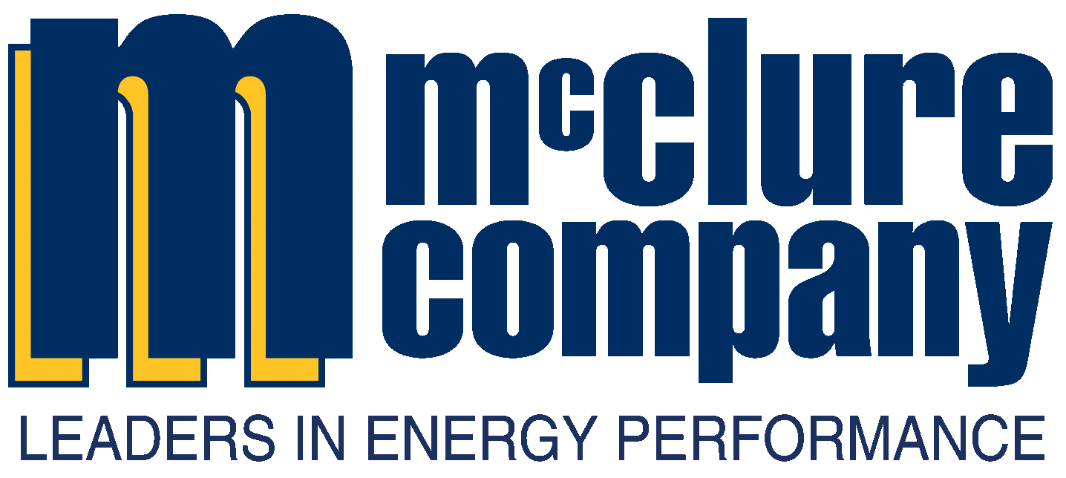

County Utilizes its Core Energy Source as a Source of Energy Savings through a Self Funded Energy Performance Contract

McClure Company was selected by the Schuylkill County Government for the County wide energy retrofit because of our solution to utilize both natural gas and anthracite coal. The result: An energy program with annual guaranteed savings of over $110,000, which was reinvested to fund multiple County infrastructure upgrades.

*Schuylkill County Courthouse*

**Contract Type:**

Guaranteed Energy Services Agreement (GESA) under ACT 39 of 2010

Three (3) Phases

Term – 15 Years

**Customer Information:**

* 3 Building Units
* 287,000 Square Feet

**Contract Amount:**

$1,920,885

**Savings Summary:**

$110,000 guaranteed in first year utility and operational savings.

$2.6M guaranteed over the term of the program (15 Years)

**A Trusted Partner**

McClure Company, a subsidiary of PPL Corporation, has over 300 professionals with offices across PA. Our in-house experts have brought technical, engineering, project management, and 24/7 service capabilities to over 115 Pennsylvania public sector customers in successfully completed, award winning GESA projects. Recognized for our flexibility, progressive solutions and dedication to meeting the ever changing energy landscape demands, we value individual goals, personally delivering dramatic gains and peak efficiency.

About 10 percent of homes in the United States still rely on coal for heat, and Schuylkill County is the nation's leading producer. So it’s no surprise when the County leaders began to look at energy saving concepts, local residents were concerned over the possibility of converting the county buildings to natural gas heat. A community with deep roots in the coal industry dating back to the 1800s found it insulting to believe the county would be turning their back on the industry.

***Testimonial:***

*“As a result of the energy savings program, the County now has new efficient equipment which is essentially paid for the cost savings associated with our energy savings. The County has recognized savings greater than guaranteed in our Agreement. These additional savings exceeded our guarantee by over 40%”*

*Lisa Mahall, P.E., County Engineer*

*Schuylkill County*

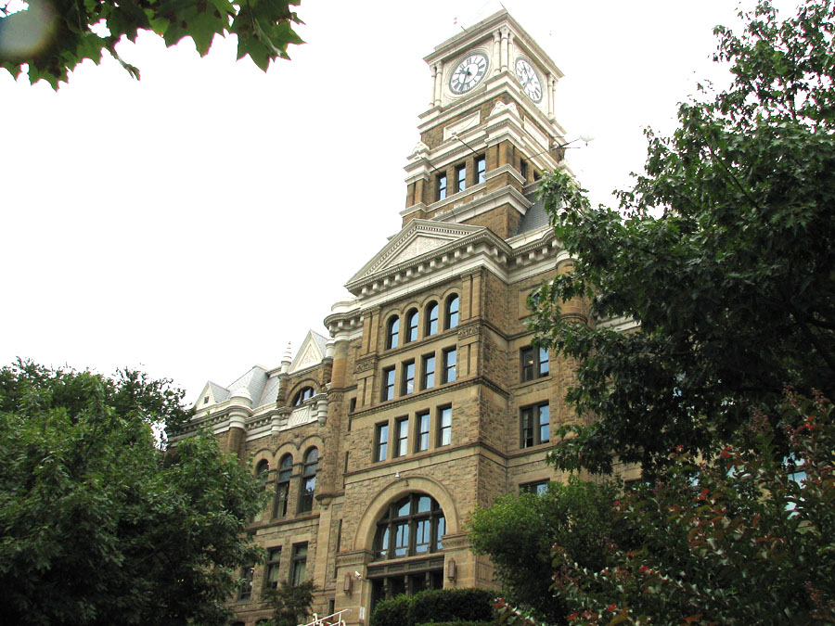

**Environmental Impact:**

The County’s partnership with McClure Company not only provided the taxpayers a budget neutral project, it also removed the equivalent of 1,648 metric tons of carbon dioxide (CO2) per year from the environment.

*CO2 Reduction Equivalent to:*

347 Cars taken off the road for a year.



CO2 sequestered by 41,850 tree seedlings grown for 10 years

CO2 produced by 151 homes for 1 year

**Project Overview**

Through this unique procurement method enabled by Pennsylvania Act 39 of 2010, Schuylkill County was able to fund necessary capital upgrades through guaranteed reductions from energy and operations bills. The results are upgraded facility infrastructures and improved indoor environments at no

additional burden to taxpayers. The project included the installation of two hybrid steam and hot water boilers plants. Each plant consisted of (1) dual fuel (anthracite coal/natural gas) boiler and (3) natural gas modular boilers. The coal boilers are utilized for high load heating months and the modular boiler for the low load months.

The table below illustrates the comprehensive scope of work performed at Schuylkill County and the energy impact. This program was funded through guaranteed savings generated from the upgrades and did not impact the operating budget of the County.

|  |  |  |  |  |  |  |
| --- | --- | --- | --- | --- | --- | --- |
|  |  | **SAVINGS POTENTIAL** | | | | |
| **ID** | **TITLE** | **ELECTRIC** | **THERMAL** | **WATER** | **O&M** | **REBATES** |
| 1 | County Wide Lighting Upgrades |  |  |  |  |  |
| 2 | Courthouse Boiler Retrofit – Coal/Gas |  |  |  |  |  |
| 3 | Prison Boiler Retrofit – Coal/Gas |  |  |  |  |  |
| 4 | Rest Haven Boiler Retrofit |  |  |  |  |  |
| 5 | Courthouse Domestic Water Heating Upgrade |  |  |  |  |  |
| 6 | Courthouse Advance Control Upgrades |  |  |  |  |  |
| 7 | Courthouse Steam Trap Upgrades |  |  |  |  |  |
| 8 | Rest Haven Domestic Water Heating Upgrade |  |  |  |  |  |

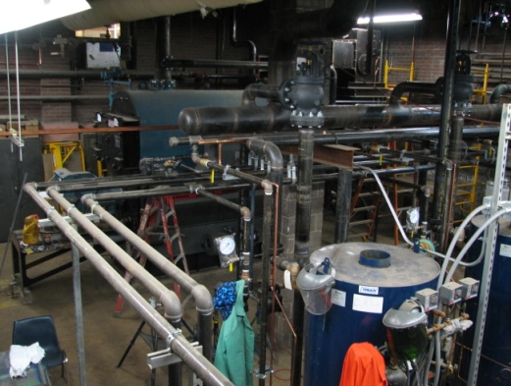

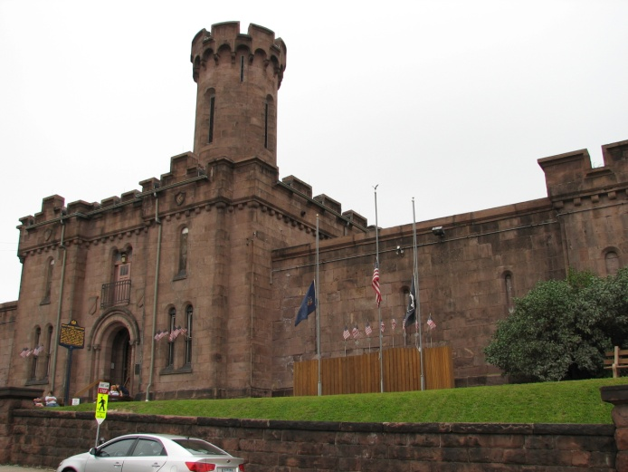

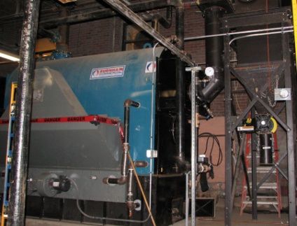

**4101 North Sixth Street, Harrisburg, PA 17110**

**717-232-9743**

**www.mcclureco.com**