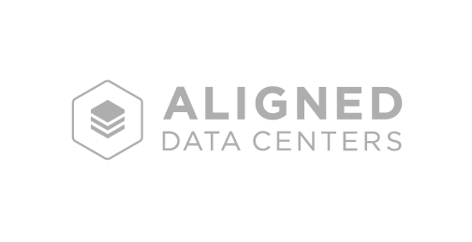

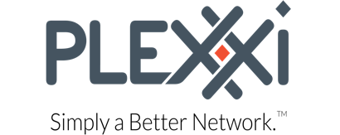

**Aligned Data Centers and Plexxi Partner to Allow Cloud Builders**

**To Consume the Data Center as a Utility**

*Industry’s First Consumption-Based Pricing Model for Data Center Power, Cooling & Capacity Resources*

**New York, NY**– July 6, 2016 – [Aligned Data Centers](http://www.aligneddatacenters.com/), a colocation provider that offers the first “pay-for-use,” consumption-based pricing model for the data center industry, and New Hampshire-based Plexxi, a pioneer of the application-defined network, announced today that they have partnered to deliver an integrated network and data center alternative that can be consumed as a service. The partnership provides the ability to provision data center capacity and connectivity as an on-demand utility.

Data centers and networks today are large upfront investments that require customers to predict future IT needs and either become barriers for growth or are underutilized. In fact, [Gartner reports](http://blog.aligneddatacenters.com/the-leadership-table/video-gartners-bob-gill-on-how-pay-for-use-pricing-can-better-align-cost-with-capacity/#.V2k7bvkrJD9) that as much as 50% of data center capacity goes unused. Aligned Data Centers offers cloud providers and enterprises with unique “plug-and-play” pods that are dynamically provisioned to deliver on-demand agility per application. These pods can scale IT resource requirements from a single rack environment to thousands with ease without having to predefine rack space and network capacity requirements. The platform adjusts to dynamic rack loads, significantly increasing the speed by which cloud players can expand and adjust to growth. Aligned’s platform can accommodate up to 10 times the power density of traditional data centers.

“The compliment between our technology platforms is significant and disruptive,” said Aligned Energy CEO Jakob Carnemark. “Cloud players need data center infrastructure that is as agile and frictionless as provisioning servers, storage and software. Our partnership solves for this by allowing customers to provision infrastructure capacity to align with application needs, significantly reducing stranded capacity and improving speed.”

“Aligned Data Centers re-invented traditional data center architecture,” said Plexxi CEO Rich Napolitano. “They’ve built the world’s first true application-defined data center from top to bottom, including power, space and cooling that adjusts based on customer application requirements and densities. This has never been done before, and truly revolutionizes the cost model of building reliable data centers. IT executives are looking to drastically reduce energy consumption in their data centers, and this partnership enhances Aligned’s transformative pay-for-use model.”

In November 2015, Aligned opened its ultra-efficient, next generation data center in Plano, Texas. Construction is well underway on their second in Phoenix, Arizona, which will be one of the largest multi-tenant data centers in Arizona, capable of offering both high-availability and high-efficiency while guaranteeing an industry-leading 1.15 PUE and reducing water consumption by as much as 85% through its patented technology.

The company will be expanding its platform into the four other cloud data center markets including California, Illinois, Virginia, and New Jersey.

**About Aligned Data Centers**

[Aligned Data Centers](http://www.aligneddatacenters.com/), a division of [Aligned Energy](http://www.alignedenergy.com/), is the first pay-for-use utility model for the data center geared toward cloud enterprise service providers who require greater control of data center cost and faster time-to-market. Aligned Data Centers’ evolved approach eliminates the need to forecast future IT demand and provides control over capacity, so its clients waste less and can better align the data center to the needs of their business.

For more information on Aligned Data Centers, please visit [www.aligneddatacenters.com](http://www.aligneddatacenters.com).

**About Plexxi Inc.**

[Plexxi](http://www.plexxi.com) delivers converged, application-defined network infrastructure building blocks and systems for building software-defined data centers and public / private clouds. Plexxi solutions enable Cloud Builders to harness the power of a single, simple platform to create private/public/hybrid cloud and data center networks. Plexxi’s converged infrastructure and application defined networking solutions provide a comprehensive suite of building blocks, from hardware to management and application integrations that dynamically help applications to perform better and operate at the speed of business. Headquartered in Nashua, N.H., Plexxi investors include GV (formerly Google Ventures), Lightspeed Venture Partners, Matrix Partners and North Bridge Venture Partners. For more information, visit [www.plexxi.com](http://www.plexxi.com) or follow us on Twitter @PlexxiInc.

Plexxi is a registered trademark of Plexxi Inc. in jurisdictions around the world. Other company names or product names may be trademarks of their respective owners.

**Contact:**

Jonathan Pappas

For Aligned Data Centers

[jpappas@solomonmccown.com](mailto:jpappas@solomonmccown.com)

(617) 981-2194

Jackie D’Andrea

InkHouse for Plexxi

plexxi@inkhouse.com

781-966-4143