Press Release For Immediate Release

Contacts:
Vinitaly International
International Media Dept.
+39 045 8101447
media@vinitalytour.com
www.vinitalytour.com
Twitter: @VinitalyTour
Join Vinitaly International Network on LinkedIn

Vinitaly China returns to the second edition of the most important b2c food and wine event in China, the Shanghai Wine and Dine Festival

A press conference organized yesterday at the Mandarin Oriental in Shanghai saw the launch of the second edition of the Shanghai Wine and Dine Festival, the most important b2c event in Shanghai to be held from the 23rd to the 25th of September at Expo Park. Organized by the city’s most influent newspaper, the Morning Post, the Chinese version of TicketOne, Gewara, and Unionpay, the three-day event will see the participation of Taiwan, Canada, Germany and South Korea that will join the other 10 countries present at last year’s edition.
Vinitaly Interntional will be leading once again the Italian Pavilion and presenting to Chinese consumers the best of Italy’s wine and food as well as all those typical Italian products such as pasta, pizza, aperitivo, artisanal beer and coffee loved so much by local consumers.
This year the Accademia Italiana della cucina (Italian Cooking Academy) and nine regional associations will also be present to offer local importers the opportunity to try local products and wines.

“Food and wine are two of Italy’s distinctive products and this emphasizes the great importance of an event like this, where the Chinese public is offered the opportunity to try new food and receipts from Italy” says the Consul General of Italy in Shanghai, Stefano Beltrame. “Italy’s presence at the event is organized and promoted by Vinitaly, which acts as the ambassador for Italian food and wine in China” he goes on to say. “In this Country Italian food and wine are still not very well known, therefore B2C initiatives such as this Festival are very useful and necessary”.

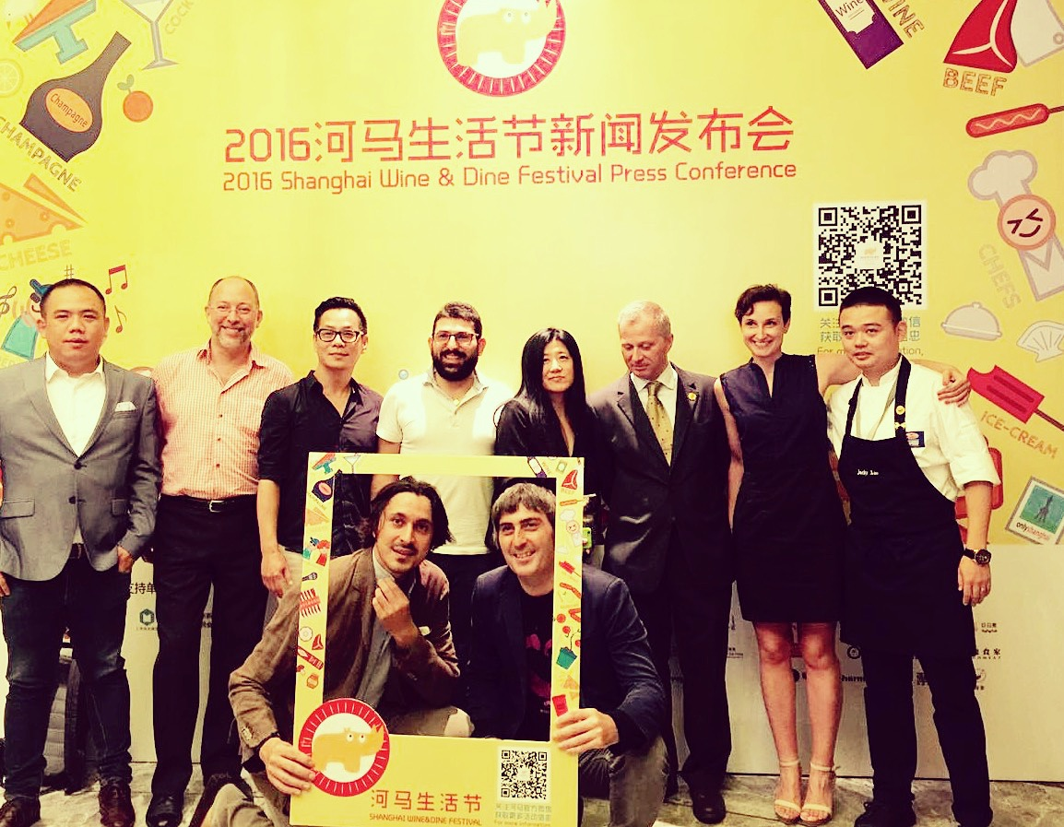

“The second edition of the Shanghai Wine & Dine Festival arrives at a very important moment, only three months after Jack Ma’s visit to Vinitaly in Verona where he launched for the very first time 9-9 (Alibaba’s special day dedicated to Wine & Spirits that this year will be at its first edition)” says Stevie Kim, Managing Director of Vinitaly International. "On that occasion Jack said that Alibaba would increase the market share for Italian wine form 6% to 60%. We are aware that this is in fact quite improbable but the important thing is that it generated a great interest for Italian wine. More than 30.200 pages around the world and another 9.000 pages in China spoke about his visit to Verona. Now with this Festival in China we are trying, together with local importers and Italian food, to seduce also the general public and bring Italian wine to the forefront”.

At the press conference the best of Made in Italy was represented by Nicola Fabbri, the founder of Fabbri 1905 in China, who commented: "The Shanghai Wine and Dine Festival is an event that allows us to present to local consumers in Shanghai the excellence of our culinary millennial tradition. The first edition offered Fabbri an interesting opportunity to present to local Chinese consumers the best haute patisserie and real artisanal gelato”.

The program for the second edition will be even richer that the previous, with new guest Countries and a greater emphasis on wine. “ I expect to see a passionate and curious public, hungry for anything that is new, a unique kermesse where the combination of food and wine will be undoubtedly a winning tool in an attractive setting” says Anna Gai, from VM Fine Wines, one of the most important Italian wine importers in China.

Marco Barnieri, the dean for Italian food in Shanghai and founder of the project Italia "Chef & the City" closed the press conference with a good omen for the Festival: "Today we have proven that Italy is present and produces half of the good things that exist in the world”. We hope that soon the Chinese people will be able to say the same thing.

For more information go to www.vinitalytinternational.com or write to china@vinitalytour.com. It will be possible to register to Vinitaly China until the 30th of July 2016.

About:

About:
Veronafiere is the leading organizer of trade shows in Italy including Vinitaly (http://www.vinitaly.com), the largest wine and spirits fair in the world. During its 50th edition Vinitaly counted more than 4,100 exhibitors on a 100,000+ square meter area and 130,000 visitors from 140 different countries. The next edition of the fair will take place on 9 - 12 April 2017. The premier event to Vinitaly, OperaWine (http://www.vinitalyinternational.com) “Finest Italian Wines: 100 Great Producers,” will unite international wine professionals on April 8th in the heart of Verona, offering them the unique opportunity to discover and taste the wines of the 100 Best Italian Producers, as selected by Wine Spectator. Since 1998 Vinitaly International travels to several countries such as Russia, China, USA and Hong Kong thanks to its strategic arm abroad, Vinitaly International. In February 2014 Vinitaly International launched an educational project, the Vinitaly International Academy (VIA) with the aim of divulging and broadcasting the excellence and diversity of Italian wine around the globe. VIA this year launched the second edition of its Certification Course and today counts 54 Italian Wine Ambassadors and 3 Italian Wine Experts.

###

