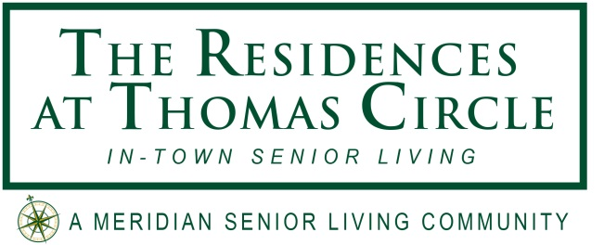
FOR IMMEDIATE RELEASE

Contact: Janet Davis
Marketing Assistant
Meridian Senior Living
240.841.2919
jdavis@meridiansenior.com

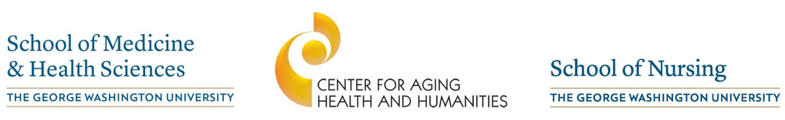
–––––––––––––––––––––––––––––––– Event Sponsors –––––––––––––––––––––––––––––––

World Renowned Dementia/Alzheimer’s Expert Teams With Meridian Senior Living to Present An Incredible Workshop in September

Washington, DC – July 11, 2016 – Meridian Senior Living, LLC and their Washington, DC based community The Residences at Thomas Circle, are proud to share they will be hosting an educational workshop with world-renowned Naomi Feil, Founder of the Validation Training Institute, and her daughter Vicki de Klerk-Rubin, RN, MBA, CVM, on Thursday, September 15, 2016. This event is also sponsored by the Center for Aging Health and Humanities, a collaboration of The George Washington University’s Schools of Nursing and Medicine & Health Science. Hundreds are expected to attend this Workshop which will be held at Dorothy Betts Marvin Theater, located in The George Washington University Marvin Center. Ms. Feil and Ms. De Klerk-Rubin will be presenting from 10am to 3pm at this once-in-a-life time opportunity and will share with attendees how validation helps to successfully communicate with and reach cognitively impaired individuals. For more detailed information on this event, contact The Residences at Thomas Circle In-Town Senior Living at 202-626-5799.

The Disease
So why is learning about Alzheimer’s and other types of dementia so important? The global impact of dementia is absolutely incredible. Just look at these staggering statistics:
- In 2015, there were 9.9 million new cases worldwide of dementia, one every 3 seconds.
- There are 46.8 million people across the world living with dementia in 2015. This number is expected to double – every 20 years – to 74.7 million in 2030 and a whopping 131.5 million in 2050.
- Much of this increase will take place in low and middle income (LMIC) countries – 58% of all people with dementia live in LMICs – rising to 63% in 2030 and 68% in 2050.
- The total estimated worldwide cost of dementia in 2015 is $818 billion US dollars. By 2018, dementia will become a trillion dollar disease, rising to $2 trillion US dollars by 2030.
- If global dementia care were a country, it would be the 18th largest economy ($818 billion) in the world, exceeding market values of companies such as Apple ($742 billion) and Google ($368 billion).
- The estimated number of people with dementia in each world region in 2015: the Americas – 9.4 million, Europe 10.5 million, Africa 4.0 million, and Asia 22.9 million.
- And in our own country, one in nine people age 65 and older has Alzheimer’s disease. By mid-century, someone in the United States will develop the disease every 33 seconds.
With that in mind, all of us will be affected by Alzheimer’s in one way or another, and understanding and learning about the disease becomes increasingly important to be able to capably deal with afflicted family members and loved ones.
We anticipate an increase in proposed legislation pertaining to individuals with dementia so it’s imperative that our politicians and state representatives understand how this disease affects our world, our country, and our economy.

The Speakers
Naomi Feil, born in Munich in 1932, grew up in the Montefiore Home for the Aged in Cleveland, Ohio where her father was administrator and her mother was head of Social Services. After graduating with a Master’s degree in Social Work from Columbia University, Naomi began her life’s work with the elderly. From 1963 and 1980, Mrs. Feil developed Validation as a response to her dissatisfaction with traditional methods of working with severely disoriented elderly people.
Ms. de Klerk-Rubin works full-time as a Validation Master-Teacher and lecturer as well as Naomi Feil’s manager in Europe. As European Manager, she was a founding member of the European Validation Association (1993) and assisted in the development of Authorized Validation Organizations in Austria, Belgium, Finland, France, Germany, Italy, Japan, Sweden and Switzerland. She taught the first formal Validation course in 1994 and since then has been training internationally, delivering certification courses at all levels. As AVO Coordinator for the Validation Training Institute, she has assisted in the development of Authorized Validation Organizations in the United States and written the AVO Guidelines. Ms. de Klerk-Rubin, working with teams of Validation Teachers, has shepherded the development of standardized course curricula, levels of certification, quality guidelines and testing materials. She has been an advisor to the Validation Training Institute Board of Trustees since its inception and a member since 2009. She currently holds the dual positions of Board Secretary and AVO Coordinator. Ms. de Klerk-Rubin received her BFA from Boston University (1978), an MBA from Fordham University (1983), and a Nursing degree from Hogeschool Holland, Amsterdam (1997). She has published numerous articles on Validation in Dutch and British magazines and co-authored the revisions of Naomi Feil’s publications. Her book, Validation Techniques for Dementia Care: The Family Guide to Improving Communication (English edition 2008) has been published in German (2006), Japanese (2009) and Swedish (2010).
Validation is a method of communicating with and helping disoriented seniors. It is a practical way of communicating that helps reduce stress, enhance dignity and promote happiness. Validation is built on an empathetic approach and holistic view of individuals where you ‘step into their shoes’ and ‘see through their eyes’ to understand the meaning of their often bizarre behaviors. This method allows seniors the opportunity to express, both verbal and non-verbal, their feelings and needs, often having been suppressed for years.
Feil founded the Validation Training Institute (VTI) in 1983 and, as Executive Director of VTI, has traveled the world, including Germany, the Netherlands, Scandinavia, France, Belgium, Italy, Great Britain, Austria, and most recently in China on behalf of Meridian Senior Living, to share her experiences and Validation method with people from all walks of life. VTI, a U.S.-based, not-for-profit organization with a professional Board of Directors, has progressively developed certification levels, training programs, and formed a network of national and regional Validation organizations to disseminate information, train interested individuals, and maintain ‘the spirit of Validation.’
“We are proud of our extensive work with Ms. Feil and Ms. De Klerk-Rubin to help educate our staff and associate businesses to better work with and create a much higher quality of life for our memory care residents across the country and in China,” says Kevin Carlin, Principal and Chief Sales Officer. “We are committed to enriching the lives of seniors and continue to actively support our memory care communities through education and proven staff training.”

Meridian Senior Living:
Meridian Senior Living, LLC owns and operates senior housing communities across the United States and in China. With more than 10,000 beds, Meridian is currently the fifth largest assisted living provider and the third largest memory care provider in the United States.
# # #

