 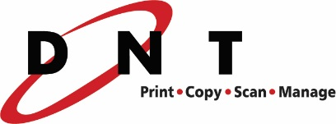

**FOR IMMEDIATE RELEASE Corporate Contacts:**

August 8, 2016Mike Golinvaux, President Jeff Gau, CEO Document & Network Technologies, Inc. Marco Work: 314.584.4900 Work: 320.259.3051

Cell: 320.267.9658

Jennifer Mrozek, CFO

Marco

Work: 320.529.1048

Cell: 320.250.9628

**MARCO PURCHASES MISSOURI COMPANY; CONTINUES NATIONAL EXPANSION**

Marco, a leading technology services provider in the United States, announced today that it has purchased Document & Network Technologies (DNT), a copier/printer and business IT services company located in   
St. Louis, Missouri. Their 80 employees have joined the Marco team.

DNT has been providing their clients with copiers/printers, managed services, IT services, shredding and imaging services for over 15 years. This purchase allows Marco to further expand its geographic footprint and technical services in the state of Missouri.

“This is our largest acquisition to date,” said Jeff Gau, Marco CEO. "It supports our strategy for continued national growth. We look forward to providing DNT’s 3,400 clients with expanded technology services."

This is the 14th acquisition the company has completed over the past three years. In January, Marco purchased Data Comm, a copier/printer and business IT services company in Missouri. They now have eight locations throughout Missouri.

Marco has 1,130 employees and serves more than 30,000 customers from its 50 locations throughout the Midwest and nationally.

“DNT is excited to become part of Marco’s strategy,” said Mike Golinvaux, President of DNT. “This strategic partnership will enhance our future by providing tremendous career opportunities for our employees and provide a best in class solution offering to our customers. We look forward to our continued commitment to support and give back to the communities we serve.”

**About Marco**

Marco was founded in 1973 and serves customers nationally with offices in Minnesota, Illinois, Iowa, Missouri, Nebraska, North Dakota, South Dakota and Wisconsin. Marco specializes in copiers/printers, business IT services, cloud services, managed services, telecom carrier services, phone systems, document management and audio/video systems. Learn more at **marconet.com.**