Razormind to launch DeOS as rival to Ethereum

The World’s First Decentralised Operating System ‘DeOS’ to Open in October

Belfast, Ireland―Aug 10, 2016―UK company Razormind announced today that the DeOS Platform will open it’s doors to the public on 10 October. DeOS is the first global public record of ownership and identity, complete with decentralized storage and an operating system powered by state of the art blockchain technology. DeOS works by harnessing safe idle time on networked computers to perform tasks across thousands of machines - creating a sustained, worldwide, public supercomputer. At the heart of this platform is the DeOS Desktop.

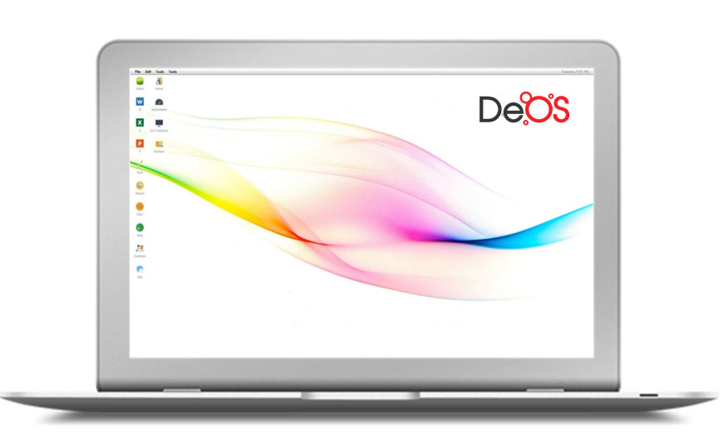

DeOS for Business
DeOS Desktop services include banking, secure global identity, smart assets, smart contracts, decentralized storage and computing. DeOS provides a Blockchain-as-a-service (BaaS) platform that organisations can use to design and deploy their own apps. DeOS provides global record keeping, safe decentralized storage, and genuine privacy through end to end encryption.

DeOS for Individuals
Online most services involve handing over your data to a third party. With DeOS, which uses the blockchain to secure and decentralise your information - you have complete control over who sees any of your data, if at all. It’s a personal and private safe space for you to communicate, and work. The blockchain means only you will access your data and ownership and privacy remain always under your control. The system is designed to work seamlessly with smartphone, Mac or PC and it’s original purpose was for use in daily family life.

The DeOS Blockchain

DeOS has been carefully sanded down over the past two years to achieve a comfortable, daily blockchain powered experience. Razormind designed DeOS to use the blockchain itself as the CPU for any number of machine. DeOS blocks manage their computing resources, and use the DeOS Platform seed nodes to verify network transactions and create blocks.
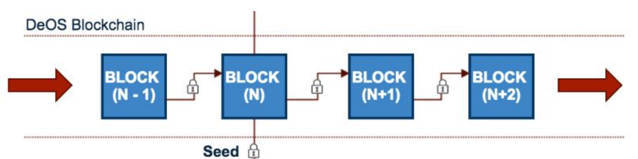
We wanted something useful day-to-day so DeOS blocks are geared toward that; Bitcoin holds monetary transactions, beautifully, but DeOS can also manage data, smart contracts, assets and public audit information. Free for the public to look up worldwide.
Jawad Yaqub, CEO, Razormind.

Unlike existing options DeOS Smart Contracts can be in existing mainstream languages like Java, C#, Scala, Python and Go. This means businesses can use their existing, tested code, and plug it directly into DeOS to run globally through the blockchain. DeOS takes care of availability and scaling, and tracking of business assets through the blockchain. This will simplify and speed up the development process and increase uptake the technology.
The DeOS platform building is underway. When live, the network will controlled by the public through the DeOS Foundation in Switzerland and run in the spirit of community. The commercial DeOS codebase will be open sourced by the Foundation which will act as guardian of the network and platform. As a public non-profit organisation the Foundation is entrusted to preserve the integrity and availability of DeOS, with full responsibility for setting standards including testing and approving releases. They are forbidden from hard-forking the DeOS blockchain under any circumstances.

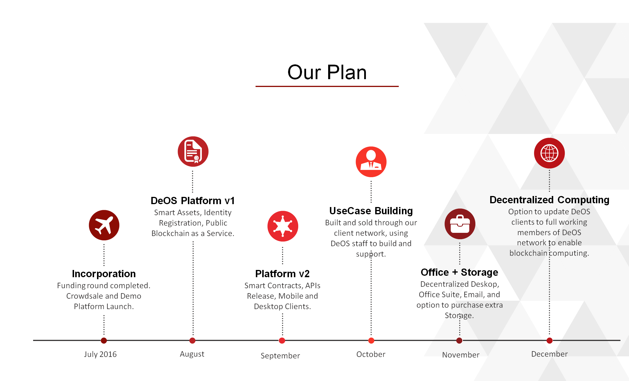

DeOS Team
The DeOS was conceived by Jawad Yaqub, Enterprise Architect and CEO of Razormind. Jawad Yaqub worked with finance institutions including Goldman Sachs on enterprise architecture and big data before branching out into blockchain development. Led by highly qualified professionals in their respective fields, the DeOS team is grounded in the belief that blockchain is for everyday use and should be easy and open..

Explore DeOS: http://www.razormind.co.uk/crowdsale/
The DeOS Demo: http://www.razormind.co.uk/deos-demo/

About Razormind
Razormind is a Northern Irish company which specialises in Enterprise Architecture; offering expertise in Blockchain, Big Data, Deep Learning and AI practices. Razormind works with clients to deliver grounded reliable results, while developing elegant solutions to give them their desired competitive edge. Razormind is committed to the highest professional and ethical standards, and is an equal opportunity employer.

Learn more about Razormind: http://www.razormind.co.uk/

Press Contacts:

Phil Sturgeon
Razormind
phil@razormind.co.uk
020 7193 6611

