Press Release
London, 15. August 2016
Nualight launches Orion. The industry leading solution for refrigeration case lighting.
- Nualight reaffirms position as refrigeration case lighting leader with the new high performance and competitive Orion range
LONDON, United Kingdom – Effective August 15, 2016, 07:00 GMT – Refrigeration lighting pioneers Nualight, known for completing some of Europe’s largest LED retrofits for supermarket chains such as Tesco and Spar, are back with a brand new performance driven, price competitive range of horizontal and vertical LED refrigeration lights.
Having worked with display case manufacturers, installers and retailers, Nualight have explored customer feedback, and combined it with the advances in LED technology, their result is the Orion range.
Orion maintains all the quality colour aspects associated with Nualight products, but has been upgraded with the latest standards in LED technology - 3SDCM LED chips, plus boasts the added convenience of stocked products, which allows for faster worldwide delivery times.
With the strap line – ‘On time. Easily integrated. Industry leading solution’, Orion certainly ticks all those boxes, Andrew Cronin, Vice President of Product Research & Development provides some insight, “Orion is the best product Nualight has ever designed, there is huge pride and passion behind bringing this range to the market. We went back to the beginning and re-evaluated everything we have ever done. Never before have we obsessed so much on a product design, and we are now proud to launch a product that is uncompromising in delivering the latest in LED and optical technology, to deliver vibrant and uniform merchandising solutions. Combined with exceptional customer service and market leading lead times, there really is no other choice in the market.”
Industry leading efficacies of up to 120 lm/w combined with a long 50,000-hour lifetime results in exceptionally low cost of ownership and quick payback. Orion presents an excellent alternative to fluorescents at a comparable cost. Furthermore, you can be confident to receive a solution that remains true to the Nualight design DNA prevalent in its predecessors, providing high colour impact as standard and is available in a range of lengths and colour temperatures with cables, brackets and covers options to fulfil all every merchandising and retail display need.
The known and much appreciated Nualight user experience is enhanced with Orion. The true colours of high margin produce such as meat, fish and cheese remain rich and enticing. True science and brilliance has been applied to provide a simple yet comprehensive range negating the need for centres, ends or specific meat or fish luminaires.
Orion is a leading solution from the leading supplier of refrigeration display case lighting. With its best in class features, Orion, sets a new benchmark in the industry. Nualight is selected and trusted by grocery retailers, display case manufacturers and distributors across the world. Orion, really has been designed to deliver.
For further information on the Orion range please visit: www.orion.nualight.com
- ENDS –
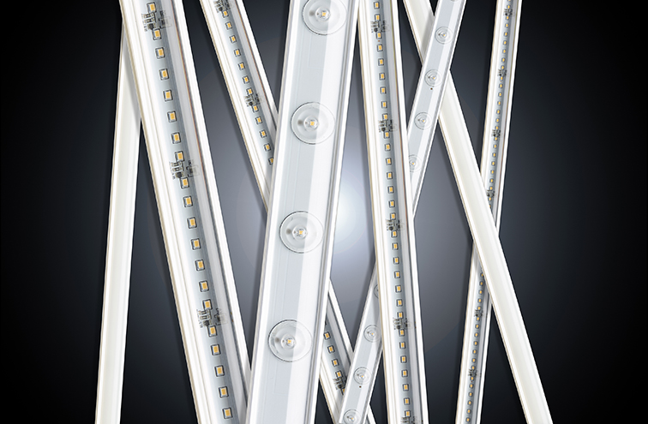
Image Enc: NUALIGHT_PR_1_ORION_RANGE.jpg
About Nualight
Founded in 2005 in Cork, Ireland, Nualight is a specialist European LED lighting company selling predominately refrigeration lighting into the world’s leading grocery retailers, refrigeration display case manufacturers, specialist refrigeration wholesalers and distributors. With a heritage in award winning, market leading solutions and due to its progressive and nimble approach, Nualight is also privileged to serve select key accounts within industrial and infrastructure applications.
Nualight is funded by major resource efficiency and renewable energy investors: Adaxia Capital Partners and ESB Novusmodus managed by Greencoat Capital. The company has a sales presence throughout Europe and Australia. For further information, please visit www.nualight.com
Nualight Contact:
Pam Chahal-Harris | VP Global Marketing & Communication
M: +44 (0)7584 560069 | pharris@nualight.com

