MetaViewer®
Enterprise Content
Management Solution


MetaViewer

Microsoft Dynamics SL Integration

Fast Track AP Solution
July 26, 2016



Overview

MetaViewer Enterprise allows users to interact with Accounts Payable documents via a web interface. The application data is stored in a SQL Server database and the documents are stored on a file system. System information, user information and document content is created during the workflow process either by internal scripts and procedures within the MetaViewer database, user interaction, or data populations from the Microsoft Dynamics SL system.
For MetaViewer to pull information that can be used in the document lifecycle, a linked server object is created on the SQL instance that houses the MetaViewer database. The linked server user requires only read access. MetaViewer application does not make any direct updates, inserts or deletes to the Dynamics SL database through the linked server.
At the end of the Accounts Payable process, the invoice data within MetaViewer is passed to the Dynamics SL system to create a voucher.
Metafile has entered into a joint partnership with Catalina Technology. The MetaViewer for Microsoft Dynamics SL solution have been standardized to integrate using the Catalina CTAPI Web Services, specifically the Finance Module which is a subset of available SL Web Services from Catalina. This is the most up-to-date and efficient integration method for passing data from the MetaViewer AP solution to Microsoft Dynamics SL. The finance module of the Catalina CTAPI contains numerous stored procedures. While there are numerous capabilities for integration within this Web Service tool, the MetaViewer integration process will only use a small subset of these objects.
These Web Services give MetaViewer the ability to integrate with Dynamics SL. This allows MetaViewer to export invoices to the Dynamics SL Voucher and Adjustment Screen. The new Dynamics SL voucher is created in unposted batches for review by a user. Here, the web service requires a login with read, write, and execute access to necessary Dynamics SL databases.
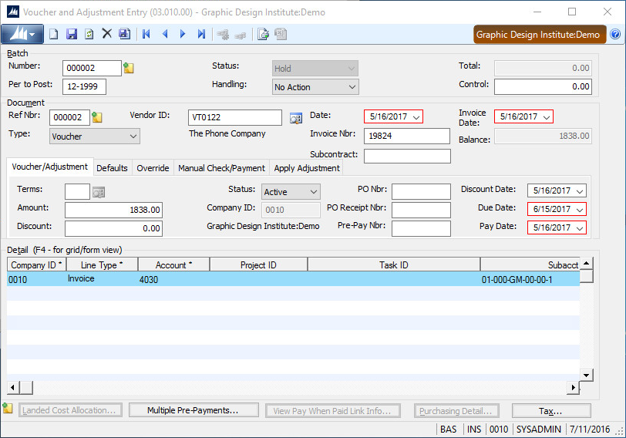

A full license and annual support for this Catalina Technology CTAPI module is included in the purchase and annual support fees of your MetaViewer for Microsoft Dynamics SL solution. To learn more ways you can take advantage of this powerful integration tool outside of the MetaViewer solution you are encouraged to contact Catalina Technology directly. Metafile also plans on expanding the use of these integration tools to further expand the breadth of the MetaViewer for Microsoft Dynamics SL solution. No additional changes to the SL solution or upgrades to the Catalina or MetaViewer software will be made without prior approval by by the customer.
For all support issues regarding the MetaViewer solution including suspected issues with the CTAPI Web Services, the customer will use the MetaViewer Support contact process outlined in the MetaViewer Support Services Agreement. Metafile will work with the customer and Catalina Technology, as necessary, to resolve the issue.

Database Impact

New SQL Objects
The Web Services components require only additions to the Dynamic SL company databases. There are no changes to existing Dynamics SL database objects.
The additions include new:
- Tables used by the Web Services. They are infrastructure tables used for logging, storing email templates settings, and other generic settings.
- Functions used to split data and get the billing month span.
- Stored procedures provided by Catalina Technology to integrate with Dynamics SL. These include lookups, validations, inserts, and updates to Dynamics SL.
As outlined earlier, only a small portion of the Web Services provided in the Finance Module will be utilized by your current MetaViewer integration. These additional Web Services are part of the standard Catalina Technology integration package and can be used by MetaViewer or other applications to expand the integration with Dynamics SL.

Data Access
MetaViewer has two components to its integration for Dynamics SL, lookups and exports. The lookups are handled via linked server. The exports are handled by Web Services.

Lookups
Lookups require read access to all the Dynamics SL databases, including all companies that will be integrated. This access is required for the MetaViewer Profile Builder workstation, the MetaViewer administration workstation, MetaViewer services and MetaViewer web application. Metafile recommends this be configured using an Active Directory group (MetaViewer Power Users Group and MetaViewer Administrators Group). If there are specific concerns, other options are available.

Exports
Exports are handled by Web Services and require read, write, and execute access to the Dynamics SL company databases. In the MetaViewer deployment, only Web Services will require this access. It can be managed by active directory group, active directory user, or by a dedicated SQL user.
The specific tables within Dynamics SL that require write permissions for the current MetaViewer implementation are:
- APDoc
- APTran
- Batch
As outlined in the previous section, the Web Services configuration requires installation of new Web Services-dedicated objects (tables, functions and stored procedures) in the Dynamics SL company databases. Web Services require read, write, and execute permissions for these objects.

SQL Users
Metafile recommends 2 new logins be created in the Dynamics SL databases. These logins will be dedicated to the MetaViewer integration, one for lookups and one for exports.
The lookup login can be an Active Directory group, an Active Directory user, or a SQL Server user. If an Active Directory group is used, named users would be added for all service accounts, the web application pool user, any administrative users, and any Profile Builder users. (This does not include MetaViewer web users.) If an active directory user is used, it would be directly embedded in the linked server as the default credentials. If an SQL user is used, it would be directly embedded in the linked server as the default credentials.
The export login can be an Active Directory group, an Active Directory user, or an SQL Server user. The login will be used by Web Services to access the SQL Objects noted in the previous section. The Web Services configuration includes a database connection string that can be configured to use integrated security or an explicit user/password.
As mentioned, both logins can be handled via Active Directory groups, Active Directory users, or SQL Server users. There are additional options not covered here if there are additional security requirements. Metafile recommends conforming to an organization’s existing security procedures. If there is not an existing precedent, Metafile recommends using Active Directory groups using integrated security to avoid storage of the passwords in clear text and to support disabling access from named users.

