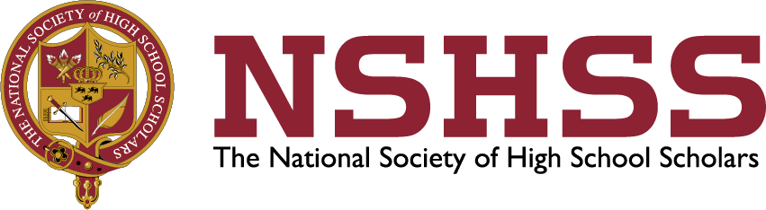
Media Contact:
Amy Adams
HL Strategy
706.570.6004
adams@hlstrategy.com

FOR IMMEDIATE RELEASE:

THE NATIONAL SOCIETY OF HIGH SCHOOL SCHOLARS (NSHSS) ANNOUNCES THE RECIPIENT OF THE INTERN GROUP $5,000 SCHOLARSHIP

Atlanta, August 26, 2016 – The National Society of High School Scholars (NSHSS), an international honor society dedicated to highlighting the accomplishments of students who have demonstrated outstanding leadership, scholarship and community commitment, announces today that Kaela Green of Blakeslee, Pennsylvania, a junior at Pennsylvania State University, has won a $5,000 scholarship from The Intern Group. The Intern Group is a leading provider of international internship programs in London, New York, China, Europe, Australia and Latin America. The scholarship covers a 6-week internship program in summer 2016 at any of The Intern Group’s international program locations.

Green is a marketing major with an international business minor and will complete a marketing related internship in Madrid, Spain this summer through The Intern Group scholarship. She has been studying Spanish since elementary school and looks forward to being immersed in a Spanish-speaking country. Green is currently a public relations intern for Women in Business and a Trendstate blogger for the Penn State Marketing Association. She also works as staff support for the University Office of Global Programs, and she is a tutor for student-athletes.

"Kaela was everything that we look for in an applicant." said Lexie Kadlec, who led the final selection process for The Intern Group. "She was able to clearly connect her past achievements to her future goals. We felt that this experience would be a natural fit in helping her continue on her already very bright path. On top of that she had the right attitude; positive, determined and open-minded."

“NSHSS is proud to partner with The Intern Group to offer our college-age members the significant opportunity to gain global business and cultural experience that is essential for success in today’s world,” stated Claes Nobel, co-founder of NSHSS and senior member of the family that established the Nobel Prize. “Together we are helping young people connect globally, making a positive impact on the future of international business and international relations.”

About the National Society of High School Scholars (NSHSS):
Formed in 2002 by James W. Lewis and Claes Nobel, senior member of the family that established the Nobel Prizes, The National Society of High School Scholars recognizes academic excellence at the high school level and helps to advance the goals and aspirations of high-achieving millennials through unique learning experiences, scholarships, internships, international study and peer networks. NSHSS members become lifetime members. At each step along the way – from high school to college to career – NSHSS connects outstanding young scholars with the resources they need to develop their strengths and pursue their passions. Currently, there are more than 1,000,000 Society members in 160 countries. To help us further efforts that provide students with continued opportunity, please acknowledge NSHSS in any press release mentions by providing a resource link to www.nshss.org. For more information about NSHSS visit www.nshss.org.

About The Intern Group
The Intern Group is an award-winning social enterprise that amplifies the global consciousness and professional & career development of talented individuals worldwide through global internships within their international network of partnerships spanning all career fields. They envisage a future where we can empower & educate individuals, regardless of socioeconomic status, to intern and travel anywhere on the globe cost-effectively, and leverage the latest technology to share their experiences with others around the world.
# # #

