-- FOR IMMEDIATE RELEASE --

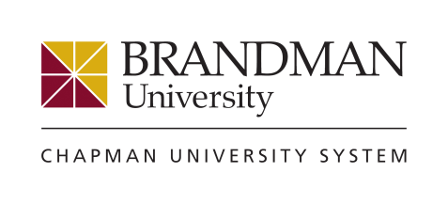

Media Contact: Karen Kalil for Brandman University
Phone: (714) 371-6783
Email: karenbkalil@gmail.com

Brandman University’s Dr. Laurie Dodge Named
Washington Monthly’s “Most Innovative in Higher Education”

Brandman’s innovative program to help adult students earn college degrees is recognized

IRVINE, Calif., Aug. 30, 2016 – Brandman University’s Dr. Laurie Dodge, vice chancellor of institutional assessment and planning, has been named as one of “The Sixteen Most Innovative People in Higher Education” by Washington Monthly. The publication’s designation honors those “creative and passionate people around the country who are working to make higher education more accessible, affordable, and effective.”

Dodge was recognized for her ongoing work helping adult and non-traditional students earn the college degrees they need to advance their careers. Specifically, Dodge was part of the Brandman University team that created a competency-based bachelor’s degree program, Brandman MyPath, that eliminates time spent on concepts adult learners have already mastered and focuses on the material necessary to earn a degree. Brandman MyPath takes approximately 30 months to complete and costs $5,400/year including textbooks. (The program is fully accredited by WASC Sr. and approved by the U.S. Department of Education.)

“In today’s world, students are questioning whether a college degree is worth their time and worth their money,” explains Dodge. “With competency-based education, the answer is a resounding ‘yes.’ Competency-based education is an accessible, affordable and effective way for adult students – often supporting families, aging parents and significant financial responsibilities – to utilize their real-world knowledge to quickly complete their degrees and ultimately achieve career advancement.”

“Brandman University is fortunate to have Dr. Dodge to move the cause of competency-based education forward. I congratulate her and the entire Brandman MyPath team on this well-deserved recognition,” said Brandman University Chancellor Gary Brahm.

Dodge is a recognized leader in competency-based education. She serves on the Board of Directors for University Professional and Continuing Education Association (UPCEA) and is chair of the Competency-Based Education Network (C-BEN). Funded by the Lumina Foundation, C-BEN is an invited, collaborative group of institutions from across the nation committed to solving common challenges around developing quality competency-based models capable of scaling to affordably serve more students.

About Brandman University
Brandman University is a private, nonprofit institution accredited by the WASC Senior College and University Commission. As part of the Chapman University System, Brandman blends a legacy of academic excellence with innovative curriculum and strong support services designed for students with busy schedules. The university offers 50+ undergraduate, graduate, credential and certificate programs across its schools of arts and sciences, business, education, nursing and health. Brandman serves 12,000 students annually with programs available online and at 26 campuses throughout California and Washington. The university’s online programs consistently rank among the top in the nation by U.S. News & World Report.

Editor’s Note: Dr. Dodge’s areas of expertise include competency-based education, higher education assessment, program and curriculum development, blended and online learning, and degree qualification profile

Dr. Laurie Dodge
Vice Chancellor, Institutional Assessment and Planning
Brandman University

###

