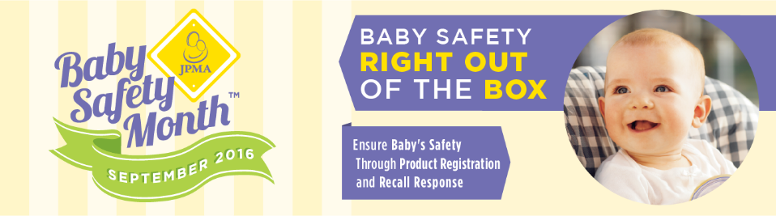
2016 Baby Safety Month Social Media Info Guide

What is Baby Safety Month?

Every September is Baby Safety Month, sponsored by the Juvenile Products Manufacturers Association. This year, JPMA is helping educate parents and caregivers on the importance of product registration cards and recall response through a month-long campaign, Baby Safety Right Out of the Box. JPMA understands the value of keeping children safe. This year’s Baby Safety Month campaign provides knowledge and information to parents and caregivers everywhere who seek to provide the safest environment for their children.

Baby Safety Right Out of the Box seeks to educate parents and caregivers on how quick and easy it is to register baby products and the importance of product registration cards when it comes to recall effectiveness. For a parent, it seems overwhelming to think about registering all of their baby gear. What do those little cards that come in every box even mean? The truth is, product registration is the #1 way to effectively manage recalls and ensure baby is using the safest products. Knowing about and responding to product recalls can be lifesaving. And while a recall may seem scary, it actually shows that the manufacturer is making a commitment to creating safe products.

How you can promote Baby Safety Month

As a valued partner of JPMA, there are several ways in which you can help promote this very important awareness program to your audiences. Social media posts, blogs, email blasts to your subscribers and even simple shares and retweets can promote these very important safety messages to parents and caregivers everywhere.

To assist in making this as easy as possible for you to participate, we have listed sample hashtags, social media messages, blog posts and images of our collateral pieces that can be used via your own communication outlets.

Social Media recommended hashtags:
#BSM2016
#BSM
#BabySafetyMonth
#BabySafetyRightOutOfTheBox
#JPMABSM
#JPMABabySafetyMonth

Facebook:

September kicks off #BabySafetyMonth; this year’s theme is Baby Safety Right Out of the Box. @JPMABabySafetyMonth helps you safeguard your home for your little loved ones. Have you registered your baby products? #BSM2016

September is #BabySafetyMonth, a campaign to raise awareness of product registration cards and recall response. Don’t forget to register your baby products as soon as you get them home and enroll in the weekly prize bundles! #BSM2016 #BabySafetyRightOutOfTheBox

September is #BabySafetyMonth. Registering baby products is quick and easy and can be done in less than 5 minutes. #BSM2016

September is #BabySafetyMonth. Did you know? Product registration is the #1 way to effectively manage recalls and ensure baby is using the safest products. Knowing about and responding to product recalls can be lifesaving. Enter to win great products every week in September! #BSM2016

Twitter: @BabySafetyZone

It’s #BabySafetyMonth! It’s Not Hard, Fill Out Your Card and stay on top of recalls in your nursery. #BSM2016

September is #BabySafetyMonth. Think product registration is scary? Think again. Learn more #BSM2016

Knowing about and responding to product recalls can be lifesaving. Registering baby products is easy as 1-2-3. @BabySafetyMonth

Instagram: @jpmababysafetyzone

Most baby gear items are required by law to come with recall-only product registration cards and online registration forms. #BSM2016

Stay on top of recalls by registering your baby products. #JPMABABYSAFETYMONTH

Check for recalls when buying or using second-hand or heirloom baby products. #JPMABSM

Pinterest: www.pinterest.com/jpmapinterst

Every September is Baby Safety Month! Check out Baby Safety Zone’s Pinterest for knowledge on how to keep your baby safe. Follow the “Baby Safety Month 2016” board. Also, be sure to follow our other boards providing information on baby products, cute clothing ideas and infant care. Every week in September, Baby Safety Zone will give away great products from its manufacturers and partners. Be sure to enter daily!

YouTube: www.youtube.com/user/BabySafetyZone

Every September is Baby Safety Month! Be sure to check out Baby Safety Zone’s YouTube channel for information on how to keep your little one safe. http://bit.ly/1WQ8ZBn

Email Blasts:

September is Baby Safety Month! This year, Baby Safety Zone seeks to educate parents and caregivers on how quick and easy it is to register baby products and the importance of product registration cards when it comes to recall effectiveness. For a parent, it seems overwhelming to think about registering all of their baby gear. What do those little cards that come in every box even mean? The truth is, product registration is the #1 way to effectively manage recalls and ensure baby is using the safest products. Knowing about and responding to product recalls can be lifesaving. And while a recall may seem scary, it actually shows that the manufacturer is making a commitment to creating safe products. Be sure to check out BabySafetyMonth.org for more information regarding products registration and managing recalls.

The Baby Safety Zone is an information hub for parents and caregivers who seek ways to keep their children safe, and that includes in their own homes. Every September is Baby Safety Month (BSM), an awareness program originally created by the Juvenile Products Manufacturers Association (JPMA). BSM raises awareness and provides knowledge on how to keep little ones safe. This year’s theme, Baby Safety Right Out of the Box, offers information on product registration cards and the importance of managing recall response. Be sure to check BabySafetyMonth.org frequently for more information regarding this campaign, and for information on how you can keep your home safe for your little ones.

Every week in September, Baby Safety Zone will hold its annual Baby Safety Month giveaway, allowing anyone to enter for a chance to win great baby products from valued manufacturers and partners. Enter daily for your chance to win everything from car seats to swaddles!

Weekly Prize Bundle Giveaways And Safety Bulletins

Be sure to check the Baby Safety Zone’s Facebook page with information on how to win cool prizes for you and baby! Be sure to connect with JPMA and Baby Safety Zone for weekly Safety Bulletins throughout September with safety tips, helpful hints and more.

Babysafetyzone.org blog

Babysafetyzone.org’s blog will feature important articles throughout the month from industry experts and Baby Safety Month supporters like the National Highway Traffic Administration and Safe Kids.

