Presenting Researchers at Gateway Symposium
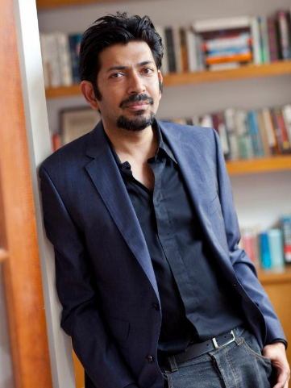
Siddhartha Mukherjee, MD, PhD
- Gateway Breakthrough: Developed a novel system to assess drug sensitives of cancer cell using a patient’s own cancer tissue, which could have a transformational impact on precision medicine for cancer.
Siddhartha Mukherjee, MD, PhD is an assistant professor of medicine at Columbia University’s College of Physicians Department of Pathology and Cell Biology. He is the author of The Emperor of All Maladies: A Biography of Cancer, winner of the 2011 Pulitzer Prize in general nonfiction, and The Gene: An Intimate History. His laboratory takes a special interest in understanding malignant and pre-malignant blood diseases such as Myelodysplastic Syndrome (MDS) and Acute Myelogenous Leukemia (AML). He is conducting a blood cancer trial, Phase 1 Trial of Personalized/Precision Therapeutics for Myelodysplastic Syndrome, for Gateway.

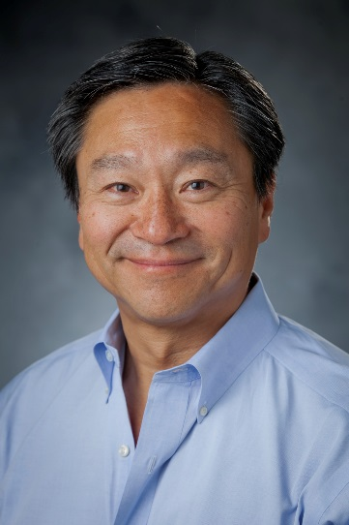
Dr. Nelson Jen An Chao
- Gateway Breakthrough: Created an approach of patient-centered medical treatments at home, which had significant advancements in terms of improved outcomes, quality of care and life, all at lower healthcare cost.
Dr. Chao is a Donald D. and Elizabeth G. Cooke cancer research professor, professor of medicine, research professor of global health, professor in immunology, professor in pathology, member of the Duke Cancer Institute and chief of the division of cell therapy in the department of medicine at Duke University. His research interests are in clinical hematopoietic stem cell and cord blood transplantation and in the laboratory studies related to graft-versus-host disease and immune reconstruction. For Gateway, he is conducting a blood cancer trial, Phase II: A Controlled Study of Microbiome and Stem Cell Transplantation Medical Home Care Compared to Standard Hospital Care.
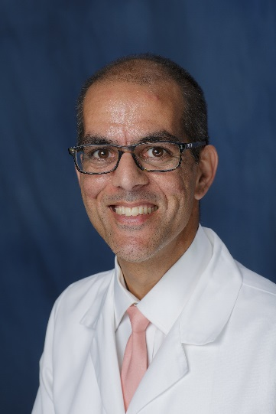
Dr. Christopher R. Cogle
- Gateway Breakthrough: Utilizing sophisticated computer program (digital droplet PCR) to sort through DNA variables (cancer maps) and matches patients with unique chemotherapy combinations.

Dr. Cogle practices at Shands Cancer Hospital at the University of Florida. He is a physician-scientist with clinical and research expertise in the myelodysplastic syndromes, acute leukemia’s, and bone marrow syndromes. He is also acts as a professor of medicine and runs a stem cell research laboratory where he dissects the mechanisms of bone marrow-derived blood vessels. He is currently conducting a blood cancer trial, Personalized Genomic Mutation informed Treatment of Patients with Myelodysplastic Syndromes (MDS).

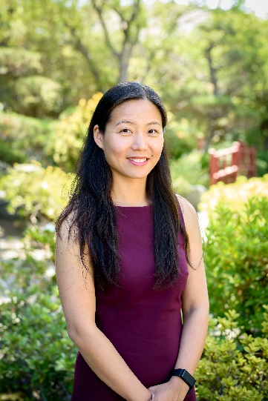
Dr. Weili Sun
- Gateway Breakthrough: First pediatric study to test the concept of epigenetic intervention in concert with chemotherapy in children with AML.
Dr. Sun is a pediatric hematologist-oncologist in Los Angeles and is affiliated with Children’s Hospital Angeles. She is involved in the treatment of children, adolescents and young adults with leukemia and lymphoma, especially acute lymphoblastic leukemia, acute myeloid leukemia, myelodysplastic syndrome, myeloproliferative disease, Hodgkin's lymphoma and Non-Hodgkin's lymphoma. She recently completed a blood cancer trial, New Epigenetic Approach to Leukemia Therapy, for Gateway.

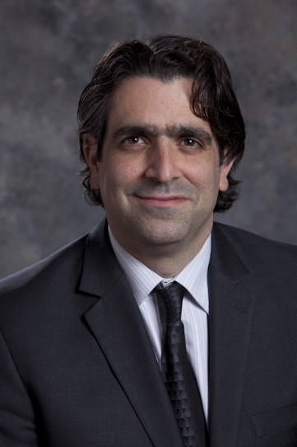
Dr. Adam Resnick
- Breakthrough: Researching cell signaling cascades and their alterations in pediatric brain tumors along with the utilization of big data and consortia building in pediatric oncology.
Dr. Resnick is a research scientist in the Department of Biomedical and Health Informatics at The Children’s Hospital of Philadelphia and is active in the Department of Surgery. He was recently appointed chair of the scientific committee for the Children’s Brain Tumor Tissue Consortium (CBTTC). In June, he participated in Vice President Joe Biden’s Cancer Moonshot Summit.

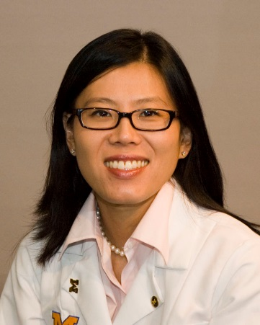
Dr. Sung Won Choi
- Gateway Breakthrough: Testing Vorinostat, an anticancer drug, that when given in low doses, reduces inflammation and interrupts a key enzyme that is part of the graft-versus-host disease.
Dr. Choi is an assistant professor of pediatrics and communicable diseases at the University of Michigan Medical School. Her research focus is in the prevention and treatment of graft-versus-host disease (GVHD), the major complication of allogeneic hematopoietic cell transplantation. She is a member of the blood and marrow transplantation program at the University of Michigan and she is working to lower the incidence of acute GVHD. She is conducting a blood cancer trial, Phase II: Vorinostat Plus Standard immunosuppression After Unrelated Donor Myeloablative BMT, for Gateway.
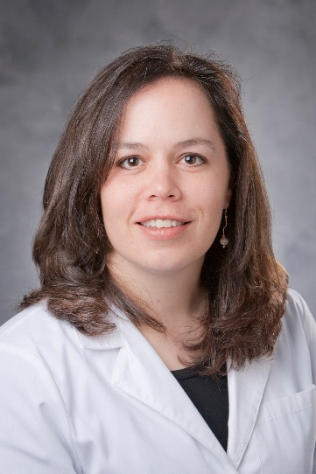
Dr. Janet K. Horton
- Gateway Breakthrough: Discovering how to treat various breast tumor types with various radiation doses and regiments to be tailored to the unique types of breast cancer.
Dr. Horton is a radiation oncologist at Duke University Cancer Center. Her primary clinical and research focus revolves around women with breast cancer. She is currently conducting a breast cancer trial, Preoperative Breast Radiotherapy: A Tool to Provide Individualized and Biologically-Based Radiation Therapy.
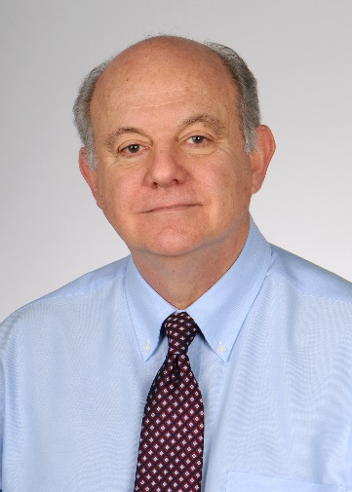
Dr. Sebastiano Gattoni-Celli
- Gateway Breakthrough: The therapy stimulates a specific cell-mediated immune response against melanoma tumor cells, and the therapy was well tolerate and showed no toxicity.
Dr. Gattoni-Celli is a professor at the Medical University of South Carolina. He is in the Department of Radiation Oncology and his academic focus is in prostate cancer and cancer vaccines. He completed a skin cancer trial, Home Cancer Research: Funded Clinical Trials Immune Therapy for Metastatic Skin Cancer: Melanoma Immune Therapy for Metastatic Melanoma, for Gateway.

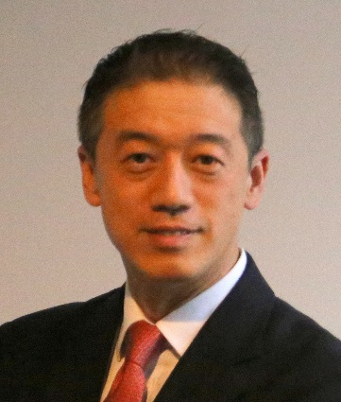
Dr. Gary E. Deng
- Gateway Breakthrough: Evaluating acupuncture’s ability to alleviate the nausea, pain and insomnia, which occurs with chemotherapy. If acupuncture proves to be beneficial, it would be a welcome alternative to pharmacological interventions.
Dr. Deng is an integrative medicine specialist at Memorial Sloan Kettering Cancer Center in New York City. He is the medical director of integrative medicine service and advises patients on the proper use of herbs and dietary supplements. Dr. Deng is conducting a blood cancer trial, Acupuncture for Symptom Control in Hematopoietic Stem Cell Transplation Patients: A Pilot Study, for Gateway.

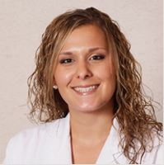
Dr. Raquel Reinbolt
- Gateway Breakthrough: Demonstrates a novel way to reduce discomfort experienced by women with breast cancer endure as a side effect to their therapies by analyzing DNA samples to determine if women who develop arthralgias have genes in common and are given Omega-3 fish oil supplements to reduce inflammation.
Dr. Reinbolt is an assistant professor of internal medicine at The Ohio State University College of Medicine. She joined the Division of Solid Tumor Oncology in 2015 and she is specifically interested in symptom and quality of life issues unique to the young adult and metastatic breast cancer populations. For Gateway, Dr. Reinbolt is conducting a breast cancer trial, Prevention of Aromatase Inhibitor-Induced Toxicity With Omega-3 Supplementation.

