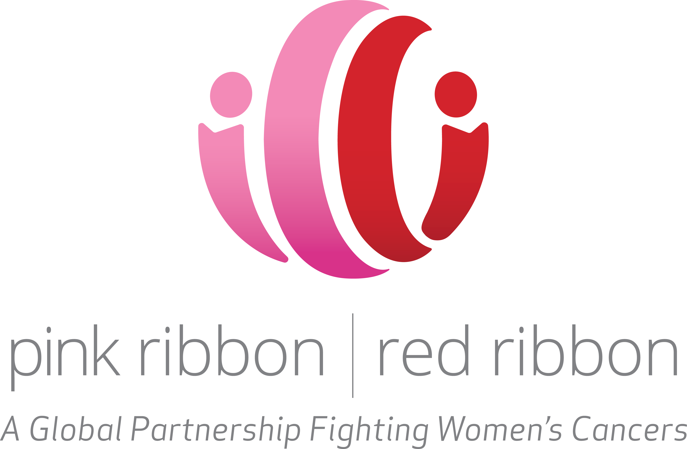

FOR IMMEDIATE RELEASE
Sept. 19, 2016

Contact: Richard Parker Jennie Aylward
(202) 662-8929 (202) 487-5078 (cell)
(202) 276-0777 (cell) jaylward@pinkribbonredribbon.org

PINK RIBBON RED RIBBON AND PROJECT CONCERN INTERNATIONAL ANNOUNCE PARTNERSHIP TO FIGHT WOMEN’S CANCERS IN AFRICA
Strategic partnership has already screened more than 15,000 women for HIV and cervical cancer in Zambia

NEW YORK — Project Concern International (PCI) and Pink Ribbon Red Ribbon (PRRR) announced a partnership to expand the fight against cervical cancer by providing screening and treatment for women in remote communities in Africa. The life-saving partnership will launch in Zambia to screen and treat even more women for cervical cancer and looks to expand this live-saving work in more countries across sub-Saharan Africa.

Cervical cancer is the most-common cancer and the second-biggest cancer killer of women in sub-Saharan Africa, responsible for approximately 57,000 deaths each year. Women with HIV are five times more likely to develop cervical cancer than those who are HIV-negative. Thanks to advances in treatment, more women are now living with HIV, but are at much greater risk of dying of preventable and treatable cancers.

“What a tragedy to save a woman from AIDS, only to lose her to cervical cancer,” said Celina Schocken, Chief Executive Officer of Pink Ribbon Red Ribbon. “Women in Africa do not seek health care in most cases, particularly preventative care, but what’s unique about this partnership is PCI’s mobile cancer screening program, taking health care to women where they are. The screening is simple, fast, and low-cost, and it’s the only opportunity many of these women will ever have to be screened.”

Combining HIV testing with screening and treatment for cervical cancer, especially through mobile outreaches in rural areas, is an effective and efficient approach to bringing life-saving services to women in Africa.

Cervical cancer is largely preventable, because of its slow development, the early detectability of pre-cancerous lesions, and the ease of the single-visit “Screen-and-Treat” approach using visual inspection with acetic acid (VIA) and cryotherapy. The growing availability in Africa of the vaccine against the human papillomavirus (HPV) will also reduce the incidence of cervical cancer in the years to come, as HPV causes most cases of the disease.

“Cervical cancer does not have to be a death sentence for women in Africa, and this unique partnership between PCI and Pink Ribbon Red Ribbon helps identify cervical cancer in its earliest stages before it can progress,” said George Guimaraes, President and CEO of PCI. “We are honored to partner with this incredible organization to scale-up the effort to reach more women with this life-saving service and provide a solid foundation for women to reach their full economic and social potential.”

Pink Ribbon Red Ribbon and PCI will work together to achieve the following:
- Educate communities about breast and cervical cancer;
- Vaccinate girls against HPV, the primary cause of cervical cancer;
- Screen women for breast and cervical cancer;
- Treat women for cervical pre-cancer;
- Provide access to life-saving care and treatment for women; and
- Train and equip public and private providers to screen for cancers.

###

About PCI: Project Concern International is a global development organization that drives innovation from the ground up to enhance health, end hunger, and overcome hardship, resulting in measureable change in people’s lives. PCI works in 15 countries throughout Africa, Asia and the Americas, impacting the lives of more than 19 million people last year alone. For more information, visit www.pciglobal.org and follow @PCIGlobal on Twitter.

ABOUT PINK RIBBON RED RIBBON: Pink Ribbon Red Ribbon, an independent affiliate of the George W. Bush Institute, saves lives from cancer in countries where the need is greatest. A global organization powered by partnerships, PRRR has screened over 300,000 women for cervical cancer, and over 15,000 women for breast cancer. For more information, visit www.pinkribbonredribbon.org and follow @pinkredribbon on Twitter.

