

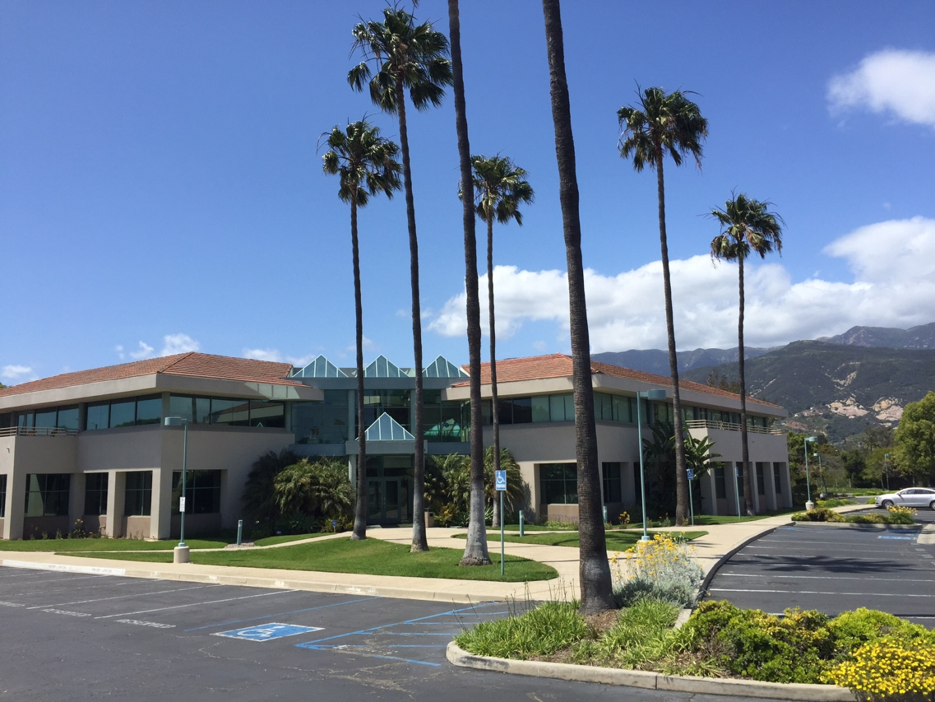

Charitable Gifts Agency®
1145 Eugenia Place Suite 150
Carpinteria, CA 93013
www.charitablegiftsagency.org
(800) 579-4707

