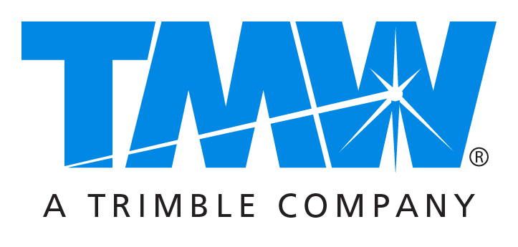

Media contacts: Caroline Lyle at clyle@tmwsystems.com or 440.721.2260
Drew Shippy at drew@pinnmedia.com or 330.687.4053

New TMW Engage.Bid Application Dramatically
Streamlines Bid Management Process for Carriers, Brokers and 3PLs

Cloud-based solution enables users to save significant time and labor,
increase accuracy and improve success rates

NASHVILLE, TN – September 26, 2016 – TMW Systems today introduced TMW Engage.Bid™, a web-based business management application that enables carriers, brokers and third-party logistics (3PL) providers to streamline the freight bidding process. The innovative application allows users to save time and labor, improve accuracy and leverage pricing intelligence to increase their success in winning business.

TMW Engage.Bid greatly simplifies the conversion and analysis of often-complicated shipper RFP documents. Users can then apply critical pricing intelligence – including the TMW Market Rate Index (MRI) – to more quickly assess each opportunity and develop bids that are consistent with their businesses’ competitive strategies and cost structures.

Developed by TMW transportation intelligence professionals who have extensive bid management experience, the application replaces the multiple spreadsheets, emails, paperwork and other manual processes that have long dominated bid assessment and pricing.

“Bid management can be an extremely complex and labor intensive process, and yet it is becoming increasingly important to the success of transportation companies of all sizes,” said David Wangler, president of TMW Systems. “This powerful new application offers the productivity tools needed to dramatically speed this process and provides industry-leading pricing intelligence that can enable our customers to more effectively compete to win business.”

TMW Engage.Bid tracks the status of open bids and indexes and stores current and historical bid data in searchable form. This helps ease workflow constraints and enables multiple users within an organization to collaborate in structuring bids. Its intuitive design minimizes training time and enables users of all experience levels to become more proficient and accurate in the bidding process.

As a web-based solution, TMW Engage.Bid is available for use by virtually any carrier, broker or 3PL with high-speed Internet connectivity.

For additional information regarding TMW Engage.Bid and other solutions for transportation businesses, contact a TMW representative, visit www.tmwsystems.com or call (800) 401-6682.

About TMW Systems
TMW is a leading transportation software provider to commercial and private fleets, brokerage and 3PL organizations. Founded in 1983, TMW has focused on providing enterprise software to the transportation industry, including asset-based and non-asset-based operations as well as heavy-duty vehicle service centers. With offices in Cleveland, Dallas, Indianapolis, Nashville, Oklahoma City, Raleigh, and Vancouver, the company serves over 2,000 customers, including many of the largest, most sophisticated and complex transportation service companies in North America. TMW is a Trimble Company (NASDAQ: TRMB) and part of the international Transportation and Logistics Division.

###

