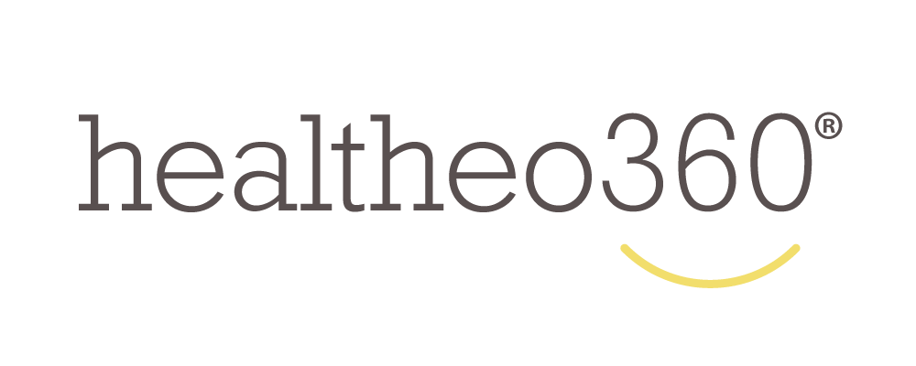

For Immediate Release Name of the Company: healtheo360
Date: 10/04/2016 Phone: 212-488-2130
Email: courtlandl@healtheo360.com

healtheo360 Announces Partnership with NYXT.nyc
NYXT.nyc is a new cable channel and digital platform that shines a spotlight on building connected communities in Manhattan

New York, NY; October 4, 2016: — healtheo360 is proud to announce an official partnership with NYXT.nyc, a new cable and digital channel that shines a spotlight on the Manhattan organizations that are working to connect people and build communities.

As part of this partnership, healtheo360 and all of its content and activities will be promoted and featured on NYXT.nyc’s cable channel (in Manhattan: TWC channel 1992 and Verizon channel 38) and website (www.nyxt.nyc). NYXT.nyc’s unique on-air experience will also showcase added value information about healtheo360’s mission and services and give viewers the tools they need to join and engage with the healtheo360 community as well as connect with other Manhattan residents.

“We are excited about our partnership with NYXT and the ability to extend our reach to the over 630,000 cable channel subscribers in the Manhattan area. This unique new TV and digital experience will provide healtheo360’s Virtual Social Therapy® platform and content to Manhattan residents living with a chronic condition, their caregivers, family members and friends,” stated David S. Duplay Founder and CEO of healtheo360.

A project of Manhattan Neighborhood Network, NYXT.nyc’s mission is to showcase the richness of life in Manhattan and to give viewers the tools they need to become participants in their communities. healtheo360 joins over 60 other content partners who will be showcased on NYXT.nyc.

For more information about NYXT.nyc, visit nyxt.nyc, or follow NYXT.nyc on Facebook and Twitter
###

About NYXT.nyc
NYXT.nyc is a project of Manhattan Neighborhood Network in partnership with over 60 Manhattan community content partners. NYXT.nyc is a new cable channel and digital media platform that helps participants and viewers connect, build and enhance their communities. Produced in the heart of the most important city in the world, its innovative program format showcases Manhattan’s many voices and provides pathways for community engagement and involvement.

About healtheo360
healtheo360 is a "Caring Community" where patients living with chronic conditions, such as Diabetes, Cancer, Alzheimer's, and many others come to find support, encouragement and information. The healtheo360 community includes patients, their caregivers, family members and friends who come to share their personal healing stories so that others may find inspiration and motivation as they go through the journey of living with their condition. Members share their health related stories and learn from each other through discussion and video sharing. At healtheo360 we believe in the healing power of story telling and how beneficial it is to share your story as well as to learn from other people with similar experiences. David Duplay founded healtheo360 in 2013 after his sister-in-law was diagnosed with stage IV breast cancer and his mother with Alzheimer’s disease. After unsuccessful efforts with other support groups, due in part to the widening age gap between members of these groups, the family was forced to search for other outlets of social support. In response, healtheo360 was started.

