New York Life Insurance Company
51 Madison Avenue, New York, NY 10010

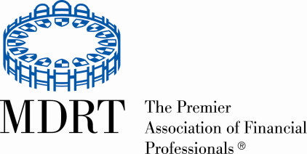
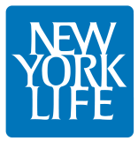

Contact: Donna Pribe
Marketing and Compliance Coordinator
419-887-4778 FOR IMMEDIATE RELEASE
Phaye3@ft.newyorklife.com

NEW YORK LIFE AGENT PAUL J. HAYE QUALIFIES FOR MILLION DOLLAR ROUND
TABLE’S “COURT OF THE TABLE”

New York Life Leads Million Dollar Round Table for the 62st Consecutive Year

Maumee, OH October, 2016 – Outstanding client service, ethics and professionalism have elevated Paul J. Haye of the Toledo General Office of New York Life to qualify for the exclusive “Court of the Table” of the Million Dollar Round Table — The Premier Association of Financial Professionals ®. In addition to being a New York Life agent since 1981, Paul J. Haye is a Qualifying and Life member throughout his tenure as an agent and in the last 13 years has been a qualifier of the Court of the Table.

Achieving Court of the Table status places Mr. Haye among the top professionals in the global life insurance and financial services industry. He is recognized for demonstrating exceptional professional knowledge, client service and ethical conduct.

Founded in 1927, the Million Dollar Round Table (MDRT), The Premier Association of Financial Professionals, is an international, independent association of the world's leading life insurance and financial services professionals. MDRT members demonstrate exceptional professional knowledge, strict ethical conduct and outstanding client service. MDRT membership is recognized internationally as the standard of sales excellence in the life insurance and financial services business.

New York Life Insurance Company, a Fortune 100 company founded in 1845, is the largest mutual life insurance company in the United States* and one of the largest life insurers in the world. New York Life has the highest possible financial strength ratings currently awarded to any life insurer from all four of the major credit rating agencies: A.M. Best (A++), Fitch (AAA), Moody’s Investors Service (Aaa), Standard & Poor’s (AA+).** Headquartered in New York City, New York Life’s family of companies offers life insurance, retirement income, investments and long-term care insurance. New York Life Investments*** provides institutional asset management. Other New York Life affiliates provide an array of securities products and services, as well as retail mutual funds.
Please visit New York Life’s website at www.newyorklife.com for more information for more information.
*Based on revenue as reported by “Fortune 500 ranked within Industries, Insurance: Life, Health (Mutual),” Fortune magazine, 6/17/16. For methodology, please see Fortune 500
** Individual independent rating agency commentary as of 7/20/16.
*** New York Life Investments is a service mark used by New York Life Investment Management Holdings LLC and its subsidiary, New York Life Investment Management LLC. Bates 1619938

# # #

