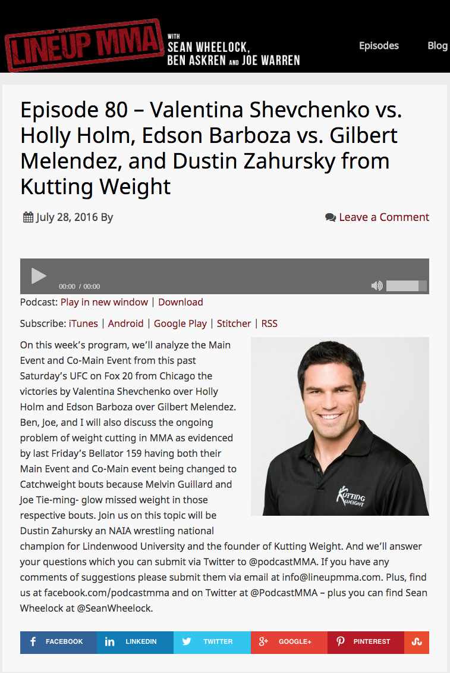

Link to episode 80:

https://itunes.apple.com/us/podcast/episode-80-valentina-shevchenko/id972433653?i=1000373243357&mt=2

