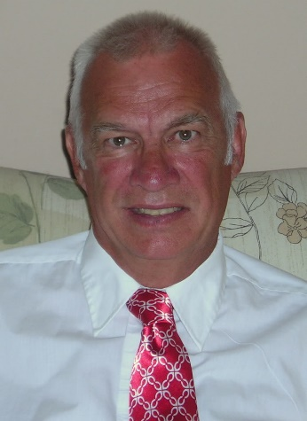

Howard Rahtz
Bio
A unique combination of experience and expertise positions Howard Rahtz as one of the most credible voices on police reform. Howard was an early practitioner of Community Policing, instructing at the Regional Community Policing Institute and authoring a guidebook for police officers interested in community policing.
Police use of force is the major element underlying the current tension between police and the black community. A use of force expert, Howard was heavily involved in changing use of force policy and training under the Cincinnati Collaborative Agreement. That agreement has been credited with improved police-community relations in Cincinnati, leading Attorney General Loretta Lynch to describe the CPD as a national model for police reform. Howard served as editor of the Use of Force Journal published by the International Law Enforcement Educators and Trainers Association (ILEETA). Howard’s book, Understanding Police Use of Force, provides a balanced and insightful overview of the use of force in American policing.
Nearly 160 years after the Emancipation Proclamation, the rift between white and black remains a significant feature of American life. Howard’s book, Race, Riots and The Police (Lynn Reinner 2016) provides a review of the history of race riots in America from the Red Summer of 1919 to the riots in Ferguson and Baltimore in 2014-2015. The book details not only the role of the police in riots over the years but provides a clear set of steps focusing on reform to close the gap between police and the African-American community.
Prior to joining the Cincinnati Police Department, Howard worked nearly twenty years in drug addiction programs. When he retired as Commander of the Cincinnati Vice Control Section, he became one of only a handful of people in the country who have worked directly on both the supply and demand sides of the drug equation. He is a tireless and passionate advocate of drug reform and a national speaker for LEAP (Law Enforcement Against Prohibition). His book, Drugs, Crime and Violence: From Trafficking to Treatment (Hamilton Books 2012), outlines a policy framework that will choke off the revenue supporting the illegal drug market.
He outlines a series of steps buttressed by a historical review of drug policy measures, a review of international efforts against trafficking, and a clear understanding of the dynamics of addiction and its role in facilitating the illegal drug market.
Howard also served with the Cincinnati SWAT Team as a Hostage Negotiator and was later appointed Coordinator of the SWAT Hostage Negotiations Team.
He currently teaches at police academies in the Greater Cincinnati region and speaks nationally on police reform. He blogs regularly about police and law enforcement on his website, www.howardrahtz.com.
His first two books continue to be standard reading by Police Academies, government entities and community leaders.
- Community Policing: A Handbook for Beatcops & Supervisors (Criminal Justice Press Project 2001)

- Understanding Police Use of Force (Criminal Justice Press Project 2001)

###

