Cubbies, Dodgers and Yankees to be sold during Texas’ great plate auction!

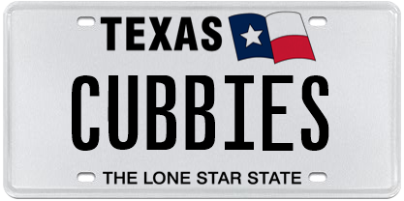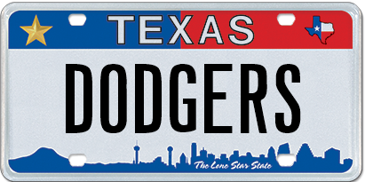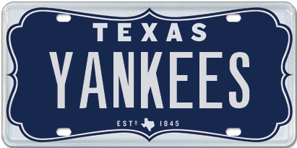
The Great Plate Auction showcases 50 unique plate messages
and will close on November 30.

Austin, TX, October 26, 2016. Making October even more special for baseball fans, three of the oldest and most famous names in baseball could now be your official license plate message on the streets of Texas! My Plates will auction 50 select, highly sought-after license plates during their next Great Plate Auction. Most have never before been available, with grand –slam worthy messages like “CUBBIES”, “DODGERS” and “YANKEES” up for grabs.

The name CUBBIES, evokes the Friendly Confines, the bleachers, Harry, and the North Side. The DODGERS is LA, Brooklyn, a host of championships and the curse of the Billy Goat. And who can forget, YANKEES, the most famous of them all, the Babe, the traditions and the pinstripes.

These three truly unique one of a kind plate messages are being offered for the first time in Texas, where all license plates have to be unique, there can only be one on the streets of Texas. Hence, only one Cubbies, only one Dodgers and only one Yankees. This is your chance to secure a piece of baseball history in Texas.

My Plates are offering a number of other team related plate messages including: GO SPURS, GO IRISH, VIKINGS, HUSKERS, BUCKEYE and SPARTAN.

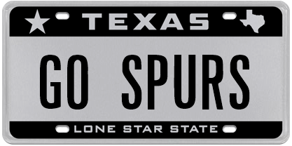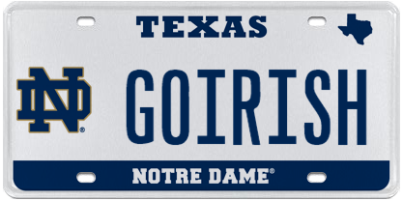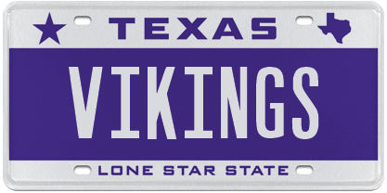

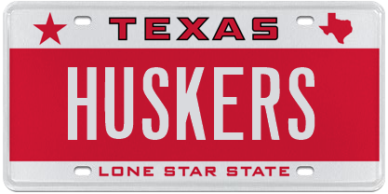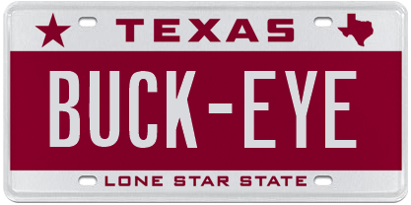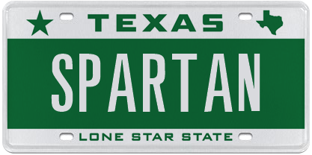

All of the plates within this auction have an opening bid of only $500 with no reserve beyond that. If no other bids are received before the auction closes, the opening bid would be the final and winning bid. “We wanted to open this auction up for all Texans to have the opportunity to secure one of these great plate messages” said Steve Farrar, President of My Plates.

The Great Plate auction will be conducted online and will run through November 30, 2016. Texans interested in the auction can visit www.myplates.com/auction for more information and the complete list of plates for sale.

My Plates will highlight other Auction plate messages over the next few weeks.
____________________________________________________________
Previous Auction Results:
- 12THMAN sold for $115,000 making it the most expensive plate message in Texas.
- HOUSTON sold for $25,000 in January 2013.
- FERRARI was sold at the very first My Plates auction in 2011 and sold for $15,000.
- ALAMO was sold earlier this year, March 2016, for $10,250.
- F1 was sold last November for $3,400.
_____________________________________________________________
Why buy at Auction?
- Opportunity to purchase a truly exclusive plate message from My Plates' reserve collection.
- First right of renewal at the state's everyday pricing, which means you can keep the plate for as long as you choose to renew it.
- Auction plates are fully transferable. Not only can they be transferred from one vehicle to another, but also person-to-person, such as parent to their children or friend-to-friend. The plate owner also has the right to sell the plate message to another person with the same ongoing rights. As a result, Auction plates could be an excellent investment.
- Peace of mind, knowing that you're purchasing your official Texas license plates from My Plates, the authorized specialty plate vendor for the Texas Department of Motor Vehicles.
- Supports the General Revenue Fund of Texas, which provides services for all Texans.
_____________________________________________________________
Links to download images:

CUBBIES: https://ce9a9387e1bc258c3cfa-af7906f4e771b24864bbfa3048e4a635.ssl.cf2.rackcdn.com/CUBBIES.jpg

DODGERS: https://ce9a9387e1bc258c3cfa-af7906f4e771b24864bbfa3048e4a635.ssl.cf2.rackcdn.com/DODGERS.jpg

YANKEES: https://ce9a9387e1bc258c3cfa-af7906f4e771b24864bbfa3048e4a635.ssl.cf2.rackcdn.com/YANKEES.jpg

GO SPURS: https://ce9a9387e1bc258c3cfa-af7906f4e771b24864bbfa3048e4a635.ssl.cf2.rackcdn.com/GOSPURS.jpg

GO IRISH: https://ce9a9387e1bc258c3cfa-af7906f4e771b24864bbfa3048e4a635.ssl.cf2.rackcdn.com/ND_GOIRISH.jpg

VIKINGS: https://ce9a9387e1bc258c3cfa-af7906f4e771b24864bbfa3048e4a635.ssl.cf2.rackcdn.com/VIKINGS.jpg

HUSKERS: https://ce9a9387e1bc258c3cfa-af7906f4e771b24864bbfa3048e4a635.ssl.cf2.rackcdn.com/HUSKERS.jpg

BUCK-EYE: https://ce9a9387e1bc258c3cfa-af7906f4e771b24864bbfa3048e4a635.ssl.cf2.rackcdn.com/BUCKEYE.jpg

SPARTAN: https://ce9a9387e1bc258c3cfa-af7906f4e771b24864bbfa3048e4a635.ssl.cf2.rackcdn.com/SPARTAN.jpg
____________________________________________________________
My Plates designs and markets new specialty license plates as a vendor for the Texas Department of Motor Vehicles. Texans have bought more than 295,000 My Plates since November 2009, putting more than $47M in the state general revenue fund. My Plates’ goal is to create a long-term, mutually beneficial relationship designed to maximize revenues for the state through the sale of My Plates specialty plates. www.myplates.com.

The Texas Department of Motor Vehicles (TxDMV) serves protects and advances the citizens and industries in the state with quality motor vehicle related services. For every $1 it spends, the TxDMV returns $11 to the state. The agency currently registers 24 million vehicles; issues more than 7 million vehicle titles; licenses more than 38,000 motor vehicle dealers and distributors; credentials nearly 60,000 motor carriers; issues more than 800,000 oversize/overweight permits; investigates more than 15,000 complaints against dealers and motor carriers; and awards grants to law enforcement agencies to reduce vehicle burglaries and thefts. Learn more at www.TxDMV.gov.

____________________________________________________________

