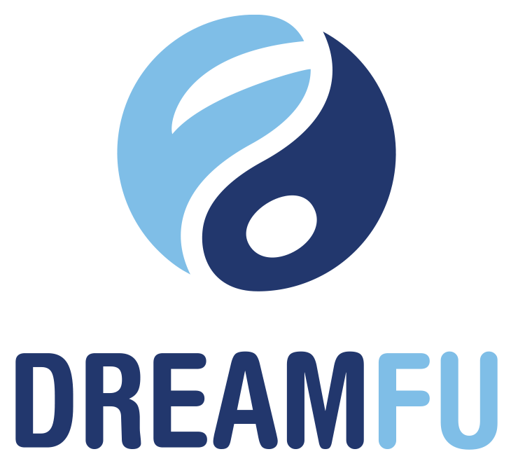
Press Contact
info@protectpharma.net
954.866.3726

DreamFu Ventures, LLC Launches Nationwide Affiliate Program

Miami, October 26, 2016. Protect Pharmaceuticals Corporation (OTC: PRTT), a Nevada Corporation, Protect Pharmaceutical intends to Launch DreamFu Ventures, LLC nationwide Affiliate Program.

DreamFu Ventures, LLC is launching its Affiliate Program and is limiting participation of Affiliates in the initial launch to 300 Founding Affiliates. Participation is limited based on geography and territory. DreamFu uses a combination of it’s network of mentors and investors to validate start-up ideas and their platform to collaborate and nurture those ideas into real businesses to offer investment opportunities to accredited investors that are vetted and risk mitigated.

Interested Affiliates, Mentors, Investors, or members can apply at www.dreamfu.com

This is not an offer to purchase or to sell securities and is qualified by the information provided on the website. Una Taylor, PRTT’s President shared, “We’re very excited to announce the launch of the DreamFu Affiliate Program. The start-up landscape is changing rapidly and it’s becoming more competitive than ever. We’re hopeful that our network will provide an edge to Dreamers, Investors and Affiliates. This program is the first of many programs to come in the future that will provide valuable knowledge, resources, mentorship and training to the next generation of entrepreneurs.”

About DreamFu: DreamFu Ventures LLC intends to create an entire ecosystem whose mission is to transform the startup entrepreneurial landscape to be inclusive, diversified and successful! We intend to create a gamified, online platform that encompasses the entire startup journey, allowing us to work with entrepreneurs at any stage - from ideation and getting started to funding successful exits. DreamFu Ventures LLC is currently operated by related parties, specifically Una Taylor. We intend to create a network of mentors and angels investors to help shape ideas, grow entrepreneurs, and invest in startup companies from the ground up. DreamFu Ventures is a dream trainer, builder and investor – a start to end ecosystem available to all startup entrepreneurs.

Forward Looking Statements: This press release contains “forward-looking statements” within the meaning of Section 21E of the Securities Exchange Act of 1934. Except for historical matters contained herein, statements made in this press release are forward-looking statements. Without limiting the generality of the foregoing, words such as “may”, “will”, “to”, “plan”, “expect”, “believe”, “anticipate”, “intend”, “could”, “would”, “estimate,” or “continue”, or the negative other variations thereof or comparable terminology are intended to identify forward-looking statements. Forward-looking statements involve known and unknown risk, uncertainties and other factors which may cause our actual results, performance or achievements to be materially different from any future results, performance or achievements expressed or implied by the forward-looking statements. Also forward-looking statements represent our management’s beliefs and assumptions only as of the date hereof. Additional information regarding the factors that may cause actual results to differ materially from these forward-looking statements is available in the Company's filings with the SEC including the Current Reports on Form 8-K and the Quarterly Reports on Form 10-Q and Annual Reports on Form 10-K. Except as required by law, we assume no obligation to update these forward-looking statements publicly, or to update the reasons actual results could differ materially from those anticipated in these forward-looking statements, even if new information becomes available in the future.

