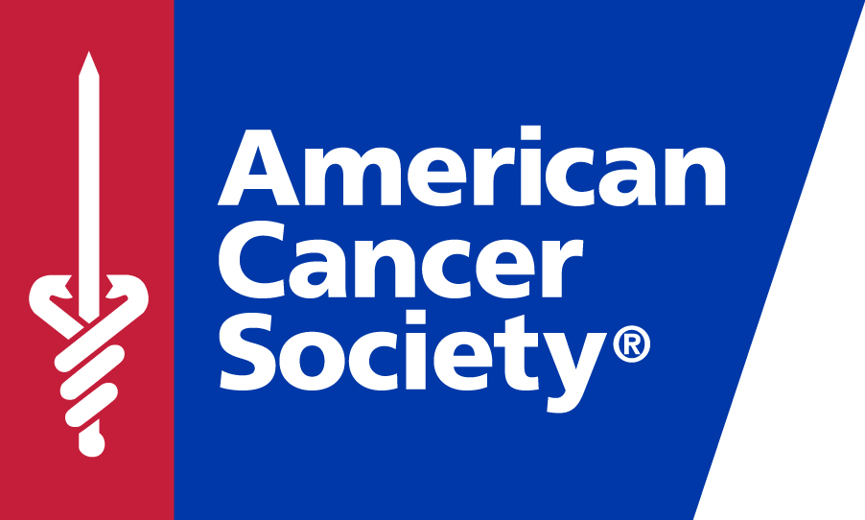

FOR MORE INFORMATION, CONTACT:

Katherine Row/American Cancer Society
Phone: (310) 924-9837
Email: Katherine.row@cancer.org

INAUGURAL GIANTS OF SCIENCE LOS ANGELES GALA HONORS SHANNEN DOHERTY, AMERICAN CANCER SOCIETY-FUNDED RESEARCHERS, NFL’S CHRIS DRAFT & GIVES BOOST TO MOONSHOT PLEDGE
November 5th gala at Four Seasons Los Angeles at Beverly Hills honors cancer survivor Shannen Doherty with inaugural Courage award

LOS ANGELES – OCTOBER 22, 2016 – Actor and producer Shannen Doherty will receive the American Cancer Society’s Courage Award at the Inaugural Giants of Science gala on November 5th at the Four Seasons Los Angeles at Beverly Hills. Giants of Science is the first Society gala to dedicate its proceeds solely to the Society’s groundbreaking research program. In conjunction with Vice President Biden’s Cancer Moonshot initiative, the American Cancer Society has pledged to double its research funding by 2021.
Doherty was diagnosed with breast cancer in February, 2015, sharing her diagnosis publicly so others might gain courage from her journey. In August, 2016, Shannen announced that her breast cancer had spread to her lymph nodes, that she’d undergone a mastectomy, and was scheduled for radiation and chemotherapy. Again, Shannen went public with the very private raw emotions every cancer patient faces.
"I wanted to put it out there the way it felt best for me to put it out there," she said. "If I can help one person then it makes me think, 'Oh OK.' It's easier to live with having cancer if I know I'm helping at least one person."
Doherty’s fellow honorees are former NFL linebacker Christ Draft, Cedars-Sinai’s Beth Karlan, MD; Children’s Hospital LA’s Shahab Asgharzadeh, MD, City of Hope’s Betty Farrell, PhD, RN; and University of Southern California’s Matthew Pratt, PhD; whose works have significantly impacted the Society’s goal of a world free from the pain and suffering caused by cancer.

more
The evening is chaired by Rachel Beller, MS, RDN, CEO and founder of Beller Nutrition Institute. California State Controller Betty Yee is honorary host and master of ceremonies Roy Firestone will preside over the evening, which is sponsored by Allstate, Beller Nutrition Institute, Cedars-Sinai Samuel Oschin Comprehensive Cancer Institute, City of Hope, Houlihan Lokey, Leica Biosystems, and UCLA Jonsson Comprehensive Cancer Center. More information is available at www.giantsofscience.org.
The American Cancer Society is the nation’s largest not-for-profit funder of cancer research, second only to the federal government. To date, the Society has funded early research of 47 Nobel Prize-winning scientists.

The American Cancer Society combines an unyielding passion with nearly a century of experience to save lives and end suffering from cancer. As a global grassroots force of more than three million volunteers, we fight for every birthday threatened by every cancer in every community. We save lives by helping people stay well by preventing cancer or detecting it early; helping people get well by being there for them during and after a cancer diagnosis; by finding cures through investment in groundbreaking discovery; and by fighting back by rallying lawmakers to pass laws to defeat cancer and by rallying communities worldwide to join the fight. As the nation’s largest non-governmental investor in cancer research, contributing more than $3.4 billion, we turn what we know about cancer into what we do. As a result, 14 million people in America who have had cancer and countless more who have avoided it will be celebrating birthdays this year. To learn more about us or to get help, call us any time, day or night, at 1-800-227-2345 or visit cancer.org.
###

