Press Release
Media Contact: Pat Thornton
Cell: 202-262-6156, email: pt@everything.coop
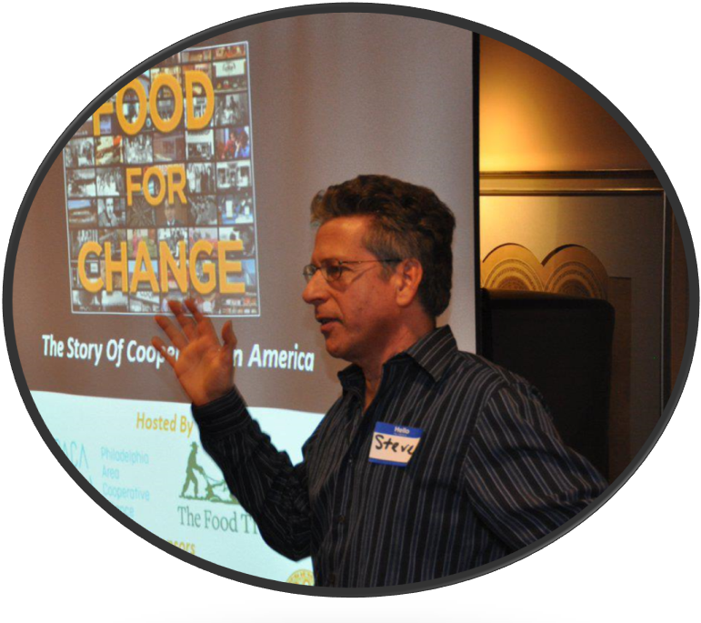
Acclaimed Filmmaker Steve Alves Joins Everything Co-op’s Screening of
Food For Change at BusBoys and Poets on October 31, 2016
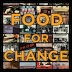
Acclaimed filmmaker, Steve Alves, joins Everything Co-op’s screening of his documentary Food For Change, and will hold a post-show discussion on Monday, October 31, 6:00 pm, at BusBoys and Poets, 1025 5th Street NW, Washington, DC. The Event is FREE and open to the public, but seating is limited. Visit EventBrite for tickets. Food for Change tells the story of the cooperative movement in the United States in a way that is both entertaining and informative. It includes interviews with co-op workers, rare archival footage, and narration by the film’s director, Steve Alves.
Alves tracks the co-op movement’s quest for whole and organic foods, and their focus on sustainable food systems. The film profiles several food co-ops that have revived neighborhoods and entire communities. Steve Alves is an internationally-acclaimed filmmaker, and member of the Franklin Community Co-op in Greenfield, Massachusetts. He hopes co-ops will use this film to raise the public’s awareness of their unique place in our country’s economic and political landscape.
Co-ops Vote materials and information will also be distributed at the screening, courtesy of National Rural Electric Cooperative Association (NRECA). The Co-ops Vote website is a great resource for voters. The site includes a Voter Resources page, that offers links to voter information, including: a list of upcoming elections, Absentee Ballots, a polling place locator, and a list of Early Voting sites. Visitors to the site can also review information on Presidential candidates, and other candidates associated with their local voting districts. Co-ops Vote is your one-stop Vote site. Visit www.vote.coop to become an informed voter.
Everything Co-op is a radio show that airs on WOL 1450AM, in the Washington, DC Metro Area market. Vernon Oakes, host and executive producer of Everything Co-op, is sponsoring this screening of Food For Change in the hope of introducing the cooperative business model to the general population, and to provide an opportunity for people to network and be empowered to take action. Everything Co-op is sponsored by National Cooperative Bank, (NCB).
Tune-in to listen to the Everything Co-op live on Thursdays, 10:30 - 11:30 am, at www.woldcnews.com, or on the WOL 1450 Station on the Tune-in Radio phone application.
# # # #

