PRESS RELEASE
****Why electricity is the silent hazard in your home****
In response to shocking statistics from the charity Electrical Safety First on the number of injuries and deaths caused by domestic electrical faults a local electrical company is now offering Kent homeowners a free safety inspection of their home electrics.
The electrical charity has published figures that reveal that every year around 350,000 people are seriously injured and 70 people are killed due to an electrical accident in the home. Alarmingly, electricity also causes more than 20,000 house fires a year – almost half of all house fires.
Managing Director Liam Walsh from Maidstone based electrical company My Home Installations commented “By using our knowledge and experience, having served over 4,000 customers in the region, we hope our free electrical safety inspections for homeowners can prevent as many electrical fires and personal injuries due to electrical faults as possible. Having seen the consequences of electrical fires we want to encourage people to think about their electrical safety. Anyone wanting to find out more can go to our website www.myhomeuk.co.uk.”
The free electrical safety inspections only take about an hour. And in case you were wondering, there is no call out fee that you might typically expect when inviting a trusted tradesperson in to your home. Further condition reports can be produced where any remedial action identified, if required, necessary to make your electrical installations safe for continued use are advised.
Mr Walsh continued “While most home owners will have their boiler checked annually by a Gas Safe registered engineer - a legal requirement for landlords - the same cannot be said for home electrics. However, statistically electrical hazards in the home pose more than double the threat of gas.”
More than half of privately owned homes do not have all five key electrical safety features; all PVC wiring, all modern earthing, modern consumer unit (fuse box), Miniature Circuit Breaker (MCB), and Residual Current Device (RCD) in consumer unit or separate RCDs.
Most electrical issues in the home are easily preventable by ensuring a home is regularly checked by a suitably registered electrician. Many homes though have never had their electrics checked, potentially putting homeowners at risk. And proportionately, older people suffer more fatal and non-fatal injuries from electrically-related house fires than the rest of the population.
People over 65 are particularly at risk because they often live in old or poor-quality housing that contains old appliances or faulty electrics installed many years before current building regulations were introduced.
So, if you’re asking yourself how often should I get my electrics fully tested the answer is: if it’s my home, every ten years. If it’s a rented home – every 5 years. That’s the advice of the charity Electrical Safety First.
A registered electrician who is Part P qualified will be able to identify and rectify any faults or carry out an Electrical Inspection Condition Report (EICR) letting you know of any potential issues that could lead to further problems.

Notes to Editor
My Home Installations Ltd is a private electrical contractor and home security company operating throughout Kent, East Sussex, Surrey and south Essex since 2005. Based in Aylesford, just outside the county town of Maidstone in Kent the company employs 90 people, including four electrician apprentices and a skilled team of ELECSA registered electricians who are Part P qualified to undertake work in accordance with current Building Regulations.
The company offers house rewiring, and various electrical installations; consumer units (fuse box), moving or adding new sockets and switches, extractor fans and home security alarm systems. The company provides also gives a 5 year warranty for peace of mind on all electrical installation works, and an optional 5 year warranty on existing installations.
For further information please call 0333 789 0111 and ask to speak to Edward Walter or contact him by email using e.walter@myhomeuk.co.uk

My Home Installations Ltd
Watson House,
St Leonard's Road,
Maidstone,
Kent, ME16 0LS

ENDS

Stats used
 | Words
Body: | 487
Notes: | 143
Total: | 630

Liam’s quote about electric being statistically more dangerous than gas was taken from: ESF A Shock to the System Electrical Safety in an Ageing Society:
- In 2012-13 in the UK, the approximate number of household gas-related fatalities was 24 (32); whilst the total number of deaths with causes of electrical origin in the same period was 55(33)
- Source 32: Based on data from the Gas Safety Trust and DCLG Fire Statistics of Great Britain 2012-13.
- Source 33: Electrical Safety First statistics, not yet published

Stat about half of homes not having 5 key electrical safety features:
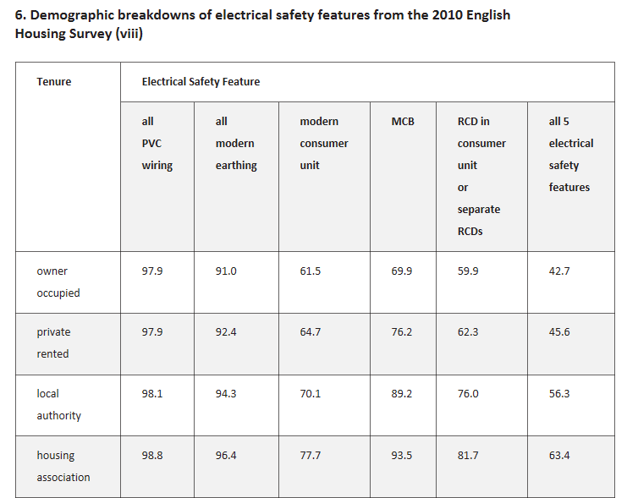
Source: http://www.electricalsafetyfirst.org.uk/what-we-do/policies-and-research/statistics/

