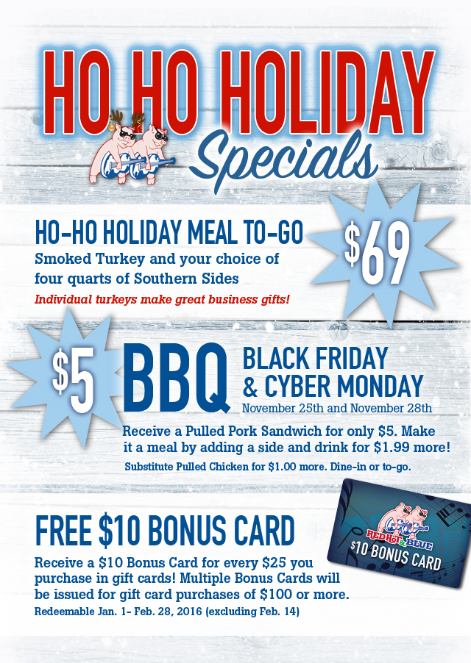

For a limited time, Red Hot & Blue Restaurants are also offering a quick fix for holiday entertaining.
Red Hot & Blue HO-HO HOLIDAY MEAL TO-GO: Choose a smoked ham or a smoked turkey with your choice of four quarts of Red Hot & Blue Southern Sides for only $69! A complete, convenient and delicious holiday meal!
The following locations are participating in the HO-HO HOLIDAY MEAL TO-GO PROMOTION:
MARYLAND: Gaithersburg
VIRGINIA: Fairfax; Herndon; Manassas; Leesburg; Warrenton; Williamsburg
NEW JERSEY: Cherry Hill
NORTH CAROLINA: Winston-Salem

Red Hot & Blue Restaurants in the Washington DC area, Texas, North Carolina and New Jersey are offering a $5 Pulled Pork Sandwich on Black Friday, November 25, 2016 and Cyber Monday, November 28, 2016.
The offer is valid for take-out or dine-in.
Make it a meal by adding a side and a drink for $1.99 more.
Black Friday and Cyber Monday Offer available at the following locations:
MARYLAND: Gaithersburg; Laurel
VIRGINIA: Fairfax; Herndon; Manassas; Leesburg; Warrenton; Williamsburg
NORTH CAROLINA: Raleigh, Winston-Salem
TEXAS: Dallas, Irving, Plano, Flower Mound, North Richland Hills, Fort Worth
In addition, Red Hot & Blue Restaurants announce that you can now

Get a $10 Red Hot & Blue Bonus Card FREE every time you purchase $25 or more in Red Hot & Blue gift cards at participating locations**
For every $25 you purchase in gift cards you will receive one $10 Bonus Card–while supplies last.
Perfect for Holiday gifts–$10 Red Hot & Blue Bonus Card for your mailman, paperboy – or keep it and treat yourself!
Bonus Cards may be redeemed from January 1-February 28, 2017 (not valid on February 14, 2017).
**Bonus Card offers available at these participating locations:
MARYLAND: Annapolis, Gaithersburg, Laurel, Waldorf
VIRGINIA: Fairfax; Herndon; Manassas; Leesburg; Warrenton; Williamsburg
MISSOURI: Joplin
NEW JERSEY: Cherry Hill
NORTH CAROLINA: Cary, Raleigh, Winston-Salem
TEXAS: Dallas, Flower Mound, Fort Worth, Irving, North Richland Hills, Plano

For more information visit: http://www.redhotandblue.com

