Press Release Contacts:
For Immediate Release Vinitaly International
International Media Dept.
+39 045 8101447
media@vinitalytour.com
www.vinitalytour.com
Twitter: @VinitalyTour
Join Vinitaly International Network on LinkedIn

Vinitaly Hong Kong closes with the coronation of two Italian Wine Experts and a Wine Ambassador

The 7th edition of Vinitaly Hong Kong put wine education as the main focus of the promotional activities during the Hong Kong Wine and Spirits Fair. Ian D’Agata, Scientific Director of Vinitaly International Academy, in fact, conducted a number of Vinitaly International Academy (VIA) Executive Wine Seminars as well as other educational tastings, while wine2wine Asia provided educational and networking opportunities for exhibitors. VIA students living in Asia came to Hong Kong prepared to sustain their final oral exam administered by Ian D’Agata. Two VIA students, Jinglin Zhang (Beijing) and Wai Xin Chan (Singapore) were named Italian Wine Experts, while Shirley Tan (Shanghai) achieved level two Italian Wine Ambassador.

Ian D’Agata was pleasantly surprised by the results and remarked, “the level of proficiency that I witnessed during the oral exam of both Wai Xin Chan and Jinglin Zhang were nearly the best or best that I have seen since the academy opened.” He added, “perhaps the most wonderful aspect of VIA, is the community that is being created through the shared experience of Italian wine education. All over the world, VIA students are connecting and making lasting friendships.”

Wai Xin Chan from Singapore, left a career in Information Technology and dove into the wine world, where he has established himself as a successful wine communicator. Among his qualifications, Wai Xin is a Certified Specialist of Wine (CSW) and a French Wine Scholar (FWS).
Wai Xin attended the Academy in Verona, last March 2015, and was the first to be awarded the title of Italian Wine Ambassador in South East Asia. He also reports on the local wine scene in a number of Singapore magazine and on-line publications.

Jinglin Zhang, left North Eastern China for studies in France. She holds a bachelor’s degree in International Business and went on to obtain a master degree in Marketing. She holds a WSET level 4 diploma, currently works at Berry Bros & Rudd in London and recently launched a new blog, “When Bach Meets Barolo”. She has a passion for wines from smaller producers, and hopes to start an export business with e-commerce distribution back home in China.

Shirley Tan got her start in the wine business as a sales manager with Veuve Clicquot China. After six years with the LVMH group, she went on to launch a successful Wine import and distribution company, East Meets West Fine Wines (EMW) in 2003. After 10 years of rapid expansion, she relinquished her stakes in the company to found the China Knot Consulting firm. China Knot has worked with various wine organizations and businesses, including Istituto Grandi Marchi, Decanter, Gaja, Pio Cesare and more.

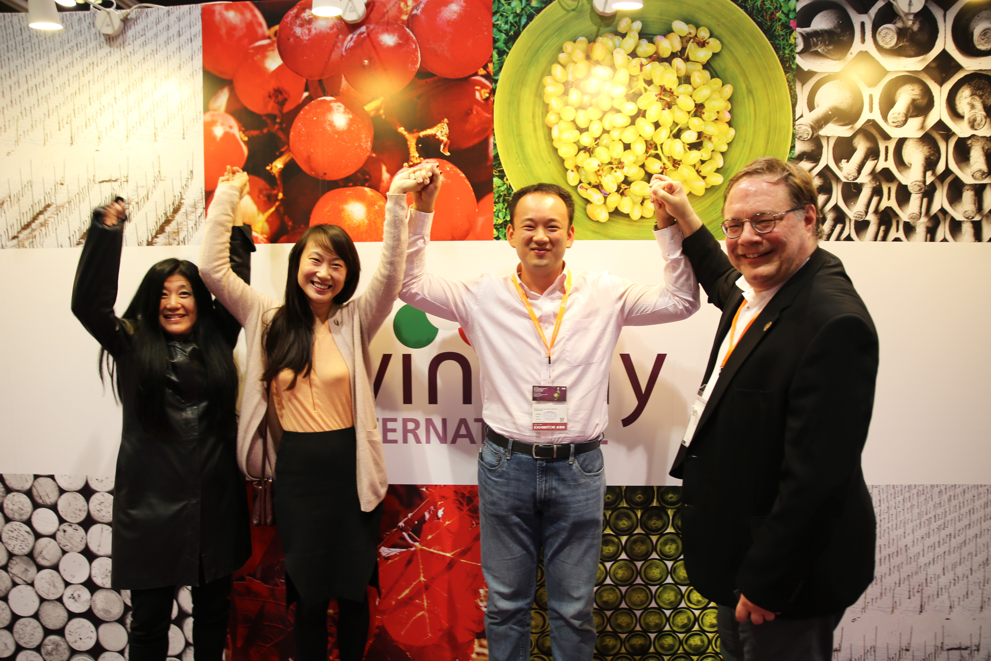

The third and final day of Vinitaly Hong Kong opened with the last session of wine2wine Asia, the educational business forum dedicated to exhibitors and visiting wine industry professionals. Debra Meiburg MW moderated “ABC to wine trade in China” with Jonathan Mather, Hong Kong based ASC Fine Wines Import, Giulia Chen Federexport, Alan Hung Executive Director PACCO and Chengdu Shangri La organizer, Shirley Tan China Knot Ltd., Fabio Piccoli Wine Meridian.

JC Viens, founder of Grande Passione and a VIA Italian Wine Ambassador, ran the third day of back-to-back wine tastings with hardly a seat empty. True to the name of his company, he brought “grande passione” to each session, with an approach to wine that offers technical “pro” insight while at the same time, involving the audience with story telling, colourful anecdotes, and folklore.

Stevie Kim, Managing Director of Vinitaly International, is pleased to see the positive reception of the various initiatives that Vinitaly International was able to bring to Hong Kong this year. She explains, “at Vinitaly Hong Kong, in addition to the traditional B2B booths represented by Italian Wineries, we were able to finally connect the dots and connect to the world by showcasing both wine2wine and the Vinitaly International Academy. Spreading the gospel about Italian Wine in this part of the world is often challenging, especially compared with the wines from French or the New World, and hence can be aided by adding a touch of “La Dolce Vita”.

Made-in-Italy was also the protagonist of the Vinitaly Lounge where attendees were able to taste some typical Italian food thanks to the collaboration with TUTTOFOOD Milano World Food Exhibition with whom Vinitaly International will be carrying out a number of initiatives in 2017.
“We hope that the Vinitaly Lounge with Italian Food and Lifestyle setting, coupled with Vinitaly Wine Bar represented by awardees from 5StarWines, engaged the attendees enough to trigger further interest in the Italian Wine community and hopefully have them also come visit Italy” adds Stevie Kim, concluding, with a tongue in cheek, “when more attendees come to visit Italian Wineries, to discover its territory, it is one step further toward making America Great Again.”

wine2wine Asia sessions were recorded live and can still be viewed on our Facebook page: @vinitalyinternational

About:
Veronafiere is the leading organizer of trade shows in Italy including Vinitaly (http://www.vinitaly.com), the largest wine and spirits fair in the world. During its 49th edition, Vinitaly counted some 4,000 exhibitors on a 100,000 square meter area and 150,000 visitors including 2,600 journalists from 46 different countries. The next edition of the fair will take place on 10 - 13 April 2016. The premier event to Vinitaly, OperaWine (http://www.vinitalyinternational.com) “Finest Italian Wines: 100 Great Producers,” will unite international wine professionals on April 9th in the heart of Verona, offering them the unique opportunity to discover and taste the wines of the 100 Best Italian Producers, as selected by Wine Spectator. Since 1998, Vinitaly International has traveled to several countries such as Russia, China, USA and Hong Kong thanks to its strategic arm abroad, Vinitaly International. In February 2014, Vinitaly International launched an educational project, the Vinitaly International Academy (VIA), with the aim of divulging and broadcasting the excellence and diversity of Italian wine around the globe. VIA has now also organized its very first Certification Course with the aim of creating new Ambassadors of Italian Wine in the World.

