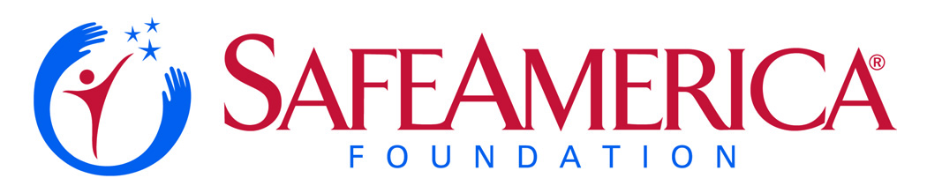

For Immediate Release  November 21, 2016 | Contact: Angie Haddad  Safe America Foundation  770-314-9272 mobile  Angie.Haddad@safeamerica.org | Contact: Christine Nestor  Miller Ingenuity  507-429-6250  cnestor@milleringenuity.com

Miller Ingenuity Wins WorldSafe Award

for Advancing Transportation Safety
with ‘ZoneGuard’ Product

(Atlanta, GA) – Miller Ingenuity has been selected for a 2016-17 WorldSafe Award for its work in advancing rail maintenance safety. Through a new product called ZoneGuard, the company has created an innovative, electronic roadway worker protection system that adheres to and improves current rail-safety standards, provides crew protection, and increases productivity.

CEO Steve Blue accepted the WorldSafe Award at the 3rd annual WorldSafe Gala, held at the Delta Flight Museum this past Saturday, November 19.

“ZoneGuard is the world’s most advanced system for warning and protecting railway track workers,” said Blue. “The ZoneGuard team has dedicated their lives and their careers to saving lives in the rail industry. We are honored to accept this recognition and are determined to continue our mission of providing high-technology, safety-critical solutions for railway worker protection.”

Miller Ingenuity’s products, led by the ZoneGuard suite, offer frontline defense solutions that benefit all functional departments of railway companies and help achieve excellence in everyday work through increased uptime, decreased risk, and overall peace of mind.

Company CEO Steve Blue noted that the firm’s goal is to save lives and believes that with its new ZoneGuard product, the number of fatalities from rail track maintenance will drop significantly.

“Many people don’t realize how vulnerable rail workers are who maintain our rail network – yet, each year, there are roughly a dozen lives lost,” noted Safe America CEO Len Pagano. “Thanks to Miller Ingenuity, this number can drop to zero – allowing rail lines to be maintained without having anyone lost.”

Miller Ingenuity, a manufacturing company based in Winona, MN, is a global supplier of life-saving, high-technology safety systems and services that surpass rail-safety standards. For more than 60 years, the organization has demonstrated the ability to conceptualize, design, produce and deliver railroad parts that meet the current and emerging needs of the industry.

About The Safe America Foundation
Safe America is a 501 (c) - 3 non-profit begun in 1994. With offices in Atlanta and Marietta, the organization is the country’s leading ‘voice for safety,’ partnering with corporate, governmental, and other non-profits to respond to emerging health and safety issues nationwide.

# # #

