**Texas license plate auction**

**ends tomorrow!**

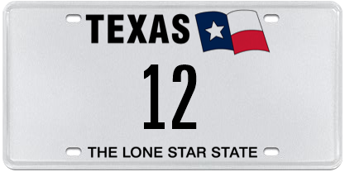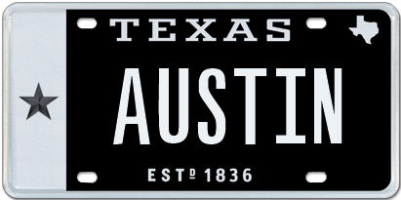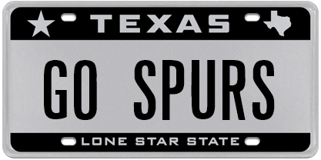

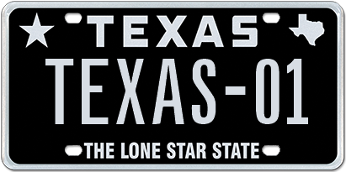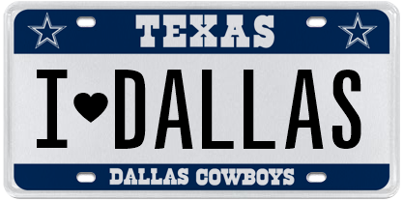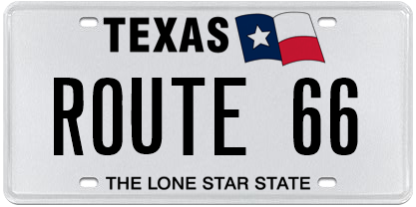

*The Great Plate Auction showcases 50 unique plate messages*

*Including historic license plate numbers!*

Austin, TX, November 29, 2016. The My Plates Great Plate Auction for 2016 will conclude at 8PM tomorrow night. The auction showcases 50 truly one-of-a-kind official Texas license plate messages, some that have never been offered to the market before.

There are a number of messages that are attracting quite a lot of interest, including the two-digit number 12, the six letter plate AUSTIN and San Antonio’s favorite team, GO SPURS. Other team related plates include 1-DALLAS and 1-TEXANS that will also be sold.

The auction features a little something for everyone, from Texas themed plates, to motor vehicle brands, College teams, two letter and even State names. Imagine owning a state’s name like ALABAMA or FLORIDA as your official Texas plate?

My Plates is also offering a variety of other historic license plate numbers including, the year **1845** symbolizing when Texas became the 28th U.S. state, or the year **1976** for those celebrating 40 years. My Plates is also offering Texans the opportunity to get in early on owning the new year with the plate number **2017**, hence one lucky person could own the new year now.

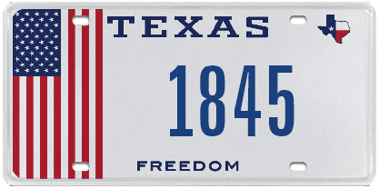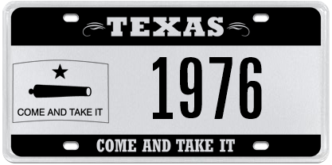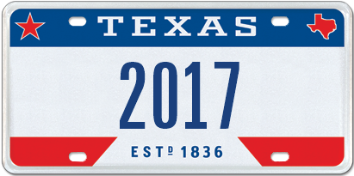

Unlike other everyday Texas license plates, plate messages sold at auction by My Plates are offered for a 5-year term and are legally transferable. The plate owner then has the right to sell the plate message to another person with the same ongoing rights or gift it to a family member or friend. Transferability also means these plates could make great investments.

All of the plate messages within this auction have an opening bid of only $500, with no reserve beyond that. If only the opening bid has been received when the auction closes, that will be the final and winning bid!

“We wanted to open this auction up for all Texans to have the opportunity to secure one of these great plate messages” said Steve Farrar, President of My Plates.

The Great Plate auction will be conducted online and will run through November 30, 2016. If you don’t live in Texas that’s okay, people from outside the state can purchase a Texas license plate for display on their wall, however, in order to display the auction plate on a vehicle, the vehicle must be registered by a Texas resident.

People interested in the auction can visit [www.myplates.com/auction](http://www.myplates.com/auction) for more information and to view the complete list of plates for sale.

____________________________________________________________

Previous Auction Results:

* 12THMAN sold for $115,000 making it the most expensive plate message in Texas.
* HOUSTON sold for $25,000 in January 2013.
* FERRARI was sold at the very first My Plates auction in 2011 and sold for $15,000.
* ALAMO was sold earlier this year, March 2016, for $10,250.
* DALLAS sold for $7,250 in March 2014.

_____________________________________________________________

Why buy at Auction?

* *Opportunity to purchase a truly exclusive plate message from My Plates' reserve collection.*
* *First right of renewal at the state's everyday pricing, which means you can keep the plate for as long as you choose to renew it.*
* *Auction plates are fully transferable. Not only can they be transferred from one vehicle to another, but also person-to-person, such as parent to their children or friend-to-friend. The plate owner also has the right to sell the plate message to another person with the same ongoing rights. As a result, Auction plates could be an excellent investment.*
* *Peace of mind, knowing that you're purchasing your official Texas license plates from My Plates, the authorized specialty plate vendor for the Texas Department of Motor Vehicles.*
* *Supports the General Revenue Fund of Texas, which provides services for all Texans.*

_____________________________________________________________

**My Plates** designs and markets new specialty license plates as a vendor for the Texas Department of Motor Vehicles. Texans have bought more than 300,000 My Plates since November 2009, putting more than $47M in the state general revenue fund. My Plates’ goal is to create a long-term, mutually beneficial relationship designed to maximize revenues for the state through the sale of My Plates specialty plates. [www.myplates.com](http://www.myplates.com).

**The Texas Department of Motor Vehicles (TxDMV)** serves protects and advances the citizens and industries in the state with quality motor vehicle related services. For every $1 it spends, the TxDMV returns $11 to the state. The agency currently registers 24 million vehicles; issues more than 7 million vehicle titles; licenses more than 38,000 motor vehicle dealers and distributors; credentials nearly 60,000 motor carriers; issues more than 800,000 oversize/overweight permits; investigates more than 15,000 complaints against dealers and motor carriers; and awards grants to law enforcement agencies to reduce vehicle burglaries and thefts. Learn more at [www.TxDMV.gov](http://www.TxDMV.gov).

____________________________________________________________

Image downloads

12 on White plate: <https://ce9a9387e1bc258c3cfa-af7906f4e771b24864bbfa3048e4a635.ssl.cf2.rackcdn.com/TxWhite_12.jpg>

AUSTIN: <https://ce9a9387e1bc258c3cfa-af7906f4e771b24864bbfa3048e4a635.ssl.cf2.rackcdn.com/AUSTIN.jpg>

GO SPURS: <https://ce9a9387e1bc258c3cfa-af7906f4e771b24864bbfa3048e4a635.ssl.cf2.rackcdn.com/GOSPURS.jpg>

ROUTE 66: <https://ce9a9387e1bc258c3cfa-af7906f4e771b24864bbfa3048e4a635.ssl.cf2.rackcdn.com/ROUTE66.jpg>

TEXAS-01: <https://ce9a9387e1bc258c3cfa-af7906f4e771b24864bbfa3048e4a635.ssl.cf2.rackcdn.com/TEXAS-01.jpg>

1845 on USA plate: <https://ce9a9387e1bc258c3cfa-af7906f4e771b24864bbfa3048e4a635.ssl.cf2.rackcdn.com/USAPride_1845.jpg>

1976 on Come and Take it plate: <https://ce9a9387e1bc258c3cfa-af7906f4e771b24864bbfa3048e4a635.ssl.cf2.rackcdn.com/ComeTake_1976.jpg>

2017 on Red, White & Blue plate: <https://ce9a9387e1bc258c3cfa-af7906f4e771b24864bbfa3048e4a635.ssl.cf2.rackcdn.com/TTX_2017.jpg>