Texas auction attracts high bids!
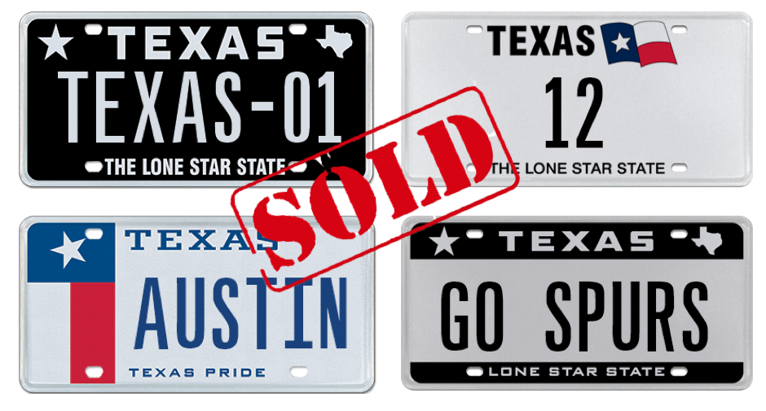
A total of 47 unique Texas license plate messages
were sold during the Great Plate Auction!

Austin, TX, November 30, 2016. The My Plates Great Plate Auction for 2016 has concluded, with a total of 47 sought after Texas license plate messages being sold. My Plates, the official marketing vendor for specialty license plates in Texas, conducted the auction event that delivered a total of $63,750 in overall sales of which $37,122 goes to the state of Texas, and thousands more to selected charities and University scholarships connected to various plate messages.

The highest selling plate was the low two-digit number 12 that sold for $6,250 followed by the state’s capital city AUSTIN, that sold for $4,900. Coming in third was the plate message MOM selling for $4,500. My Plates will be donating their share of proceeds from the MOM plate to the National Breast Cancer Foundation.

Unlike other everyday Texas license plates, plate messages sold at auction by My Plates are offered for a 5-year term and are legally transferable. The plate owner then has the right to sell the plate message to another person with the same ongoing rights or gift it to a family member or friend. Transferability also means these plates could make great investments.

My Plates plans to conduct more plate auctions in 2017, including an event where the first single digit number plate will be offered to the market. Texans who are interested in these upcoming auction events may contact My Plates or visit myplates.com/register.

Auction Results
Plate Message Sold Price
- 12 $6,250.00
- 123 $3,600.00
- 1845 $1,900.00
- 1976 $1,200.00
- 2017 $550.00
- TV $500.00
- DO $550.00
- VT $500.00
- CA $500.00
- GRANDMA $3,000.00
- GRANDPA $3,200.00
- NYC $650.00
- MOM $4,500.00
- VINTAGE $700.00
- CHARGER $2,000.00
- PONTIAC $550.00
- BUGATTI $950.00
- ALABAMA $3,400.00
- GEORGIA $600.00
- FLORIDA $550.00
- MONTANA $550.00
- YANKEES $800.00
- GO SPURS $1,600.00
- DODGERS $500.00
- CUBBIES $850.00
- VIKINGS $550.00
- IRELAND $850.00
- ITALIAN $500.00
- MEXICAN $550.00
- GERMANY $500.00
- ENGLAND $700.00
- ROUTE 66 $750.00
- 1-DALLAS $800.00
- 1-TEXANS $1,600.00
- TEXAS-01 $2,000.00
- AUSTIN $4,900.00
- VAQUERO $500.00
- HISTORY $500.00
- HUNTERS $700.00
- BUCKEYE $1,500.00
- GO IRISH $1,500.00
- HUSKERS $1,800.00
- OLE MISS $600.00
- 1-BAYLOR $1,300.00
- FL STATE $500.00
- SPARTAN $500.00
- WRECKEM $700.00
____________________________________________________________
Previous Auction Results:
- 12THMAN sold for $115,000 making it the most expensive plate message in Texas.
- HOUSTON sold for $25,000 in January 2013.
- FERRARI was sold at the very first My Plates auction in 2011 and sold for $15,000.
- ALAMO was sold earlier this year, March 2016, for $10,250.
- DALLAS sold for $7,250 in March 2014.
_____________________________________________________________
Why buy at Auction?
- Opportunity to purchase a truly exclusive plate message from My Plates' reserve collection.
- First right of renewal at the state's everyday pricing, which means you can keep the plate for as long as you choose to renew it.
- Auction plates are fully transferable. Not only can they be transferred from one vehicle to another, but also person-to-person, such as parent to their children or friend-to-friend. The plate owner also has the right to sell the plate message to another person with the same ongoing rights. As a result, Auction plates could be an excellent investment.
- Peace of mind, knowing that you're purchasing your official Texas license plates from My Plates, the authorized specialty plate vendor for the Texas Department of Motor Vehicles.
- Supports the General Revenue Fund of Texas, which provides services for all Texans.
_____________________________________________________________

My Plates designs and markets new specialty license plates as a vendor for the Texas Department of Motor Vehicles. Texans have bought more than 300,000 My Plates since November 2009, putting more than $47M in the state general revenue fund. My Plates’ goal is to create a long-term, mutually beneficial relationship designed to maximize revenues for the state through the sale of My Plates specialty plates. www.myplates.com.

The Texas Department of Motor Vehicles (TxDMV) serves protects and advances the citizens and industries in the state with quality motor vehicle related services. For every $1 it spends, the TxDMV returns $11 to the state. The agency currently registers 24 million vehicles; issues more than 7 million vehicle titles; licenses more than 38,000 motor vehicle dealers and distributors; credentials nearly 60,000 motor carriers; issues more than 800,000 oversize/overweight permits; investigates more than 15,000 complaints against dealers and motor carriers; and awards grants to law enforcement agencies to reduce vehicle burglaries and thefts. Learn more at www.TxDMV.gov.

____________________________________________________________

Image Download:
Four Plates with SOLD banner.
https://ce9a9387e1bc258c3cfa-af7906f4e771b24864bbfa3048e4a635.ssl.cf2.rackcdn.com/SOLD_PRimage.jpg

