Heilind Asia Is Now Stocking TE Connectivity MTA Connectors

Bangalore, 10 October 2016 - Heilind Asia, the leading global distributor of interconnect and electromechanical components, announced an expanded inventory with MTA connectors from TE Connectivity (TE), a global leader in connectivity and sensors. 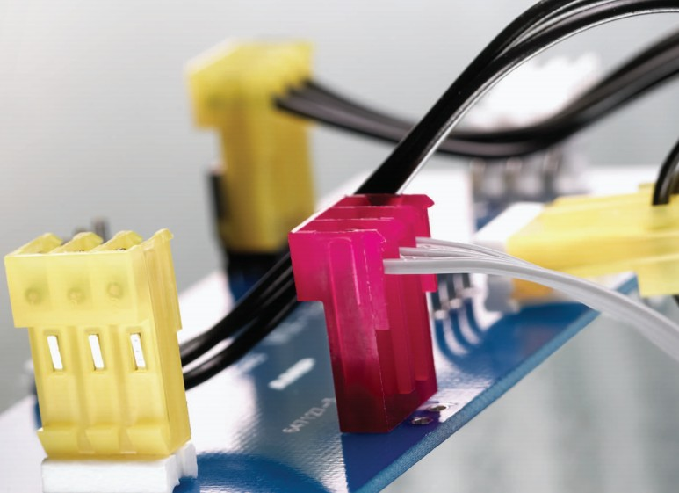
TE’s MTA connectors are utilized to distribute low current signals throughout electronic equipment. Mass termination of wires provides the lowest applied cost because it drastically reduces the labor content of virtually any cable or harness assembly required. TE’s MTA connector system is a wire-to-board and wire-to-wire system based on insulation displacement contact (IDC) technology.

TE’s MTA-100 connectors have contacts in a single row on .100 in [2.54 mm] centers, while MTA-156 connector contacts are in a single row on .156 in [3.96 mm] centers. The design features wire feed-through capability for daisy-chain applications. IDCs are used to terminate a wide range of conductor sizes. Ribbon cable can also be terminated when the appropriate receptacle assembly and strain relief cover are used. Header assemblies for board mount applications include right-angle and vertical mount products available in through-hole and surface mount configurations.

Heilind Asia supports both original equipment and contract manufacturers in all market segments of the electronics industry, stocking products from the industry’s leading manufacturers in 25 component categories, with a particular focus on interconnect and electromechanical products.

About Heilind Electronics
Founded in 1974, Heilind Electronics, Inc. (http://www.heilind.com) is one of the world's leading distributors of connectors, relays, switches, thermal management & circuit protection products, terminal blocks, wire & cable, wiring accessories and insulation & identification products. Heilind has over 40 facilities in the United States, Canada, Mexico, Brazil, Germany, Hong Kong, Singapore and China.

Heilind Asia Pacific (http://www.heilindasia.com) commenced operations in Dec 2012, and now has 19 locations throughout Asia. Its industry leading service offering to customers in Asia Pacific is the result of a commitment to the belief of “Distribution As It Should Be”.

About TE Connectivity
TE Connectivity (NYSE: TEL) is a $12 billion global technology leader. Our connectivity and sensor solutions are essential in today’s increasingly connected world. We collaborate with engineers to transform their concepts into creations – redefining what’s possible using intelligent, efficient and high-performing TE products and solutions proven in harsh environments. Our 72,000 people, including over 7,000 engineers, partner with customers in close to 150 countries across a wide range of industries. We believe EVERY CONNECTION COUNTS – www.TE.com.

MTA, TE Connectivity, TE and EVERY CONNECTION COUNTS are trademarks.

