Classic Black is Texas’ number 1 plate in 2016!
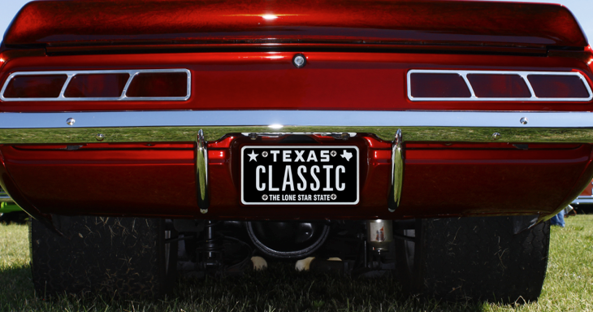

5 January 2017 (Austin, TX) – It’s official; the number one specialty license plate design sold by My Plates in 2016 is the full black background design, Classic Black. This new design outsold the previous record holder Lone Star Black that had held the top spot for the past seven consecutive years.

In 2016, more than 8,100 Texans purchased the new Classic Black design. The last time a full black plate was available in Texas was in 1968 as a general issue pattern. Since that time, Texas has moved to a number of other designs with the most recent being the full white plate with black lettering.

The launch of this retro Classic Black license plate design in March 2016 has proven to be very popular confirmed Steve Farrar, President of My Plates. “From day one, the new Classic Black design has eclipsed the sales of the Lone Star Black, it is a very sought after design” said Farrar.

In second spot with 7,712 plates sold in 2016, not surprising is the ever popular Lone Star Black design that can still boast having more plates sold in Texas, totaling more than 73,000. Rounding out the top 4 plates included two more black and white designs, Texas Black 1845 and Small Star Black respectively. In fact, the top 4 plates that are all black and white account for more than 51% of total sales. With over 43,000 plates sold each year, that’s a lot of black and white plates.

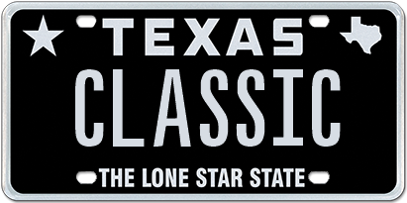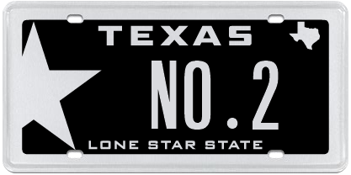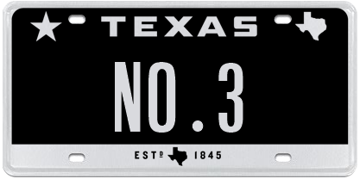

My Plates - Top 5 Selling Plates 2016
- Classic Black 8,212
- Lone Star Black 7,712
- Texas Black 1845 4,034
- Small Star Black 2,257
- Small Star Silver 1,063

“Black and white plates are very popular in Texas, they look smart, sleek, cool, and compliment any vehicle color,” said Steve Farrar.

So, if you were wondering what other plates proved popular in 2016, like which plate was the top College Plate? Or, the top Sports plate? Well, My Plates also released the rankings for other plate categories including College, Sports, Flags, Texas Theme, Colors and Charity.

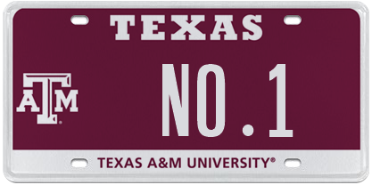 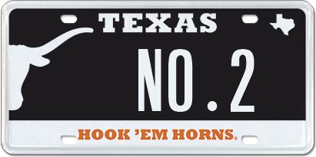 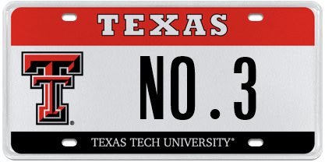’
My Plates - Top 5 College Plates (In-State)
- Texas A&M University
- University of Texas
- Texas Tech University
- Texas Christian University
- University of Houston

My Plates - Top 5 College Plates (Out-of-State)
- University of Colorado (launched in 2016)
- Louisiana State University
- University of Alabama
- University of Oklahoma
- University of Arkansas

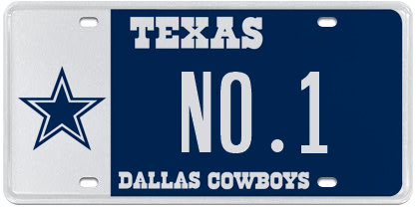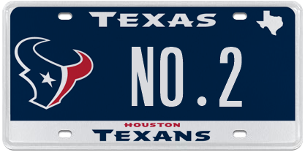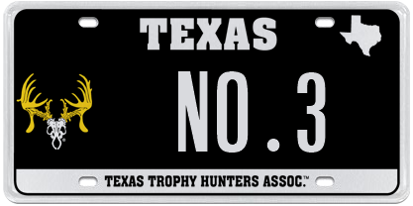

My Plates - Top 5 Sports Themed Plates
- Dallas Cowboys
- Houston Texans
- Texas Trophy Hunters
- San Antonio Spurs
- I’d Rather Be Golfing

My Plates - Top 5 Flag or Texas Themed Plates
- Come and Take It
- Texas Oil & Gas
- Don’t Tread on Me
- Natural Texas
- Yellow Rose of Texas

My Plates - Top 5 Colors (excluding black)
- Pink
- Silver
- Red
- Blue
- White

My Plates - Top Charity Plates
- Calvary Hill
- Protect Wild Animals
- Breast Cancer
- Peace Officers Memorial

____________________________________________________________

My Plates designs and markets new specialty license plates as a vendor for the Texas Department of Motor Vehicles. Texans have bought more than 300,000 My Plates since November 2009, putting more than $48M in the state general revenue fund. My Plates’ goal is to create a long-term, mutually beneficial relationship designed to maximize revenues for the state through the sale of My Plates specialty plates. www.myplates.com.

The Texas Department of Motor Vehicles (TxDMV) serves protects and advances the citizens and industries in the state with quality motor vehicle related services. For every $1 it spends, the TxDMV returns $11 to the state. The agency currently registers 24 million vehicles; issues more than 7 million vehicle titles; licenses more than 38,000 motor vehicle dealers and distributors; credentials nearly 60,000 motor carriers; issues more than 800,000 oversize/overweight permits; investigates more than 15,000 complaints against dealers and motor carriers; and awards grants to law enforcement agencies to reduce vehicle burglaries and thefts. Learn more at www.TxDMV.gov.
____________________________________________________________
Contact Steve Farrar at (512) 633-7978 or steve@myplates.com

Image download: Classic Plate on car:
https://ce9a9387e1bc258c3cfa-af7906f4e771b24864bbfa3048e4a635.ssl.cf2.rackcdn.com/ClassicCarImage.jpg

Image download: Classic Plate
https://ce9a9387e1bc258c3cfa-af7906f4e771b24864bbfa3048e4a635.ssl.cf2.rackcdn.com/ClassicBlack.jpg

