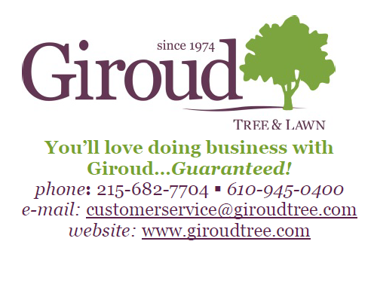
Why Removing Deadwood is Important
We see deadwood all the time, but probably never think twice about it. Take a look at your trees. Chances are you’ll see at least a branch or two with little or no foliage. Perhaps you’ll wonder if it really matters that your tree has dead branches.
Deadwood is pretty much exactly what the word implies; it’s a dead branch or dead section of wood still connected to a tree. There are a million reasons why a tree gets deadwood. Sometimes, it’s just part of a very natural process that happens to every tree. But, most often, it’s the result of issues like insects, diseases or structural and environmental problems.
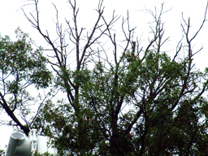
One thing is for certain – Deadwood WILL fall, and when it does, it can cause quite a bit of damage. If you’re lucky, the branch will hit the ground and kick up some dirt and grass that will need to be replaced. Those of us who are a little less lucky may need to call our home or auto insurers to help repair a roof or fix a newly dented car hood. For the very unfortunate, you or a loved one may be walking under the tree when the unthinkable happens, making a peaceful day turn into one of panic at the hospital.
Excessive deadwood is exposed at the top of this tree.
Now I know that sounds like a lot of shock and hype, but it actually happened to me a few years ago while driving to work. A dead branch about 3 diameters thick and 15 feet long fell from about 60 feet up. The branch smacked straight into the hood of my sturdy Ford Explorer. It sheered the steel bars that hold my engine in place, while the rest flew right through my windshield on the passenger side, completely totaling my vehicle. It was one of the scariest moments of my life, and it happened in a flash. The whole accident could have been avoided if the tree’s owner had called a certified arborist to trim any hazardous branches, but instead he and his insurance company were responsible for replacing my Explorer.
Aside from the liability side of things, deadwood can lead to your tree’s demise. A tree wound is similar to an open wound on a person. If you accidentally cut your hand while chopping a tomato, the smart thing to do is to put some antiseptic on the cut, and place a bandage over it. The same thing goes for a tree. Once deadwood falls off a tree, internal wood, also known as heartwood, is exposed and becomes an easy target for a variety of insects or diseases. Once either gets into the heartwood, it will take a certified arborist to come out, assess the damage, and eliminate the problem. But if the infestation goes unnoticed, you may be paying for a pricey tree removal in the near future.
Luckily, our team here at Giroud knows a thing or two about deadwood and how to properly take care of your trees. With certified arborists, highly trained tree climbers, and a ground crew that looks after the well-being of your property during the entire project, Giroud can help remove unwanted deadwood before it becomes a major liability. The consultation is free and easy. Don’t delay, and call today to make sure you’re trees are fully secured to stand healthy in your yard for years to come.

