Contact: Lera Salman  F.A. Davis Company  1915 Arch StreetPhiladelphia, PA 19103  Phone 215-215-825-8559Fax 215-568-5272  E-Mail LMS@FADavis.com |  | 
For immediate release
F.A. DAVIS NURSING LEADING THE WAY AND HONORED BY AJN
Two digital products recognized as the most valuable in 2016.
Philadelphia, PA, January 18, 2017: F.A. Davis Company has been recognized by AJN as the publisher of two of the titles awarded 2016 Book-of-the-Year Awards in the digital products category. These awards recognize the most valuable publications of the year, as chosen by AJN’s panel of judges. Peer-reviewed and evidence-based, AJN is considered the profession’s premier journal and has been identifying its selections of the year’s best work since 1969.
“These products reflect new models of active, adaptive, and personalized learning empowered by the technology that is changing how nursing is taught and how students are learning. Davis Advantage Patho and Davis Edge NCLEX® were designed and built from the ground up only after extensive research into how students learn, the best evidence-based educational practices, and in-depth conversations with educators, administrators, and students to ensure that they would meet the needs of today’s students and provide a clear path to success,” said Jean Rodenberger, Editor-in-Chief, Nursing. “We believe that Davis Advantage Patho and Davis Edge NCLEX® represent the future of nursing education. We are honored that AJN has recognized the role of these products in the education of the next generation of nursing students and the professional development of the field.”

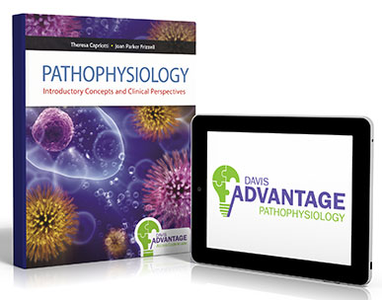
Awarded second place in the 2016 AJN Book of the Year Award
in the Digital Products category
Davis Advantage for Pathophysiology
Introductory Concepts and Clinical Perspectives
Theresa M. Capriotti, DO, MSN, CRNP, RN
Joan Parker Frizzell, PhD, CRNP, ANP-BC
www.DavisAdvantage.com
“…visually stimulating, responsive to user need, and multifaceted. The preassessment that tailors a learning plan for each student is fantastic, and the lessons that follow include interesting videos and interactive case studies, not just text. The product also provides a scorecard with graphical data display, as well as the functionality for instructors to assign sections and chapters with deadlines. Not only does this resource have expert content, it’s dynamic and enjoyable to use.”—AJN

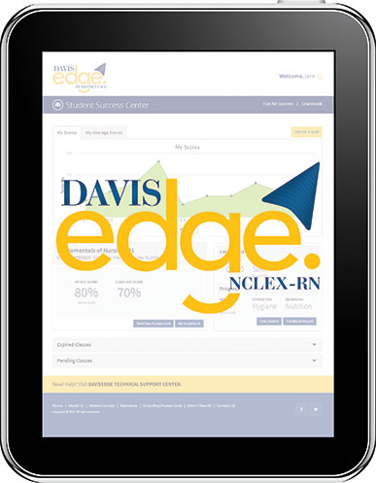
Awarded third place in the 2016 AJN Book of the Year Award
in the Digital Products category
Davis Edge for NCLEX-RN®

www.DavisEdge.com
“What would I have given for a product like Davis Edge NCLEX-RN! Simply put, this is a bank of questions. It is easy to jump in and create exams ranging from five to 20 questions, or an entire 75-question test. The program tracks students’ progress and tailors practice exams to their individual needs. This program also presents incredibly relevant and clear depictions of progress in a graphical format that all nurses will see in the workplace—such as in quality metrics, hospital initiatives, or research.”—AJN

These titles are available at bookstores or directly from F.A. Davis Company.
For more information, call 800-323-3555 (US) 800-665-1148 (Canada) or visit www.FADavis.com.

About F.A. Davis Company
F.A. Davis Company is one of the oldest independent, family-managed publishing houses in America. Since 1879, we have been meeting the needs of nursing, medical, and health science professionals seeking information of the highest quality.
Today, F.A. Davis carries on that tradition through its print, digital, and online products for students, educators, and clinicians in Nursing and the Health Sciences. Our flagship titles, Taber’s® Cyclopedic Medical Dictionary and Davis’s Drug Guide for Nurses® are among the most trusted names in health care.
For more information, visit www.FADavis.com.
###

