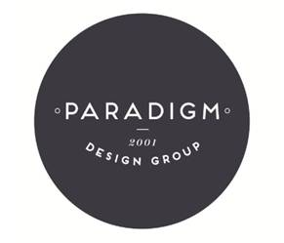

PARADIGM DESIGN GROUP EXPANDS TO CHICAGO

Company’s PDG Studios to be Run From New Location

CHICAGO, IL – February 8, 2017 – Paradigm Design Group, an award winning design firm specializing in hospitality projects, is expanding with a new office in Chicago. The firm was started in Houston more than 15 years ago and is now expanding to Chicago to run PDG Studios, the firm’s newer family brand that focuses on boutique and lifestyle properties.

“Our work takes us all over the U.S. as well as abroad,” said Lisa Haude, principal and president of Paradigm Design Group. “We’ve noticed an increasing need to be close to clientele in Chicago, and have experienced a higher demand for our boutique and lifestyle design services in key markets. We are excited about the growth happening at PDG Studios and felt that it was the right time to expand, as well as bring on some of the great design talent located in the Chicago area.”

Lisa will be based in Chicago and will continue to work closely with the team in Houston.

Paradigm Design Group works with some of the world’s leading hotel brands and has won numerous awards for its work. In 2016, Lisa won a Bronze Stevie® award in the Management category – Woman of the Year. The firm is known for being style makers and detail-oriented perfectionists with a unique ability to incorporate local elements into every project. Paradigm Design Group offers a variety of services including interior design, artwork and accessory selections and project styling.

About Paradigm Design Group
Founded in 2001, Paradigm Design Group is an award winning interior design firm that specializes in the hospitality industry. The company has worked on projects throughout the U.S. and abroad for major hotel chains. Developing a meaningful design requires careful research of the location, property and unique story of a space. It is that special consideration that sets Paradigm Design Group apart. The firm has also expanded its capabilities with PDG Studios, a boutique and lifestyle interior design services brand. For more information, visit www.paradigm-design.com.

# # #

Contact:
Janel Steinberg
janel@adesignpartnership.com
310-359-6438 ext. 707

