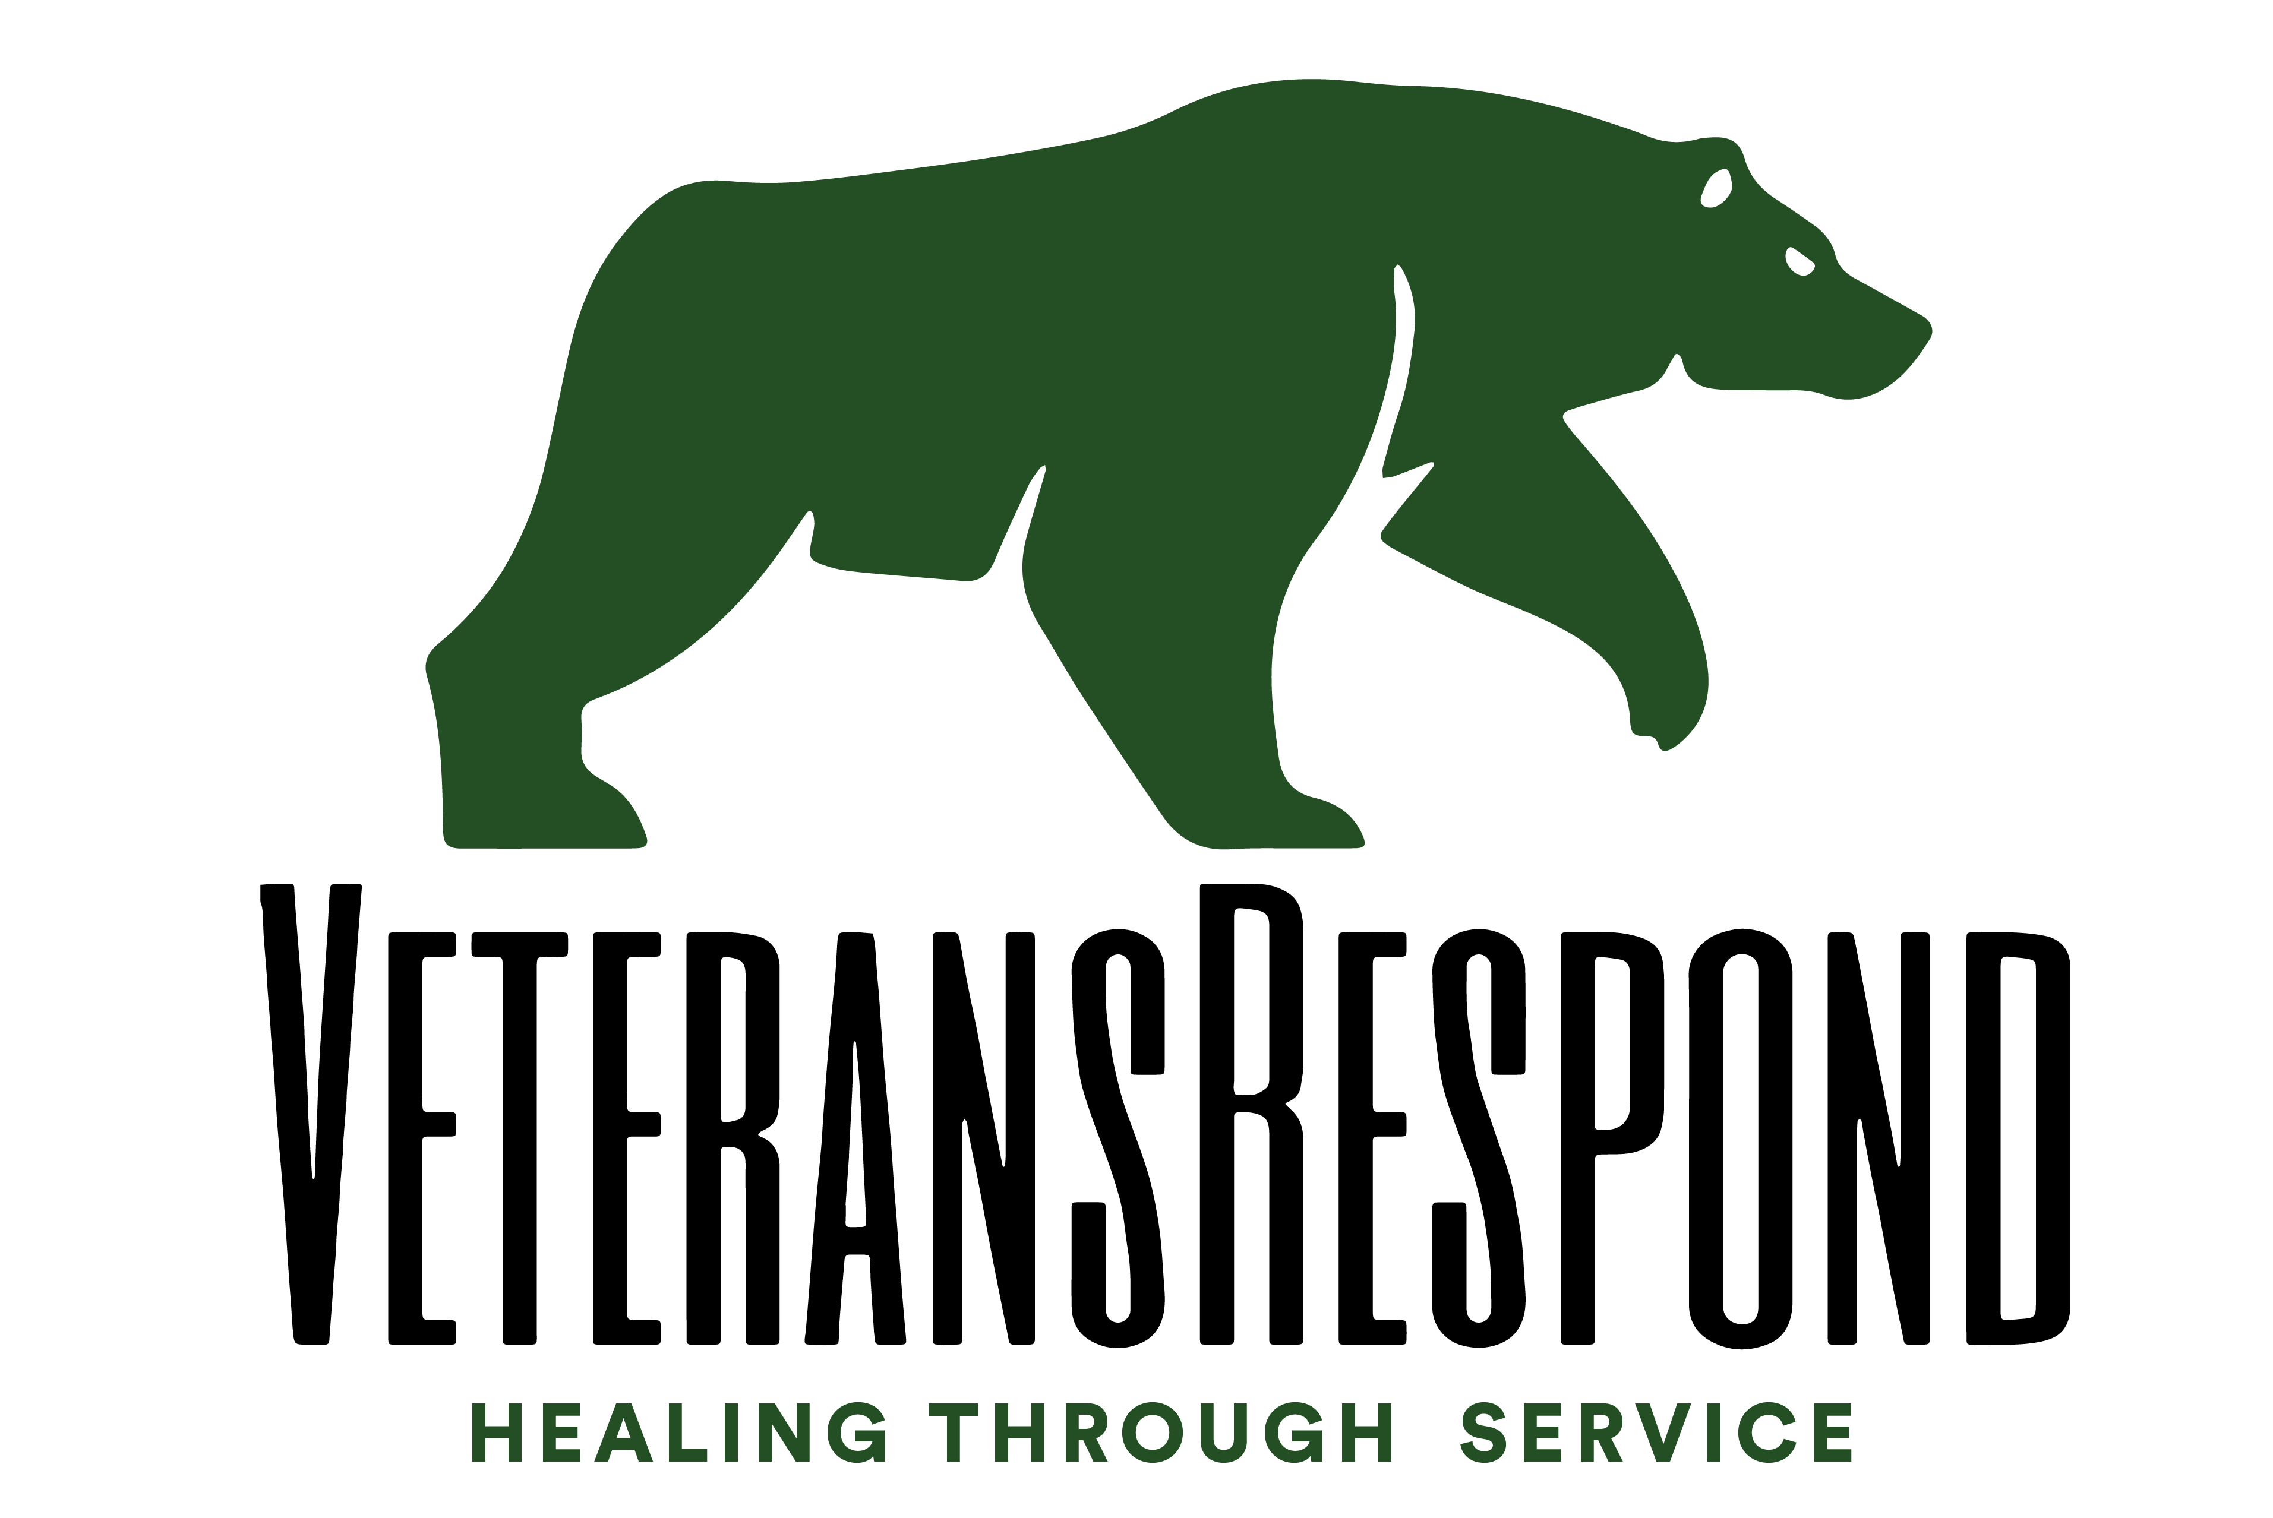
FOR IMMEDIATE RELEASE
February 9, 2017

Media Inquiries:
Elizabeth Williams
elizmegs@gmail.com
607-242-3300

387 Franklin Street
Buffalo, NY 14202

The Last Stand: Veterans Return to Standing Rock

VeteransRespond will deploy to Standing Rock, North Dakota this afternoon. A supply convoy left earlier this week from Houston, Texas and will be met by a small leadership team traveling from headquarters in upstate NY.

Due to recent events and ongoing needs at Sacred Stone Camp, LaDonna Brave Bull Allard personally requested assistance from VeteransRespond. The deployed unit will assist the camp, located on privately owned land, to strengthen operations in preparation for what water protectors are calling “The Last Stand”.

VeteransRespond will arrive at Sacred Stone Camp late on Friday and will be completely self-sustaining. The team has been tasked with reinforcing logistics and creating infrastructure that will allow for Sacred Stone Camp to continue in prayer and vigilance against the Dakota Access Pipeline. “We have a highly skilled unit headed out there,” says Mark Sanderson, executive director of VeteransRespond. “Our mission is simple: to use our experience and expertise to help train, organize and protect”.

VeteransRespond has recently completed two successful missions. A small security and press team deployed to Washington D.C. to serve and support those who engaged in peaceful assembly during the Inauguration and Women's March. VeteransRespond also recently trained residents of Two Rivers Camp in emergency medical procedures and crisis response.

VeteransRespond is committed to supporting water protectors at Standing Stone Camp in non-violent protest and lawful assembly. Sanderson discourages any type of mass mobilization of veterans that could interrupt the fragile infrastructure in the camps. “Anyone who feels compelled to help right now can get in touch with me,” says Sanderson. “Donations to this mission are really critical. We aren’t going out there, creating a mess and then leaving. VeteransRespond is a sustainable and efficient organization.”

About VeteransRespond

VeteransRespond organizes highly trained veterans to serve in communities impacted by environmental and social injustices. The VeteransRespond community allows veterans to reconnect, reintegrate, and thrive by utilizing unique and diverse skill sets gained through military service. The organization’s principles reflect and keep with the highest traditions of the United States military. VeteransRespond advocates non-violence and fair treatment of all Americans. They also stand against the financial exploitation of humanitarian disasters.

