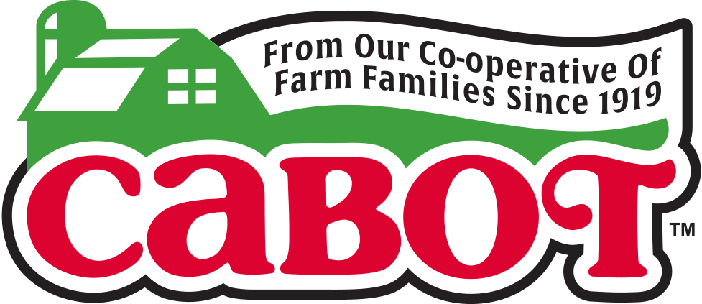
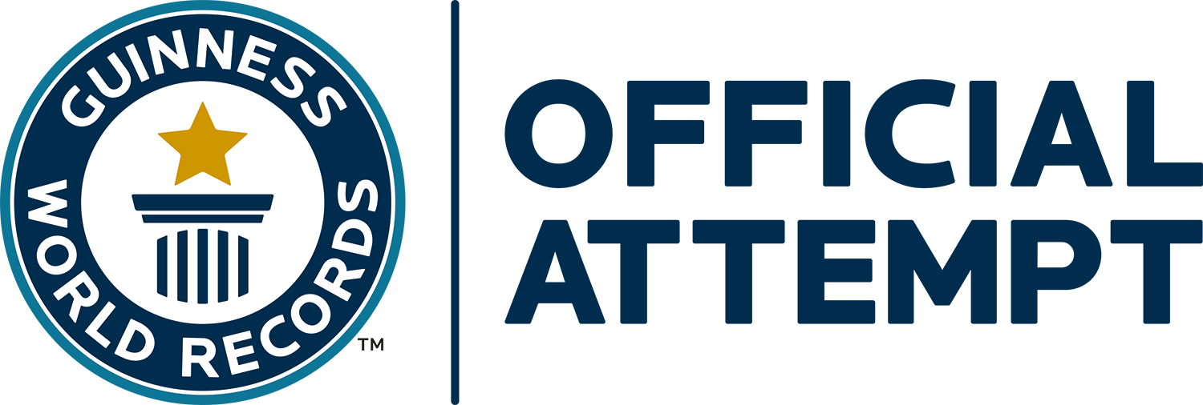

FOR IMMEDIATE RELEASE
Contact: Mary Lou Janson, At The Table PR
Cell: (813) 361-1061
Email: wordmssmith@gmail.com

Help Us Make It BIG…
GUINNESS WORLD RECORDS™ BIG To Benefit
United Food Bank of Plant City & Feeding Tampa Bay

Tampa, FL (Feb. 22, 2017) — There’s something BIG going on in Plant City on Friday, March 3 … REALLY, REALLY BIG! In fact, it’s GUINNESS WORLD RECORDS BIG!

Cabot Creamery Co-operative is joining forces with the Florida Strawberry Festival to create the Largest strawberry yogurt smoothie – all to benefit United Food Bank of Plant City and Feeding Tampa Bay.

When we say REALLY, REALLY BIG, we’re not kidding! The Cabot Smoothie prep team, led by Cabot Chef Jimmy Kennedy, will be hard at work beginning at 10am on March 3 during the 2017 Florida Strawberry Festival in Plant City, FL blending a healthy and delicious smoothie made from more than 250 gallons of Cabot Vanilla Bean Greek Yogurt, that represents more than 1,100 two-pound tubs of Cabot Greek Yogurt for every one of Cabot’s 1,100 farm families, 2,000 pounds of fresh Florida strawberries, 3,375 pounds of ice and 265 pounds of Cabot Whey protein powder.

“The Florida Strawberry Festival is pleased to host Cabot’s GUINNESS WORLD RECORDS attempt to recapture the record by creating the World’s Largest Strawberry Yogurt Smoothie to benefit United Food Bank of Plant City and Feeding Tampa Bay. Featuring Florida strawberries in this world record attempt showcases our amazing 87th Annual Festival and brings more awareness to Plant City’s rightful claim as the ‘Winter Strawberry Capital of the World,’” said Paul Davis, Florida Strawberry Festival general manager.

The Cabot Smoothie team previously set the GUINNESS WORLD RECORDS mark of more than 400 US gallons of smoothie on Friday, May 3, 2013 at the Bike Expo New York event held at Pier 36 in Basketball City in New York City.

That record has been eclipsed several times since 2013. The current GUINNESS WORLD RECORDS mark for the Largest smoothie is held by McGill University of Montreal, Canada and stands at 825 US gallons.

“We are excited to attempt to establish a new Guinness World Record for the World’s Largest Smoothie to benefit United Food Bank of Plant City and Feeding Tampa Bay,” said Roberta MacDonald, Senior Vice President of Marketing for Cabot Creamery Co-operative. “The 1,100 farm families who own Cabot Creamery are dedicated to supporting communities where we sell our dairy products, and raising money for United Food Bank of Plant City and Feeding Tampa Bay is one of the many ways our farm families give back to those in need.”

The record attempt will take place at the Cabot Tent located on the north side of the Life Storage Carriage House just inside the Amscot Main Ticket Gate at the Festival. Blending will commence at 10am and is estimated to take four to six hours. Once completed, all proceeds from the sale of the record setting Smoothie - sold in commemorative cups for a suggested donation of $1.00 – go directly to United Food Bank of Plant City. In keeping with Guinness World Records’ zero food waste policy, any remaining Smoothie will go directly to Feeding Tampa Bay and will be distributed to Food Banks and Pantries throughout the greater Tampa Bay area for consumption by those in need.

"We are grateful to be the recipient for this record-breaking event with our partners at Cabot. The enormity of this record reminds us of the enormity of the hunger issue in our community, with 700,000 of our neighbors not having stable access to food. The fresh and healthy ingredients used in this smoothie are perfectly aligned with Feeding Tampa Bay’s goal to deliver more fresh, nutritious foods to those in need every year,” said Thomas Mantz, Executive Director of Feeding Tampa Bay.

Can we do it again? We don’t want to brag, but our track record speaks for itself! Cabot established and still holds the GUINNESS WORLD RECORDS titles for the Largest grilled cheese sandwich, 320 pounds) set on November 4, 2000 in Everglades City, FL, and The World’s Largest Mac & Cheese (2,469 pounds) set in 2010 in New Orleans – all for charities!

This year the Cabot Smoothie team doesn’t want to simply surpass the current record. They plan to shatter it by blending a whopping 1,000 gallons of strawberry yogurt smoothie.

Cabot’s famous Greek Yogurt took home top honors as “Best In Class” in the competition’s first-ever High-Protein Dairy category at the 2016 World Championship Cheese contest in Madison, WI. Available in convenient two-pound tubs, Cabot Greek Yogurt can be used for baking, and Cabot Plain Greek Yogurt makes a great substitute for sour cream or cream, or as a base for dips and sauces.

Also included in the recipe are enough Plant City Strawberries - 2,000 pounds in all - to fill nearly 25 household bathtubs.

“We are extremely pleased to be part of this event and to have fresh Florida strawberries the featured fruit in making the world’s largest strawberry smoothie. This is a record we are proud to be part of and we hope that the record stands for many years,” said Kenneth Parker, Executive Director, Florida Strawberry Growers Association.

The Smoothie will be made using two human-powered Vitamix Bicycle Blenders as well as four Commercial and eight residential Vitamix blenders, and continuously poured into a 1,000 gallon food-grade holding vessel packed in ice.

“Vitamix is excited to partner with Cabot Creamery to regain the Guinness World Book Record for the world’s largest smoothie,” said Vitamix Marketing Programs Manager Wendy Manfredi. With Vitamix equipment doing the blending, we can promise that the smoothie will not only be the largest but also the smoothest! This will please everyone who will be making a donation and tasting this record-breaking smoothie. Vitamix is proud to support the efforts of Cabot to provide a generous donation to United Food Bank of Plant City and Feeding Tampa Bay because we support similar organizations in our headquarters home town of Cleveland, Ohio and recognize the importance of providing healthy meals to those in need.

ABOUT CABOT CREAMERY CO-OPERATIVE: Cabot Creamery Co-operative has been in continuous operation in Vermont since 1919 and makes a full line of cheeses, yogurt, sour cream, cottage cheese and butter. Best known as makers of “The World’s Best Cheddar and The World’s Best Lowfat Cheddar,” Cabot is owned by 1100 dairy farm families throughout New England and Upstate New York. For additional information on Cabot Creamery Co-operative, please visit http://www.cabotcheese.coop

