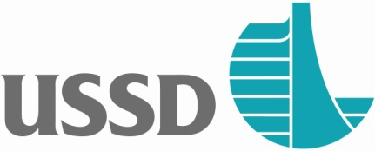

February 27, 2017

FOR IMMEDIATE RELEASE

Contact: Gene Guilford, 860-989-0756, gene@ussdams.org

**US - Canada Joining To Create Greater Public Safety**

**Around Dams**

With recent events surrounding Oroville Dam in California and others like it around the nation, the United States Society on Dams and the Canadian Dam Association have joined together to bring every community in America greater safety and security for the public wherever dams are located.

On April 6-7, 2017 during its annual conference in Anaheim, California, the United States Society on Dams and the Canadian Dam Association will deliver a critically important program on ***Public Safety Program Development for Dams,*** a practical hands-on workshop providing case studies and tools that can immediately be applied for the assessment of public safety risks at dams. Instruction is based on CDA Guidelines for Public Safety Around Dams. Everyone attending the workshop will leave with materials that can be put to immediate use in their own community. The workshop will benefit dam owners, managers, and operators of dam facilities, state and federal dam safety regulators, state and federal public safety officials and those involved in risk management assessments or decisions related to public safety around dams*.*

Registration for this important workshop is at <https://ussdams.wildapricot.org/event-2282875> or for more information contact USSD at 303.628.5430 ext 1 or by email at gene@ussdams.org

Interested parties may either register for the entire conference from April 3-7 or only register for the two-day Public Safety Program Development for Dams on April 6-7.

This program is sponsored by Worthington Waterway Barriers - [http://www.tuffboom-ussd.com/](http://www.tuffboom-ussd.com/%20)  Canton, Ohio.

