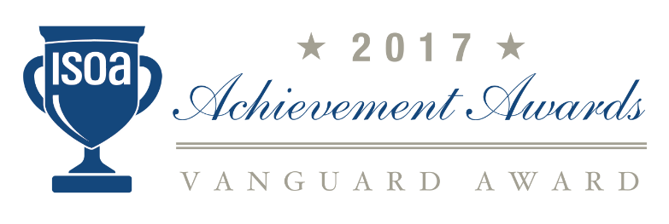

International Stability Operations Association (ISOA)
2017 Achievement Awards

*** In Recognition of Outstanding Work in the Stability Operations Field ***

Eligibility Criteria and Nomination Form

Due date for submissions is Friday, March 31, 2017

ISOA’s First Annual 2017 Achievement Awards
The ISOA 2017 Stability Operations Awards will recognize small, medium, and large companies who consistently demonstrate commitment to accountability, transparency, and ethics in the stability operations field. The top award in each category will be presented as a “Vanguard” Award. Individual Awards recognizing sustaining support of ISOA and an ongoing commitment to the stability operations field will also be presented, for which nominations are not required.
The 2017 Awards will be presented at the ISOA Spring Awards Dinner on Thursday, June 1, 2017 at the National Press Club, 529 14th St NW, Washington, DC 20045. For additional information about this event, please contact howielind@stability-operations.org.
The ISOA Achievement Award categories include:
Recognition of Small, Medium, and Large Companies – Continuously demonstrate commitment to accountability, transparency, and ethics in the stability operations field.
Eligibility Criteria: Eligible nominees include corporate members of the ISOA who are in good standing with the industry. Companies may apply who are not members of ISOA, but to be selected as a finalist, your company must have joined the association.
Award Timeline
Nominations Due: by March 31, 2017
Award Winners Notified: April 2017
Presentation of Awards: Winners will be recognized at the ISOA Spring Awards Dinner on Thursday, June 1, 2017 at the National Press Club, 529 14th St NW, Washington, DC 20045.
ISOA Awards Program Contacts: For specific questions about the nomination process, please contact our awards committee members, Michelle at 202-344-9030, or Kelley at 202-680-9888.
About the International Stability Operations Association (ISOA): The International Stability Operations Association (ISOA) is a global partnership of private sector and nongovernmental organizations providing critical services in fragile environments worldwide. The ISOA seeks to promote ethical standards in operational contractor support through the ISOA Code of Conduct, to build key relationships within and across sectors in the stability operations space by identifying common interests, to advocate for the effective utilization of private sector services in fragile environments, and to facilitate business development opportunities for ISOA members by leveraging our extensive ISOA network. www.stability-operations.org

ISOA 2017 Achievement Awards Nomination Form

To nominate your company, or another company, for any of the ISOA’s Achievement Awards, please provide the following. Fill in and submit the information requested below. Separately, please write-up your responses to the nomination questions further below in the following format: typed on no more than two pages, normal-sized font, and in an MS Word document. Submit via email to howielind@stability-operations.org, by Friday, March 31, 2017.
Company name:

Headquarters address:

Member of ISOA: Yes ☐ No ☐

Year your company joined ISOA:

Membership Tier level (based on gross annual revenue): ☐ Tier 1 is over $500m, ☐ Tier 2 is from $200m to 500m, ☐ Tier 3 is from $100m to 200m, ☐ Tier 4 is from $20m to 100m, ☐ Tier 5 is from $3m to 20m, ☐ Small Business is under $3m.
Name of CEO/President:

Individual nominating your company:
Please include their name, relationship, phone number and email address.

Nomination questions:

- Please provide a brief background/summary of your company. (Include number of employees, countries where you operate, core competencies, and any other helpful background information.)

- From your company's recent operations, please provide an example of which your company is most proud, demonstrating your company's work in stability operations. Include the specific program, country, program goals, and how you achieved them.

- Please provide a specific example of your efforts/success in capacity building, humanitarian support, or charitable assistance, to advance the citizens of a Host Nation where you operate and/or have programs.

- Transparency, ethical conduct, respect for human rights are all hallmarks of our ISOA member companies. Please provide one example of which your company is most proud, which reflects how you execute those standards on an operational level in one of your programs/initiatives/contracts.

