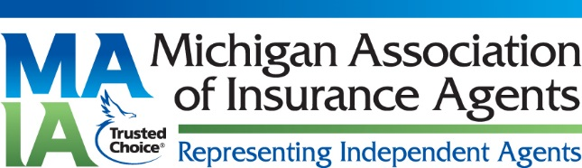

FOR IMMEDIATE RELEASE
MEDIA CONTACT:
Janet Kapa
(517) 796-6296
jkapa@waltoninsurancegroup.com

JACKSON, MI (March 1, 2017) - Eric “Ric” B. Walton with The Walton Insurance Group in Jackson, MI has been named the 2017 Forsetlund Agent of the Year by the Michigan Association of Insurance Agents. The Award recognizes a member who has contributed the most to his or her agency and community. Ric Walton entered the agency business when he was introduced to his father’s agency at a young age and the value of protecting and serving the people was instilled in him. He has earned the CIC designation and served as President of the Association in 1991-1992.
Walton has always been a strong supporter of Jackson County organizations, especially those relating to community and children, leading by example and giving back.
Walton received the award at the Associations’ recent state convention in Grand Rapids. The Michigan Association of Insurance Agents is a statewide trade group that represents approximately 7,000 independent agents and industry employees.
For more information on Ric Walton at Walton Insurance Group, visit www.waltoninsurnacegroup.com

