Status Report – REACTOR

Overview

Full name | ThorCon
Acronym | ThorCon
Reactor type | Molten Salt Reactor
Purpose | Prototype/Demonstration
Coolant | NaF, BeF2 salts
Moderator | Graphite
Neutron Spectrum | Thermal
Thermal capacity | 557 MW per module
Electrical capacity | 250 MW per module
Design status | Under design
Designers | Jack Devanney, Lars Jorgenson, Chris Uhlik  Martingale, Inc
Last update | July 19, 2016

Description of the Nuclear Systems

Demand for Clean, CO2-free Power Cheaper than Coal, NOW
Currently mankind consumes electricity at a rate of about 2,300 GWe. The distribution of consumption is highly uneven. While the USA consumes 1,400 W per person and the Scandinavian countries considerably more, most of Latin America consumes less than 250 W, most of South Asia less than 100 W, and most of Africa less than 25 W. A billion humans have no access to electricity at all. If mankind is to prosper, it is imperative that clean, affordable, dependable power be available to all. This power must be provided without polluting the air we breathe, without poisoning the land we live on, and without impacting the climate we depend on.

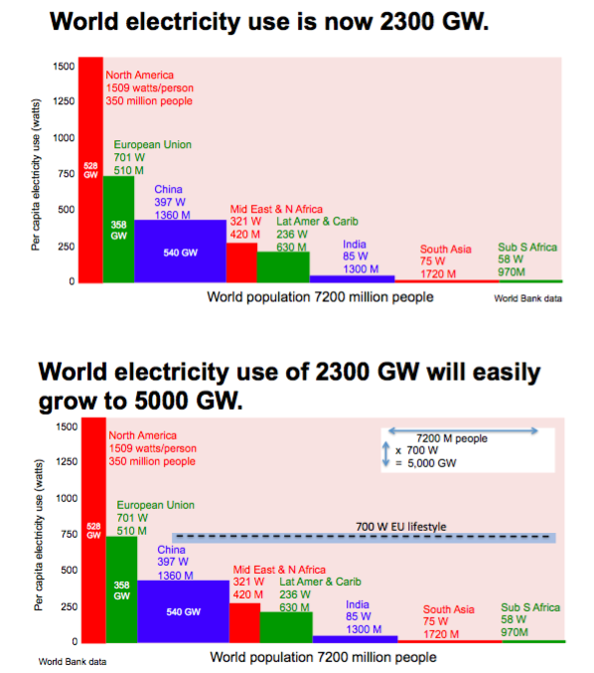
Figure 1: Regional distribution of electricity consumption

The rapidly growing electricity demand in developing countries, as Figure 1 indicates, requires at least 2,000 GWe of new capacity over the next 20 years, or 100 one GWe plants per year, or about 2 plants per week. As things stand now, most of these plants will be coal fired. According to the MIT Technology Review, as of June, 2013, 1,199 coal plants are planned worldwide, with a nameplate capacity of 1,401 GWe.
Each one of these coal fired plants will require about 4 million tons of coal per year. Each one will produce between 400,000 and a million tons of ash per year and about 10 million tons of CO₂ per year. Each one will kill at least 9 miners per year (European numbers) and will shorten the lives of at least 300 people per year (European numbers) via pollution. In aggregate, these 1200 new coal plants will require 5 billion tons of coal annually, kill or shorten the lives of at least 400,000 people per year, and produce 12 billion tons per year of CO₂.
ThorCon proposes an alternative: an alternative that produces nil pollution, nil CO₂, and 100,000 times less waste than coal; an alternative that uses dramatically less of the planet’s precious resources, less steel, less concrete than coal; and an alternative that can be deployed more rapidly than coal.

Design Philosophy
The following principles are followed in the ThorCon design:
ThorCon is Walkaway Safe
ThorCon is a simple molten salt reactor with the fuel in liquid form. If the reactor overheats for whatever reason, it will automatically shut itself down and drain the fuel from the primary loop and passively remove the decay heat. There is no need for any operator intervention and the operators cannot prevent the draining and cooling. The reactor is 15 m underground. ThorCon has three gas tight barriers between the fuelsalt and the atmosphere. The reactor operates at slight over-pressure so that in the event of a primary loop rupture, there is no dispersal energy and also no phase change. The spilled fuel merely flows to a drain tank where it is passively cooled. The most troublesome fission products, including Sr-90 and Cs-137, are chemically bound to the salt. They will end up in the drain tank as well.
ThorCon is Ready to Go
The ThorCon design should not need new technology development. ThorCon is a scale-up of the successful Molten Salt Reactor Experiment (MSRE). Currently the designers foresee no technical reason why a full-scale 250 MWe prototype cannot be operating within four years. The intention is to subject this prototype to all the conceivable potential failure modes that the designers claim the plant can handle. As soon as the prototype passes these tests, commercial production can begin.
ThorCon is Rapidly Deployable
The entire ThorCon plant including the building is designed to be manufactured in blocks on a shipyard-like assembly line. These 150 to 500 ton, fully outfitted, pre-tested blocks are then barged to the site. A 1 GWe power station will require less than 200 blocks. Site work is limited to excavation and erecting the blocks. This should result in order of magnitude improvements in productivity, quality control, and build time. A single large reactor yard can turn out one hundred 1 GWe ThorCons per year. The philosophy is therefore that ThorCon is much more than a power plant; it is a new system for building power plants.
ThorCon is Fixable
The design does not foresee any complex repairs to be attempted on site. Except for the building everything else in the nuclear island is replaceable with little or no interruption in power output. Every four years the entire primary loop is changed out, returned to a centralized Fuelsalt Handling Facility, decontaminated, disassembled, inspected, and refurbished. The instrumentation design and monitoring system is designed to identify incipient problems before they can lead to failures. Major upgrades must be possible without significantly disrupting power generation. A nuclear power plant following such a change-out strategy can in principle operate indefinitely; but decommissioning should be little more than removing, but in this case not replacing, all the replaceable parts.
ThorCon is Cheaper than Coal
ThorCon requires far less resources than a coal plant. Assuming efficient, evidence-based regulation, ThorCon aims to produce clean, reliable, carbon-free electricity at less than the cost of coal.

Nuclear Steam Supply System
Figure 2 is a cutaway view of the underground structure. ThorCon is divided into 250 MWe power modules. The drawing shows two such modules. Each module contains two replaceable reactors in sealed Cans. The Cans are depicted in red in the drawing. They sit in silos. At any one time, just one of the Cans of each module is producing power. The other Can is in cooldown mode. Every four years the Can that has been cooling is removed and replaced with a new Can. The fuelsalt is transferred to the new Can, and the Can that has been operating goes into cool down mode.
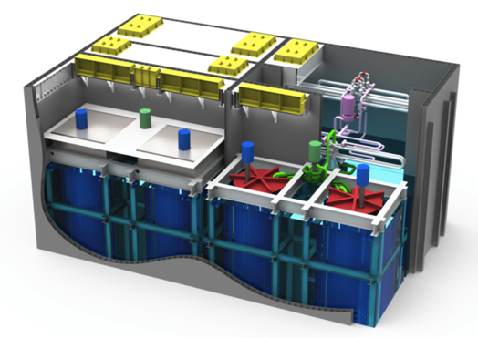
Figure 2: Cutaway view of two module silo hall

Figure 3 takes a look inside a Can. The Can contains the reactor, which we call the Pot, a primary loop heat exchanger (PHX), and a primary loop pump (PLP). The pump (blue upper left) takes liquid fuelsalt — a mixture of sodium, beryllium, uranium and thorium fluorides — from the Pot (orange) at 704 ºC, and pushes the fuelsalt over to the PHX at a rate of just under 3000 kg/s (1 m³/sec).  Flowing downward through the PHX (skinny blue), the fuelsalt transfers heat to a secondary salt, and is cooled to 564 ºC in the process. The fuelsalt then flows over to the bottom of the Pot, and rises through the reactor core where the graphite moderator slows the neutrons produced by the fissile uranium, allowing a portion of the uranium in the fuelsalt to fission as it rises through the Pot, heating the salt and (indirectly) converting a portion of the thorium to fissile uranium. | 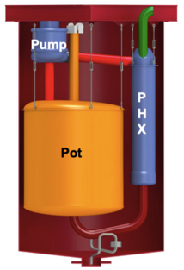
 | Figure 3: The ThorCon can: a pot, a pump, and a still (right)
The Pot pressure is 3 bar gage at the maximum stress point. The outlet temperature of 704 ºC results in an overall plant efficiency of about 45%, and a net electrical output per Can of 250MW. The Can’s net consumption of fissile uranium is 112 kg per year. The Can (red) is a cylinder 11.6 m high and 7.3 m in diameter. It weighs about 400 tons. The Can has only one major moving part, the pump impeller.
Directly below the Can is the Fuelsalt Drain Tank (FDT) (green) shown in Figure 4. In the bottom of the Can is a fuse valve (grey). The fuse valve is merely a low point in a drain line. At normal operating temperatures, the fuelsalt in the fuse valve is frozen creating a plug. If the Can heats up for any reason, the plug will thaw, and the fuel salt will drain to the FDT. Since the drain tank has no moderator, fission will stop almost immediately. This drain is totally passive. There is nothing an operator can do to prevent it.
A critically important feature of ThorCon is the silo-cooling wall, made up of two concentric steel cylinders, shown in blue in Figure 4. The annulus between these two cylinders is filled with water. The top of this annulus is connected to a condenser in a decay heat pond. The outlet of this condenser is connected to the basement in which the Can silos are located. This basement is flooded. Openings in the bottom of the outer silo wall allow the basement water into the bottom of the annulus. The Can is cooled by thermal radiation to the silo-cooling wall. This heat converts a portion of the water in the wall annulus to steam. This steam/water mixture rises by natural circulation to the cooling pond, where the steam is condensed, and returned to the bottom of the cooling wall via the basement. In this process, some of the water in the pond is evaporated. The decay heat cooling towers return almost all this water to the pond.
The silo-cooling wall also cools the Fuelsalt Drain Tank (FDT). The drain tank is tall, thin rectangular trough that has been wrapped into a circle. This arrangement provides sufficient radiating area to keep the peak tank temperature after a drain within the limits of the tank material. This cooling process is totally passive, requiring neither operator intervention nor any outside power.

MAJOR TECHNICAL PARAMETERS

Technology developer | Martingale
Country of origin | International consortium planning first deployment in Indonesia
Reactor type | Thermal Molten Salt Reactor
Electrical capacity (MWe) | 250 (per module)
Thermal capacity (MWth) | 557 (per module)
Expected capacity factor (%) | > 90%
Design life (years) | 80 years
Plant footprint (m²) | 20,000 for 500 MWe
Coolant/moderator | NaF, BeF2 salt, graphite moderated
Primary circulation | Forced circulation
System pressure (MPa) | 0.3 at primary loop max stress point, 1.05 at exit of primary pump
Core inlet/exit temperatures (ºC) | 565 / 704
Main reactivity control mechanism | Negative temperature coeff; salt flow rate, control rod insertion
Reactor Pressure Vessel height (m) | 12 m includes full primary loop and off-gas
RPV diameter (m) | 8 m
RPV or module weight (metric ton) | 400
Configuration of reactor coolant system | Four loops: Fuel salt, secondary salt, solar salt, steam.
Power conversion process | Rankine steam
Passive Safety Features: | Fully passive shutdown and cooling. 72 day grace period.
Active Safety Features: | Drain fuel salt, shutdown rods.
Fuel salt | 12% heavy metal in NaBe salt.
Heavy metal composition | 80% Th, 16% U-238, 4% U-235
Makeup salt | 12% uranium (enriched to 19.7%) in NaBe salt
Fuel enrichment (%) | 19.7
Fuel burnup (GWd/ton) | 256 GWd/ton U
Fuel cycle (months) | 96
Approach to engineered safety systems | Avoid them. Physical limit on fuel addition rate; hardware limit on pump speed change rate.
Number of safety trains | Three means to remove decay heat. Two are fully passive.
Emergency Safety Systems | Three levels of containment, 3 cooling systems, 2 shutdown systems
Residual Heat Removal System | Primary cooling to ocean; natural circulation to air; steam release
Refueling outage (days) | Approximately 7
Distinguishing features | Low cost, full passive safety, short construction time
Modules per plant | 1-4 per building, arbitrary per generating station
Target construction duration (months) | 6
Seismic design | Target 0.8 peak ground acceleration
Design Status | Finishing conceptual design

Each Can is located in a Silo. The top of the Silo is 14 m underground. Figure 4 shows the secondary salt loop in green. The secondary salt is a mixture of sodium and beryllium fluoride containing no uranium or thorium. Hot secondary salt is pumped out of the top of the Primary Heat Exchanger to a Secondary Heat Exchanger where it transfers its heat to a mixture of sodium and potassium nitrate commonly called solar salt from its use as an energy storage medium in solar plants. The solar salt, shown in purple in Figure 4, in turn transfers its heat to a supercritical steam loop, shown in red.
ThorCon is a high temperature reactor that translates to thermal efficiency of up to 45% compared to about 32% for standard light water reactors. This reduces capital costs and cuts cooling water requirements by 60%. It also allows us to use the same steam cycle as a modern coal plant.

Reactor Core
The reactor core is inside the pot (Figure 3). The core is 90% filled with graphite slabs, the moderator. The core is 5m diameter, and 5.7m high.
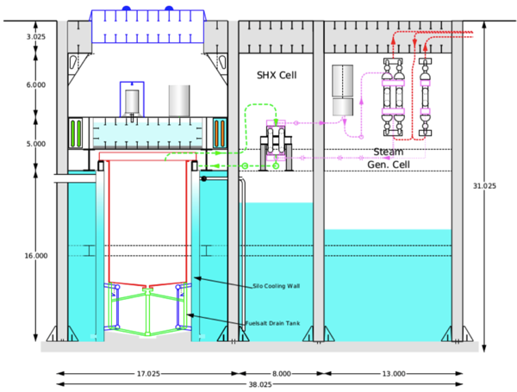
Figure 4: Silo Hall Cross-Section

Fuel Characteristics
The fuelsalt is NaF-BeF₂-ThF₄-UF₄ 76/12/9.5/2.5 where the uranium is 19.7% enriched. As fissile is consumed more fissile (either U-233 or Pu-239) is generated but not enough to replace the fuel burned. The reactor has no excess reactivity, no burnable poisons, no poison control rods. Makeup fuel must be added daily.
Fuel Handling System
Makeup fuel is added by applying gas pressure to the makeup fuelsalt tank which forces makeup fuel into the primary loop. The makeup fuel composition is NaF-BeF₂-UF₄ 76/12/12 where the uranium is 19.7% enriched. The makeup fuel addition rate is physically limited to ensure the adding reactivity rate stays within acceptable limits. Excess fuelsalt flows into a holding tank.
Reactivity Control
The primary reactivity control is temperature and fuelsalt flow rate. For slow reactivity control makeup fuelsalt (or makeup fertile salt with no fissile) additions allow modest daily increase or decrease of the reactivity.
Reactor Pressure Vessel
The ThorCon reactor is never under high pressure so that the typical term Reactor Pressure Vessel does not really apply. In the design the Can plus the Fuel Drain Tank fulfill the same function since all radioactive material (except tritium) should be contained within these structures. Since no high pressure is present that can act as a driving force to spread the content into the environment, the RPV does not have the central safety importance in an MSR that it does in a LWR.

Shipyard productivity, shipyard quality
If we are to overcome coal’s dominance of electricity production, we will need 100 one GWe ThorCons per year for the foreseeable future, and we need them soon. We need a system for producing nuclear power plants, not individual fortresses. Fortunately, such a system exists. It’s called a shipyard.
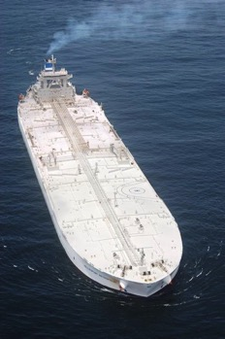
ThorCon’s genesis is in ship production. Figure 5 shows one of eight ships built by ThorCon’s predecessor company. This ship is the largest double hull tanker ever built. She can carry 440,000 tons of oil. Her steel weight is 67,000 tons. She required 700,000 man-hours of direct labor, a little more than 10 man-hours per ton of ship steel. About 40% of this was expended on hull steel, the rest on outfitting. She was built in less than 12 months and cost 89 million dollars in 2002.
Figure 5: The Hellespont Metropolis, 500,000 tons on the move, 89 million dollars

A good shipyard needs about 5 man-hours to cut, weld, coat, and erect a ton of hull steel. The yards achieve this remarkable productivity by block construction. Sub-assemblies are produced on a panel line, and combined into fully coated blocks with piping, wiring, heating, ventilating, and air conditioning and pre-installed. In the last step, the blocks, weighing as much as 600 tons, are dropped into place in an immense building dock.
ThorCon uses exactly the same production process. The essential difference between shipyards and most other assembly lines, such as aircraft manufacturing, is that shipyards build blocks on the assembly line, not the final product. The final product is put together elsewhere. Thinking in terms of blocks rather than final product is a key element in the ThorCon philosophy.

Block construction is not just about productivity. It’s about quality. Very tight dimensional control is automatically enforced. Extensive inspection and testing at the sub-assembly and block level is an essential part of the yard system. Inspection at the block level can be thorough and efficient. Defects are caught early and can be corrected far more easily than after erection. In most cases, they will have no impact on the overall project schedule.

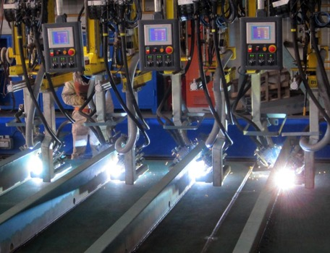
Figure 6: Shipyard productivity, 5 man-hours per ton of erected steel

ThorCon is designed to bring shipyard quality and productivity to nuclear power. But ThorCon’s structure is far simpler and much more repetitive than a ship’s. The ThorConLand version is in a below-grade silo hall made of concrete-filled, steel plate, sandwich walls. This results in a strong, air-tight, ductile building. A 1 GWe ThorCon building requires about 18,000 tons of steel for the nuclear island, all simple flat plate. A properly implemented panel line will be able to produce these blocks using less than 5 man-hours per ton of steel.
Similarly, all the other components will be manufactured on an assembly line and delivered to the ThorConLand site as fully outfitted and pre-tested blocks. Each power module will require a total of 31 blocks. Upon arrival at the site, the blocks will be dropped into place and the wall and roof blocks welded together using the automatic hull welding machines the yards have developed for this purpose. The wall cells will then be filled with concrete. Almost no form work is required.
To make the system work we must have big blocks — blocks that are far larger than can be transported by truck or rail. ThorCon blocks are up to 23 m wide and 40 m long. Such blocks can be barged well up most major rivers, including the St. Lawrence and into the Great Lakes.
Site erection work
On site structural work to install ThorConLand is limited to

- Excavation.
- Pour the basemat.
- Carefully position wall and silo bearing plate blocks on the basemat and pin the bearing plates to the basemat.
- Drop the basement beam blocks into place and weld to the bearing plates and each other.
- Drop the circular silo-cooling wall blocks into place,
- Pour refractory cement into the bottom of the silos.
- Drop the module grid block into place and weld to the basement columns and silo walls.
- Working from one end of the silo hall, lower the wall blocks into place and weld to the bearing plates, basement and grid beams and neighboring wall blocks.
- Drop the secondary heat exchanger, steam generator cell wall blocks into place and weld to the bearing plates and silo hall walls.
- Drop the roof blocks into place and weld the roof to the walls.
- Pour concrete into the walls and roof.

If it breaks, send it back
In the ThorCon system, no complex repairs are attempted on site. Everything in the nuclear island except the building itself is replaceable with little or no interruption in power output. Rather than attempt to build components that last 40 or more years in an extremely harsh environment with nil maintenance, ThorCon is designed to have all key parts regularly replaced.
Up to 50 ThorCon plants are supported by a Centralized Recycling Facility (CRF) and a separate Fuel Handling Facility (FHF). Normally, the Cans are changed out every four years. When the Cans need replacing, they are shipped to the CRF in a special purpose Canship. At the CRF, the Cans are disassembled, cleaned, inspected, and worn parts replaced. The problems of decontamination and waste disposal are shifted from the plant to this facility. Figure 7 depicts the overall system.
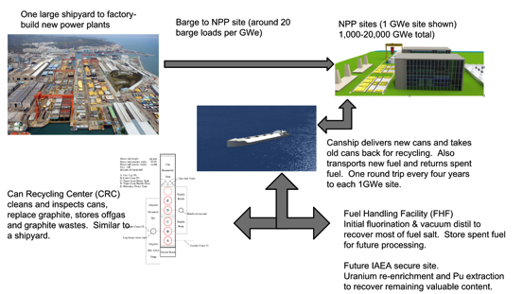
Figure 7: The Overall ThorCon System

After eight years of operation, the buildup of fission products will require us to change out the fuelsalt. The old fuelsalt will remain in its Can for four years. During this cool down period, the old fuelsalt is as well protected as the salt in the operating Can. There is no need for a separate, vulnerable spent-fuel cooling and storage system. By the time we pump the old fuelsalt to a shipping cask, its decay heat will be down to 80 kW, 0.25% of the original. The casks will then be transferred to the FHF in the Canship.
The fuelsalt going both ways will be unattractive weapons material. The uranium will be both fully denatured and, after the initial load, contain enough U-232 to further complicate a bombmaker’s life, while at the same time allow tracking of any diversion. The returning plutonium will be reactor grade. More importantly, it will be mixed with 50 times as much neutron absorbing thorium. To produce even a weak fizzle weapon, the plutonium must be separated from the thorium. A paper by twenty scientists from three US national laboratories reports this is even more difficult than separating plutonium from fission products. Section 4 explains how ThorCon’s fuelsalt will be far more proliferation resistant than MOX fuel.
This system of regular replacement of the most critical components means that major up- grades can be accomplished without significantly disrupting power generation. And since the returned Cans are disassembled and fully inspected, incipient problems will be caught before they can turn into casualties.
Such renewable plants can operate indefinitely; but, if a ThorCon is decommissioned, the process is little more than pulling out but not replacing all the replaceable parts.

Description of Safety Concept

Walkaway Safe
The ThorCon design combines a negative temperature coefficient with a large margin between the operating temperature of 700 ºC and the fuelsalt’s boiling temperature (1430 ºC). In any event that raises the temperature of the salt much above the operating level, the reactor will automatically shut itself down. If the high temperature persists, the fuse valve will thaw and drain the fuel from the primary loop to the drain tank, where the silo-cooling wall will passively remove the decay heat. There is no requirement for operator (or control system) intervention at any time since there are no valves to realign, pumps to activate, or any other actions to be taken. In fact there is nothing the operators can do to prevent the drain and cooling. The decay heat is transferred to an external pond which has sufficient water for 72 days cooling. After 72 days without any intervention the water in the pond will be running low. Adding more water is simple because the pond is accessible and at atmospheric pressure. If the pond cooling line is lost, there is enough water in the basement to handle the first 30 days of decay heat
Release Resistant
The ThorCon reactor is 15 m underground. ThorCon has three gas tight barriers between the fuelsalt and the atmosphere. Two of those barriers are more than 10 m underground. ThorCon reactor operates at near-ambient pressure. In the event of a primary loop rupture, there is no dispersal energy and no phase change and no vigorous chemical reactions (like zirconium and steam). The spilled fuel merely flows to the drain tank where it is passively cooled. Moreover, the most troublesome fission products, including iodine-131, strontium-90 and cesium-137, are chemically bound to the salt. They will end up in the drain tank as well. Even if all three barriers are somehow breached, almost all these salt seekers will not disperse.
No separate, spent fuel storage
ThorCon uses an eight-year fuelsalt processing cycle, after which the used salt is allowed to cool down in the non-operating Can for four years, eliminating the need for a separate, vulnerable spent fuel storage facility. The fuelsalt that is cooling is as well-protected as the fuelsalt that is currently being burned.
Four loop separation of steam and fuelsalt
ThorCon employs four loops in transferring heat from the reactor to the steam turbine. The solar salt loop captures tritium that has made it to the secondary loop, and more importantly ensures that a rupture in the steam generator creates no harmful chemicals and harmlessly vents to the Steam Generating Cell via an open standpipe.

Decay Heat Cooling
ThorCon has three nearly independent means for handling decay heat in the event of casualty, the Sentry Turbogenerator, the Silo-cooling Wall Pond, and Basement Water Cooling.
Sentry Turbogenerator
ThorCon has black start capability. Each ThorCon plant will be equipped with a 15 MW Sentry turbogenerator. This TG supplies power during the start-up sequence, drastically reducing the need for diesel generator capacity. During this process the Sentry TG obtains its steam from a 50 MWth auxiliary boiler. The Sentry TG is also the first line of defense in a station black out. After start up, the Sentry TG stays on line, running in parallel with the main turbine-generator. It takes its steam from the cold reheat line. During a plant black out, decay heat steam will keep the Sentry TG operating. Even if the plant consists of only one 250 MWe module, the decay heat at 8 hours is about 4 MW which will be more than enough to maintain enough circulation in the four loops while the auxiliary boiler is being brought on-line. The auxiliary boiler will then support the Sentry TG indefinitely to allow a warm restart. This process is aided by natural circulation in the primary, secondary and tertiary loops, each of which extracts heat at a height that is above that at which it receives heat.
Decay Heat Pond
The baseline ThorCon uses the silo-cooling wall and a cooling pond to reject the Can silo wall and offgas system heat during operation and to handle at least the first 72 days of decay heat in the event of a shutdown in which the secondary/tertiary/steam loop path is not available. The decay heat pond does not handle the heat rejected by the TG condensers during normal operation. The pond water volume is 4669 m³, comfortably above our 72 day spec with no makeup water and no recirculation. The pond uses platecoil condensers to transfer the cooling wall heat to the pond water. The condenser will see a peak requirement of about 6 MW three hours after a drain that occurred at full power.
Pond Towers
The normal full power heat load on a decay heat pond is about 1.9 MW. The corresponding once through make up water requirement is about 72 m³ per day. At most sites, it will make sense to conserve pond water with simple cooling towers. The cooling towers are located directly above the pond. The pond and cooling towers are simple flat plate steel structures built in blocks on the yard panel line like the rest of ThorCon. During normal operation, pond water is pumped to sprayers in the tower. The water passes over the large surface area of fill within the tower. Cooling air pulled in at the bottom of the tower rises by natural convection. After a full power plant black out, the tower will be operating solely by natural convection. Much of the water evaporated from the pond will condense on the fill and tower sides and drain back into the pond.
Running Dry
Although the pond size spec is 72 days without intervention, as long as the cooling wall loop is intact, ThorCon can probably handle an infinitely long full power shutdown with no intervention. Under the worst case assumption of no pond water recycling from the tower, the pond will run dry in about 72 days. At this point the decay heat will be down to less than 1 MW per Can. At this point the plate coils will be exposed to air and likely will dissipate this heat.
Basement Water Cooling
If both the secondary/tertiary/steam loop path and the cooling wall loop are lost, then the basement water comes into play. There is a little over 5100 m³ of water in the basement under the grid. This water alone is sufficient to handle well over 100 days decay heat. Valves between basement partitions are normally open and fail open, but even if a malicious or mistaken agent managed to close the valves when they should be open, each Can would still have 1900 m³ of basement water available, sufficient to handle 30 days of decay heat.
The expansion tank has a reserve of about 375 m³ of water. An undetected, unrepaired leak in the cooling water loop might eventually result in the waterline in the expansion tank falling. To protect against this the downcomer line is fitted with a stub into the pond; This stub is fitted with a check valve; when the water level in the expansion tank drops to the pond level, the check valve will open and all the water in the pond above the intake level of the stub is now available to the leaking cooling wall.
Between the basement water (even with the partition valves closed), the expansion tank, and the cooling pond draining, about 6000 m³ of water is available to the leaking silo. This represents well over 100 days of decay heat. If the partition valves are open as they should be, then over 9000 m³ of water are available. This gives the plant over 1.5 years to react by which time the decay heat will be down to about 150 kW.
The steam created by the decay heat has to go somewhere. If the rupture in the silo-cooling wall loop is high in the loop, then the steam will leave through this path. If the rupture is low in the loop or a malevolent agent has blanked off the loop, then pressure will build in the silo wall. To handle this, a vent line is fitted in the top of the silo wall. This line leads to the basement under the Steam Generating Wing. This line is fitted with a 4.5 bar pressure relief valve. If this valve lifts, the steam will vent to the other basement which serves as a quench tank. On over-pressure, the SGW basement in turn vents to the secondary heat exchanger cell. And the SHX cell in turn vents at 4.5 bar to the silo hall. The silo hall vents at 1 bar over-pressure to the atmosphere through a HEPA filtering system.
Design Safety Principles Summary
ThorCon control and safety is predicated on an important physical principle. The fissile materials are uniformly dissolved in molten salt. Neutron moderation by the graphite planks in the Pot allow the fissile materials to reach criticality and fission, releasing heat. The heating effects on the fissile materials, the fuel salt, the moderator, and the Can structures reduce Keff, the ratio of new neutrons available for fission to those absorbed by fission. This negative feedback keeps the reactor power level stable and prevents any thermal runaways that might be occasioned by a variety of externally-induced failures. This behavior has been modeled with extensive computer simulations, with three independently created, authoritative modeling software systems: SCALE, MCNP, and Serpent.
The ThorCon’s fuse valve will melt if the Can overheats for an unanticipated reason. This will drain the fuelsalt into the drain tank, which has a geometry that prevents neutron moderation and makes criticality impossible. Criticality is not possible, even if the silo is flooded with moderating water. It is also possible for an operator to command the fuse valve to be melted using electric heating, bringing the reactor to cold stop.
ThorCon has three control rods, but these are not used in normal operations, nor for response to casualties such as loss of heat sink. They are not safety critical. They can be used during cold startup and for achieving cold shutdown. The control rods provide a mechanical backup facility to shut down the reaction.
ThorCon has physical guards against rapid increases in reactivity that might be initiated by a malevolent or mistaken agent to overpower the reactor. The control rods can be rapidly inserted by gravity, stopping a reaction, but can only be withdrawn by a weak, slow, geared motor, so that reactivity increases slowly. Liquid makeup fuel addition rates are limited by small orifices, so reactivity can not increase faster than thermal response lowers Keff or the fuse valve melts.
If, somehow, these protections fail and the reactor experiences a rapid, uncontrolled thermal runaway, the severe overheat conceivably might rupture the primary loop. The fuelsalt would spill into the containing Can and drain by gravity into the drain tank. Fission stops as the fuelsalt moves away from the graphite moderator planks and into the unmoderated drain tank. Three barriers remain between the radioactive fuelsalt and the environment. The power plant is not harmed, but the Can must be removed and sent to the Centralized Recycling Facility for repair. A new Can will be required to return the power module to operation. Other modules can continue to operate.
In a loss of load such as caused by a transmission line failure, the steam normally turning the turbine-generator can bypass it to the cooling water heat exchanger. This allows the reactor to continue to operate normally, while operators determine a course of action. If this fails, or if the solar salt loop or secondary salt loop fails, the primary loop sees a loss of heat sink and the fuelsalt temperature will increase rapidly. As it heats, reactivity decreases, criticality ceases, and the always-on cooling wall and cooling pond removes the decay heat safely.
The most environmentally troublesome radioactive fission products, including Sr-90 and Cs-137, are chemically bound to the fuel salt. In the event of some external catastrophe that destroys the underground power plant, the radioactive materials are in hot liquid form that will cool to solid form.

Proliferation resistance
ThorCon fuel is always denatured. Denatured just means that the uranium will have to undergo a lot of enrichment before it becomes usable in a weapon. To be legally denatured, 6 times the U-233 fraction plus 4 times the U-235 fraction must be less than the U-238 fraction. The ThorCon baseline fuel starts out just denatured, but becomes progressively more over-denatured thereafter.
The U-232 concentration is not impressive. It rises slowly to about 22 ppm at year 8. This will certainly complicate a bomb maker’s life and make any transgressions easily trackable. Given the choice, a bombmaker would much rather have U-232 free material, even if it were at a lower enrichment. But ThorCon’s main anti-proliferation argument is that we are always perfectly compliant with the requirements for use of non-weapon-grade material. The U-232 just makes us super-compliant.
The other issue is plutonium. One problem with starting out with fresh salt every 8 years is ThorCon will produce weapons grade plutonium at the beginning of each such period. This is true of any reactor which burns low enriched uranium.
This was demonstrated by the Iranians in October 2012 when they shut down the Bushehr reactor after only 60 days operation, and pulled the fuel elements. The removal period was said to be Oct 22 to 29. [Solomon, S. and Barnes, J. Wall Street Journal, 2012-12-02] WSJ received estimates of 10 to 100 kg of weapons grade plutonium in these fuel elements. After a long silence, the shutdown was blamed on “stray bolts” that had fallen to the bottom of the reactor vessel. The dropped bolts story was later denied by the Russians who said the shutdown was for “safety testing”. Others claimed it had to do with the handover from the Russians to the Iranians. The US and others protested, but did nothing. The assumption presumably was that the Iranians do not have the capability of separating out the plutonium. But we can be confident they have a supply of weapons grade Pu waiting for the day they do. In mid-2013, the Bushehr reactor resumed operation.
At 60 days into the fuel cycle, a ThorCon module will have produced 7 kg of 95% pure 239Pu. Shortly thereafter the material is no longer weapons grade. This plutonium will be dissolved in 50 tons of highly radioactive salt. If he could remove the plutonium, a bombmaker would have to let that salt cool for a multi-year period before he could handle it.
At first glance it would seem easier to remove the fuel from a liquid fuel reactor than a solid fuel LWR. But ThorCon is designed to make the removal of fuel from a module a difficult task requiring at a minimum an extended shut down of the module, and several multi-100 ton lifts; such an attempt would be revealed by even the most rudimentary surveillance system.
Thus it is virtually impossible to remove this material from ThorCon without detection. And if the material were removed, the plutonium would have to be separated from (a) the uranium, (b) the salt, and (c) the fission products. (a) and (b) are difficult but doable for a country committed to getting a bomb. (c) will require a Purex-like facility, an immense and extremely difficult undertaking. For practical purposes, there are no substantial differences between ThorCon and a LWR in these regards, but ThorCon has additional protections.
Reactor Grade Plutonium Spiking
Although a ThorCon Can fueled with fresh fuel does generate relatively pure, weapons-usable Pu-239 during the first 60 days of operation (as do LWRs), recycled fuel salt is too contaminated with Pu-238 and Pu-240 to be weapons-usable. After 8 years of use and 4 years of decay cooling, used fuel salt is shipped back to a Fuel Processing Center where fission products are separated from valuable uranium and reactor-grade plutonium fissile material. Adding reactor-grade plutonium to future fuelsalt loadings will assure that future fuel loads never generate any weapons-usable plutonium. This will be accomplished without separating plutonium from thorium.
Thorium Dilution
Separating plutonium from thorium is difficult. Thorium is always mixed with plutonium in the ThorCon fuel cycle, in a ratio of at least 50:1 and over 1000:1 at the critical beginning part of the cycle. Bathke’s analysis reports that a thorium/plutonium ratio of 2:1 makes plutonium unattractive for bomb material, and a ratio of 9:1 has an attractiveness rating of zero.
[Bathke, C. et al, The Attractiveness of Materials in Advanced Nuclear Fuel Cycles for Various Proliferation and theft Scenarios, Proceedings of Global 2009, Page 9543, September,2009.]

Safety and Security (physical protection)
The entire structure of the nuclear island of ThorConLand is below ground, as shown in Figure 8. All radioactive materials are below the 50 mm thick silo hall deck which is 12 m below grade. They are isolated by a 3 m roof, a 3 m neutron barrier radtank, and 270 mm of lead shielding.
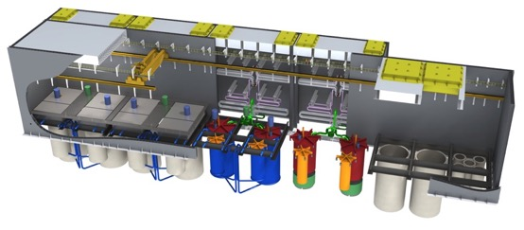
Figure 8: ThorConLand Nuclear Island below grade

ThorCon is designed so that essentially everything can be manufactured on a shipyard-like assembly line. To make this work, the entire plant is built in blocks, weighing up to 500 tons. The silo hall, the SHX cell and the Steam Generating Cell use concrete-filled, steel plate, sandwich walls as shown in Figure 9. The wall cells are dual 25 mm thick steel plates with 1 m of concrete between plates in the sandwich. Each wall block consists of 12 to 20 cells.
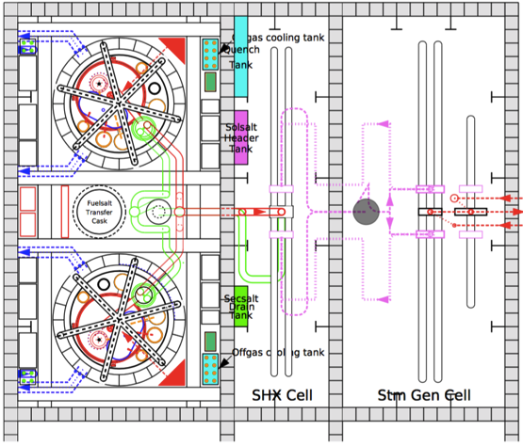
Figure 9: Plan View of Power Module

Aircraft strike
The double roof is an extremely strong structure that will resist aircraft penetration. The hatch deck and the ceiling plating are 25 mm thick. The stiffeners on both sides are on 1 meter centers, supported by web frames about every 5 m. Preliminary calculations indicate that the deflection associated with a perpendicular 777 aircraft engine impact will be of the order of 0.1 m. Additional resistance is provided by 3 m of concrete in the space between the hatch deck and the ceiling. The concrete alone should be able to handle this impact.
Penetrating the roof still leaves the penetrator 6 m away from the silo hall deck. The silo hall deck is 50 mm steel plate, under which is the 3 m deep radtank, mostly filled with water, under which is a 270 mm thick layer of lead, and then another 50 mm plate. The radtank stiffeners and web frames are nearly as strong as the roof.
Even if pieces of the penetrator were somehow able to get through the radtank, they would still have to breach the 50 mm thick Can lid, before there is any chance of a release of radioactive materials. Any release would be limited to the 0.06 gram inventory of noble gas, most importantly Xe-137, which will decay to Cs-137 with a half-life of 3.8 minutes. In comparison, Fukushima released 4 kg of Cs-137, 67,000 times as much all above ground.

Description of turbine-generator systems
The ThorCon steam loop is a standard, first generation, single reheat, super-critical steam cycle, essentially the same as that currently used by coal power plants with the boiler replaced by a pollution free, steam generator. This table shows the main parameters for a ThorCon power plant design with two power modules providing steam for a single turbine-generator generating 500 MWe.
Steam throttle pressure | 24.8 | MPa
Steam throttle temperature | 538 | ºC
Steam flow before HP valves | 450 | kg/s
Feedwater pressure | 26 | MPa
Top Feedwater temperature | 288 | ºC
Reheat pressure | 3.84 | MPa
Reheat temperature | 538 | ºC
Condenser pressure | 5000 | Pa
Gross cycle efficiency | 47.8 | %
Net cycle efficiency | 44.4 | %

The turbine generator and auxiliaries required to implement this power conversion loop are not only existing technology but nearly off the shelf. Thanks to the solar salt loop, no special high pressure feedwater preheater is required. The turbine is fitted with 100% cascade by-pass. A loss of load need not trip the reactor.
ThorCon plants have a black start capability. They are equipped with a 50 MWth oil or gas fired auxiliary boiler and a 15 MWe Sentry turbine. The auxiliary boiler provides steam to heat up and roll the main turbine during a cold start. This boiler also provides steam for the Sentry turbogenerator whose power in turn is used to heat up the first power module to be brought on line. The boiler allows us to use steam turbine driven main feed pumps improving cycle efficiency and drastically reducing the requirement for diesel generator power during start up. It can also keep the plant warm during extended shutdown, allowing a quick restart.
The Sentry TG is the first line of defense in a station black out. After start up, the Sentry TG stays on line, running in parallel with the main turbogenerators. It takes its steam from the cold reheat line, which is at 55 bar steam at 425 °C. During a plant black out, decay heat steam is fed to the standby generator to maintain power while the auxiliary boiler is being ramped up. Even if the plant consists of only one 250 MWe module, the decay heat at 8 hours is about 4 MW which will be more than enough to maintain enough circulation in the four loops while the auxiliary boiler is being brought on-line. The auxiliary boiler will then support the sentry TG indefinitely to allow a warm restart. This capability will avoid a drain in many casualties.
Each ThorCon plant will be equipped with two 1 MW diesel generators These generators supply initial power during the very beginning of a cold start. They can also be used to keep the lights on during a long, cold, off the grid shutdown. They serve no safety function.

Electrical and I&C systems
ThorCon does not depend on an outside source of electric power. It is designed with the ability to provide power to regions where there is no other source of electricity. ThorCon can be the anchor providing stable, reliable electric power to a developing grid. Consequently ThorCon has black start capability. Two 1 MWe diesel generators provide initial power. A petroleum-fueled boiler provides steam for a 15 MWe Sentry turbine-generator, which is used to roll the main turbine-generator and heat up heat transfer loops and the fuelsalt.
ThorCon is designed to have no safety-critical instrumentation and control systems. Safety features are implemented by physical principles and materials properties, not multiple redundant electrical/electronic systems and valves.
Besides a control room within the ThorCon power plant, each power plant site will have one external control room to supervise all power plants on that site. We anticipate that a continuous stream of operational data will also be transmitted to a central management site, to be overseen by ThorCon nuclear engineers. This monitoring will enable forewarning of developing issues requiring maintenance attention, and also contribute to improving designs of future power plants. A similar information stream, with video observation capabilities, will be available for IAEA monitoring.
ThorCon is a load-following power plant. Changes in power settings will not be responsibility of skilled operators, but will be controlled by an automated system, which controls the speeds of the motors operating the pumps for the primary fuelsalt loop, secondary clean salt loop, tertiary solar salt loop, feedwater, and cooling water. There are no valves involved in normal operations, except loss of load may trigger a 100% steam bypass, not safety critical.

Spent Fuel and Waste management
One Cubic Meter of High Level Waste every 1 GW-year
The nuclear waste problem is largely a political construct. The volumes are tiny. The “waste” can be very valuable. And after a few hundred years, it is fairly easily handled since almost all the penetrating gamma radiation will be gone. The remaining radiotoxicity is almost all from alpha emitters which must be ingested or inhaled in order to do harm. Since almost all these are in ceramic form, e.g. plutonium oxide, this would require eating rocks. The amounts are so small that, if the USA went all nuclear using light water reactors and recovered none of its high level waste, the country would have to allocate 200 acres of desert every 20 years for dry cask storage.
For ThorCon the situation is even better. Every 8 years, a 1 GW ThorCon will return 220 tons of used fuelsalt to the Fuelsalt Handling Facility, 25 tons per GW-y. The first step will be to separate the uranium from the fuel salt via fluoride volatility, the same process that was used in the enrichment step. That will remove about 2 tons of 9% LEU from the waste stream. This uranium can be used as is as part of the initial fuel charge for other ThorCons or better yet re-enriched. Either way it will be returned to the plants. In the re-enrichment case, we will have about 1000 kg (52 liters) of depleted uranium to store until any residual U-232 has decayed to background levels.
The next step will be vacuum distillation to recover the salt. This will remove over 80% of the volume. The recovered salt will be returned to the plants. We will be left with about 7 tons of ash. This ash will be mostly ThF₄ but will contain 103 kg of transuranics and 789 kg of fission products. The volume of this ash will be about 1.1 m³. This leads to the approximate ThorCon Rule of Thumb: 1 m³ of HLW for every 1 GW-y of power.
This 1.1 m³ will be stored in dry casks until a combination of the reduction in gamma radiation and technological progress makes it economic to separate out the transuranics. The transuranics can be fed back to the plants where the fissile isotopes will be burned.
The remaining fission products can be simply stored in dry casks for 500 years at which point they will have decayed to near background levels. In terms of volume a coal plant produces over 100,000 times more solid waste per kWh than ThorCon.

Plant layout
There are two variants or packages of ThorCon:

ThorConLand: A landside version in which 150 to 500 ton blocks are manufactured shipyard style, barged to the site, and erected.

ThorConIsle: An offshore version in which an entire 500 MW plant is encapsulated in a hull, entirely built in a shipyard, towed to a nearshore or offshore site with a water depth of 0 to 10 m, ballasted down to the seabed, and if necessary surrounded by a breakwater.

Both packages use exactly the same nuclear island and steam cycle. The only difference is in the packaging.

ThorConLand
The entire nuclear portion of the plant is underground as shown in Figure 8. This drawing shows a 1 GWe ThorCon. The decay heat cooling towers are on the left. The underground nuclear island is center left. The yellow rectangles are hatches. These hatches are served by gantry cranes. The turbogenerator halls are center right, and the switchyard is on the right. The main cooling towers if required are to the right of the switchyard.

The cranes allow periodic replacement of all critical components including the reactors and fuelsalt. The reactors and fuelsalt are transported by a special purpose ship shown in the background.

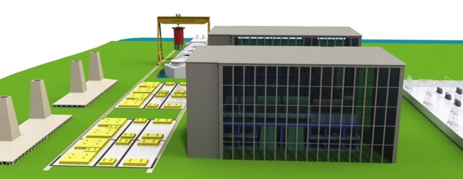
Figure 8: Birdseye view of 1 GWe ThorConLand

ThorConIsle
Each ThorConIsle plant is based on one or more hulls, each containing two modules, a 500 MW super-critical turbogenerator, room for gas insulated switchgear (GIS), a decay heat pond, and room for auxiliaries. Figures 9 and 10 indicate the overall layout of a ThorCon hull.

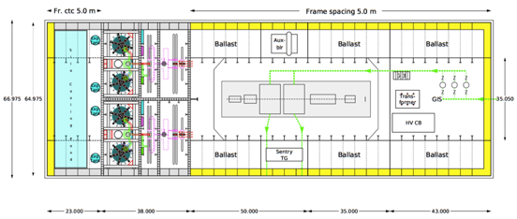
Figure 9: Plan View of ThorConIsle Hull

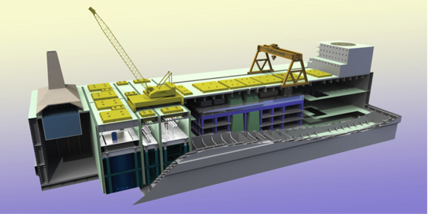
Figure 10: Cutaway View of a ThorConIsle Hull

The nuclear island is at the forward end of the hull. It is made up of two 250MWe ThorCon power modules. These are exactly the same as the landside power modules including the silo-cooling wall loops and cooling pond.
Aft of the nuclear island is the turbine hall, which contains the turbogenerator, exciter, condensers, feedheaters, pumps, and condensate treatment. The auxiliary boiler and sentry turbine are also located in the turbine hall. These components are used during start up — ThorCon has the capability of a black start — and the sentry turbine plays an important role in certain casualties.
The switchgear hall is at the aft end. It contains space for the Gas Insulated Switchgear, which steps up the 25 kV generator voltage to 345 kV or higher. The superstructure above the switch gear hall contains support systems, the control room, and accommodations. Blackstart diesel generators are located on either side of the superstructure.
Advantages:
- No land acquisition costs, no excavation.
- Easy access to once through cooling. Easy, and effectively unlimited expansion.
- Essentially all the erection work is shifted to the yard. Higher productivity, better quality control, more complete testing before transport. The overall construction schedule will be shortened and less susceptible to delays.
- A plant 10 miles offshore will have zero residential population within most countries’ Emergency Planning Zone. Nimby (not in my backyard) opposition and evacuation issues will be greatly eased. This could be crucial, making a nuclear plant politically palatable where otherwise it would not be.
- A hull can be refloated if necessary and towed to shipyard for repairs. It can be decommissioned by refloating.

Disadvantages:
- ThorConIsle requires much more steel than ThorConLand. The hull envelope results in an extra steel weight of about 25,000 tons per 500 MW Isle, or about 50,000 tons more per GWe than the landside plant. But steel is cheap in a shipyard. The extra 50,000 tons, fully erected and coated, will cost the yard a good deal less than 50 million dollars.
- Unless we are quite close to shore, we will have the logistical problems of operating offshore.
- Unless the site is very close to shore, we will have the cost of transmitting power underwater to shore.
- We will have the cost of dredging and providing breakwaters. This will be very site dependent. And it will be partly balanced by avoiding on-shore land purchase cost and excavation.

For a site less than 20 km offshore, the marginal cost of ThorConIsle over ThorConLand will be between 0.2 to 0.5 cents/kWh.

Plant Performance
Availability
ThorCon power generation availability is planned to exceed 95%. This is possible because fuel is changed by pumping liquids and because the reactor Cans are duplexed. After an initial 4 year period the fuelsalt is transferred to the duplex Can within the power module and the fresh Can is put into operation. After 4 more years of decay of fission products the first Can is exchanged with a third Can and fresh fuelsalt provided via the Canship. The second can with 8-year-old used fuelsalt remains in its silo for 4 more years as fission products decay, then it is pumped to a transfer cask to be sent to the Fuelsalt Handling Facility.
Low Costs
The manufacturing costs for building a 500 GWe ThorConLand power plant are expected to be $1.2/watt, leading to a generation cost of $0.024/kWh. These estimates result from a bottom-up buildup of component cost estimates. A ThorCon design objective is energy cheaper than coal.
The fuel costs are low because uranium and thorium costs are low, because fuel burnup is low compared to current LWR technology, and because expensive fabrication costs of solid fuel are sidestepped by using fueling with uranium fluorides dissolved in molten salt. Although the baseline fissile material to fuel ThorCon is low-enriched uranium, plutonium can also be consumed in an unmodified ThorCon.
The capital costs are low for several reasons:
- The ThorCon molten salt reactor operates at 700 °C, enabling the use of supercritical steam turbine-generators that are standard for modern coal plants. This means higher thermal/electric conversion efficiencies, less fuel consumption, and less cooling water for heat rejection. Such TGs are competitively priced.
- The block manufacturing approach is designed to be compatible with the existing capacities, facilities, experience, technologies, and skills of existing, competitive shipyards. ThorCon’s designers are experienced in specifying, tendering, selecting, and managing construction of supertankers, leading to low costs and high quality. Because nearly all the construction work is completed in a high-quality shipyard, the skilled labor required at the plant site is limited.
- ThorCon’s design uses few exotic materials. Stainless steel suffices for most salt handling. Use of TZM and Hastelloy alloys is limited. Commercially unavailable lithium-7 is not required. Nuclear-grade graphite is a specialty material.
- Containment of radioactive materials is accomplished with multiple barriers that must withstand only garden-hose pressures, so no expensive, reinforced concrete confinement dome is necessary.
- No multiple, redundant, engineered safety-grade control systems are required because ThorCon relies on physical principles and material properties to prevent overheating and releasing radioactive materials in casualties. Electronic systems are important for operational control, but not critical for safety.
- Processing of fuelsalt to remove radiation products is largely conducted at a central site, keeping plant costs down. At a ThorCon plant fission product noble gasses Xe and Kr are captured in tanks; noble and semi-noble metal fission products plate out on the heat exchanger surface, while other fission products remain in the fuel salt for eventual processing at a centralized Fuelsalt Handling Facility.

Development status of technologies
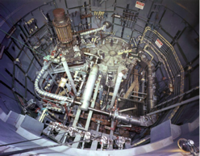
Rule 1: No New Technology. Rule 2: see Rule 1
Figure 11: Oak Ridge National Laboratory Molten Salt Reactor Experiment (MSRE)
ThorCon is about NOW. ThorCon requires no new technology. ThorCon is a straightforward scale-up of the Molten Salt Reactor Experiment (MSRE), which ran successfully for four years at the Oak Ridge National Laboratory. The MSRE is ThorCon’s pilot plant. There is no technical reason why a full-scale 250 MWe prototype cannot be operating within four years. The intention is to subject this prototype to all the failures and problems that the designers claim the plant can handle. This is the commercial aircraft model, not the US Nuclear Regulatory Commission model. As soon as the prototype passes these tests, commercial production can begin. By using only existing technology, we intend to be in full scale commercial production in year 7.
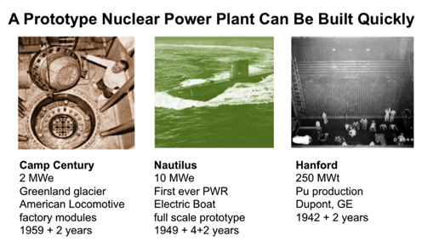
Figure 13: Prototype Power Plant Construction Times

Some will scoff. The conventional wisdom is that there is something fundamentally different about nuclear that mandates multi-decade long project times. Here are three counter examples, projects which faced far more difficult problems than ThorCon does.
Wigner and Hanford
In April, 1942, Eugene Wigner arrived in Chicago and set out to make a reactor to produce plutonium for what turned out to be the second atom bomb. At the time, no one had even demonstrated that a chain reaction was possible. Little was known about nuclear cross sections or just about anything else. Wigner went straight to 500MWt when no zero MWt plant existed. In five months, his five man team using adding machines and slide rules completed the design. In February 1943, Wigner convinced the Army to use his design In October, 1944, the plant located at Hanford, WA, started producing plutonium. In 2.5 years, Wigner went from literally zero to 500 MWt. Wigner was furious that it took this long, blaming “too much money”.
Rickover and the Nautilus
The Nautilus chronology is more well known. The decision to go pressurized water was not made until March, 1950. Shortly thereafter Rickover, against the advice of all, decided to go straight to a full scale prototype. At the time no such thing as a PWR existed at any scale. Rickover wasn’t scaling up. He was going from nothing to full scale.
Camp Century
An instructive exception to Rickover’s control of American nuclear effort was the Army’s successful small reactor program in the very late 1950’s. Camp Century was one of those plants. Camp Century was located at 77N in one of the most inhospitable places on the planet, 6000 feet above sea level on the Greenland Plateau, 800 miles from the North Pole. In January, 1959, the Army signed a 4.5 million dollar contract with the American Locomotive Company (ALC) for 10 MWt nuclear plant, dubbed PM-2A. ALC designed, built, and tested the plant in 16 months. The plant comprised 27 blocks. In mid-summer of 1960, the blocks were shipped to Thule, sledded 150 miles north, and erected in 78 days. In the summer of 1964, Camp Century was shut down. The PM-2A was disassembled and returned to the USA. Points to ponder: Non-standard nuclear manufacturer. Plant built entirely on assembly line. Transported by ship in blocks to site. Erection time measured in weeks. Disassembled by reversing the process.
When you consider what these three projects accomplished, the ThorCon schedule not only becomes feasible, but appears downright dilatory. Eugene Wigner, for one, would not be impressed.

Deployment status and planned schedule
Development Milestones
2011 | Conceptual design development
2016 | Pre-feasibility study in Indonesia
2018 | Pre-fission testing starts
2020 | Fission testing starts
2022 | Commercial operation starts

ThorCon has been presented to Bapeten, the Indonesian nuclear regulator, and discussions continue.

References
Succinct description of philosophy and design: http://thorconpower.com/docs/domsr.pdf
Complete ThorCon website: http://thorconpower.com
Designers’ essays on molten salt reactor aspects: http://thorconpower.com/library/documents
ORNL MSR background http://www.energyfromthorium.com/pdf/

Appendix: Summarized Technical Data (MSR module)
General plant data
Reactor thermal output | 557 | MWth
Power plant output, gross | 250 | MWe
Power plant output, net | 247 | MWe
Power plant efficiency, net | 44.4 | %
Mode of operation | load following
Plant design life | 80 | Years
Plant availability target | 95 | %
Seismic design, SSE | 0.8 | g
Primary Coolant material | BeF2, NaF
Secondary Coolant material | BeF2, NaF
Moderator material | graphite
Thermodynamic Cycle | Rankine
Type of Cycle | Indirect
Non-electric application | Focus on electricity
Safety goals
Core damage frequency (primary loop rupture) | 1e-4 | /reactor-year
Large early release frequency | 1e-6 | /RY
Occupational radiation exposure | 0.050 max | Sv/Person/Y
Operator Action Time | 1728=72x24 | hours
Nuclear steam supply system
Steam flow rate at nominal conditions | 238 | kg/s
Steam pressure/temperature | 15.7/538 | MPa(a)/℃
Feedwater flow rate at nominal conditions | 238 | kg/s
Feedwater temperature | 32 | ℃
Reactor coolant system
Primary coolant flow rate | 2934 | kg/s
Reactor operating pressure | 0.552 | MPa(a)
Core coolant inlet temperature | 564 | ℃
Core coolant outlet temperature | 704 | ℃
Mean temperature rise across core | 140 | ℃
Reactor core
Active core height | 3.78 | m
Equivalent core diameter | 3.43 | m
Average linear heat rate | 147,000 | kW/m
Average fuel power density |  | kW/kgU
Average core power density | 13.8 | MW/m³
Fuel material | UF₃, UF₄
Cladding tube material | none
Outer diameter of fuel rods | n/a | mm
Rod array of a fuel assembly | n/a
Number of fuel assemblies | n/a
Enrichment of reload fuel at equilibrium core | 19.7 | Wt%
Fuel cycle length | 96 | months
Average discharge burnup of fuel | 256 | MWd/kg
Burnable absorber (strategy/material) | none
Control rod absorber material | gadolinium
Soluble neutron absorber | ThF₄
Reactor pressure vessel
Inner diameter of cylindrical shell | 4861 | mm
Wall thickness of cylindrical shell | 50 | mm
Total height, inside | 5717 | mm
Base material | SS316
Design pressure/temperature | 0.552/704 | MPa(a)/℃
Transport weight (of containing Can) | 400 | t
Steam generator (if applicable)
Type
Number
Total tube outside surface area |  | m²
Number of heat exchanger tubes
Tube outside diameter |  | mm
Tube material
Transport weight |  | t
Reactor coolant pump (if applicable)
Type | Centrifugal
Number | 1
Head at rated conditions |  | m
Flow at rated conditions |  | m³/s
Pump speed |  | rpm
Pressurizer (if applicable)
Total volume | n/a | m³
Steam volume: full power/zero power | n/a | m³
Heating power of heater rods | n/a | kW
Primary containment
Type | SS316 Can
Overall form (spherical/cylindrical) | cylindrical
Dimensions (diameter/height) |  | m
Design pressure/temperature |  | kPa(a)/℃
Design leakage rate |  | Vol%/day
Is secondary containment provided? | 2nd = silo; 3rd = hall
Residual heat removal systems
Active/passive systems | 1 active, 2 passive
Safety injection systems
Active/passive systems | none
Turbine (for two module power plant)
Type of turbines | Supercritical
Number of turbine sections per unit (e.g. HP/MP/LP) | 1x HP  1x double flow IP  2x double flow LP
Turbine speed | 3000 | rpm
HP turbine inlet pressure/temperature | 25.5/538 | MPa(a)/℃
Generator (for two module power plant)
Type
Rated power | 776 | MVA
Active power | 640 | MW
Voltage | 21 | kV
Frequency | 50 | Hz
Total generator mass including exciter | 391 | t
Condenser
Type | Surface single pass
Condenser pressure | 200 | kPa(a)
Feedwater pumps
Type
Number | 1 per module
Head at rated conditions |  | m
Flow at rated conditions | 15 | m³/s
Pump speed |  | rpm

