M2COMM Launches All-New ELSA at EuroShop 2017
ELSA Gets Cloud Capability

[Düsseldorf, Germany, March 5st 2017] M2COMM will launch a series of new ELSA (Electronic Labelling System Application) products at EuroShop 2017. ELSA is the world's most compact electronic shelf labelling (ESL) solution, its new product line features upgraded hardware, improved functionality and a new range of ESL tags. The company will be exhibiting and demonstrating ELSA at EuroShop 2017 in Düsseldorf, Germany (Booth #2A11 - Hall 2).
Launched in 2014, ELSA is based on M2COMM’s proprietary, cellular-inspired communication protocol. With its superior performance in data transmission and ultra-low power consumption, this latest release of ELSA has more advanced system integration, robustness and multi-store management capabilities.
The integrated ELSA Access Point (iAP) at only 100 x 68 x 25mm, is the smallest ESL base station in the world. With coverage of up to 30,000 square meters, the iAP’s all-in-one solution handles data transactions with the ELSA iRT (Router) without the need for additional hardware, a built-in SD card slot for data back-ups, integrated battery backup (iAP and iRT); and for fast and easy deployment, the iAP supports magnetic attachment to suitable surfaces. Both the iAP and iRT can coexist within a Wi-Fi environment. But a smart label solution is not just about displaying/changing prices or promos on demand; the new ELSA Cloud now provides customers with a simple way to manage and monitor ESLs across different locales remotely.

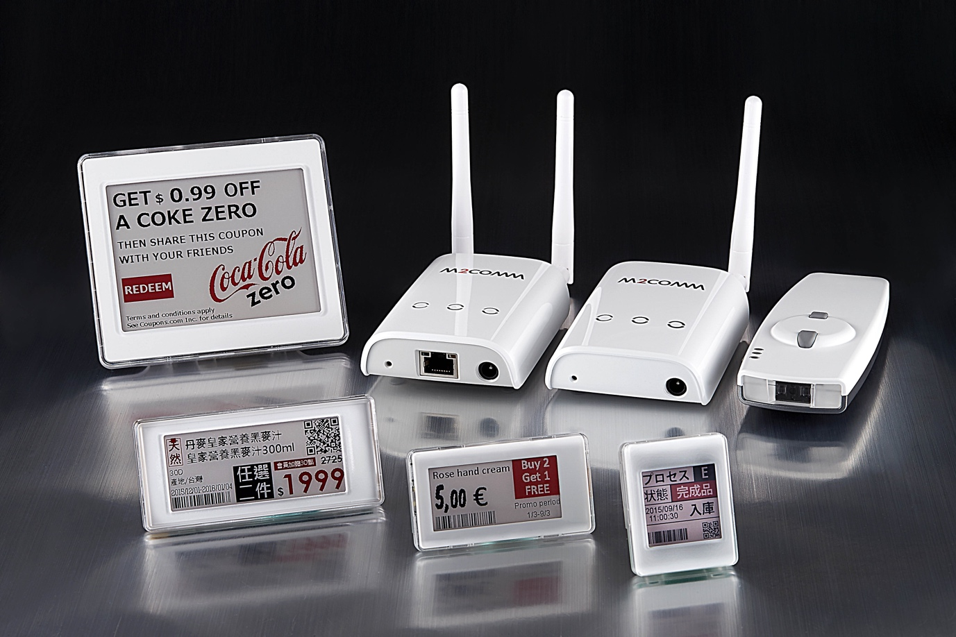
M2COMM’s new Elsa is the world's most compact ESL solution with advanced system integration, robustness and multi-store management capabilities.
M2COMM is also pleased to announce the introduction of its new sleek ‘Courbure’ range of ESL tags. In the past, ESL has been widely adopted in general retail markets, logistical businesses and inventory management whose focus was on performance, stability and ultra-low power consumption. With its curvaceous and elegant style, the new ‘Courbure’ tags bring a level of sophisticated design that should appeal to even more markets, such as fashion retail trade.
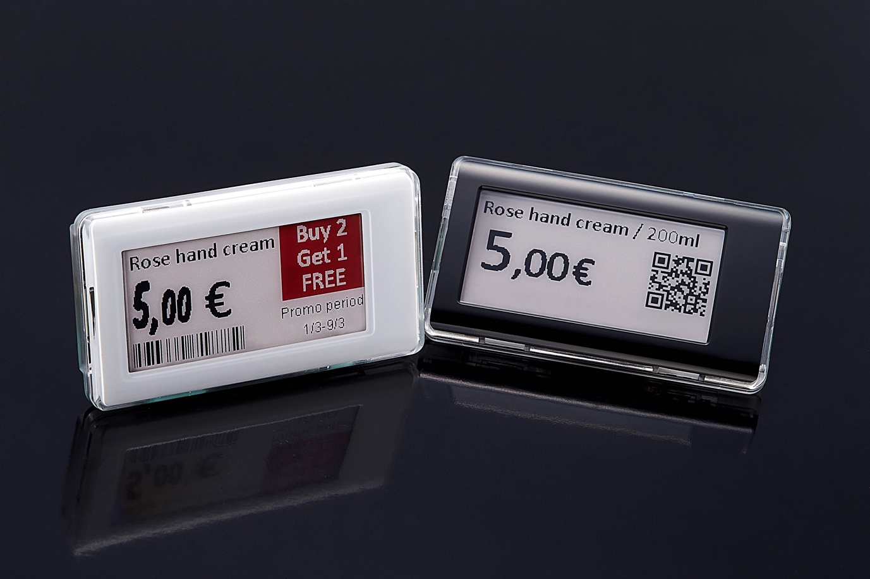
M2COMM introduces new sleek ‘Courbure’ range of ESL tags to attract fashion retail trade.
“The elegant and simple design of M2COMM’s ELSA system is what first attracted our attention; and we have been immensely satisfied with the products quality and reliable service,” says Piper Chiu, President of Simple Mart. “M2COMM excels at doing good things ‘better’, we will continue our close partnership with M2COMM and adopt more ELSA ESLs into our stores.”
“The new ELSA is a big move in ESL evolution, not only the sleek curved label design and the hardware renovation, it also presents a solution for connected stores,” said Derrick Wei, CEO of M2COMM. “ELSA has a solid technology to support remote, accurate and fast ESL operation. With our new products and ELSA cloud, we have confidence to greatly elevate operational efficiency in retail and will expand the ESL application to more industries.”
Availability
New ELSA products and ELSA cloud will be ready and available in Q2 2017. M2COMM will be demonstrating ELSA at booth #2A11 (Hall 2) in EuroShop 2017 in Düsseldorf, Germany from March 5th - 9th.
About M2COMM
M2Communcation Inc. (M2COMM) is a pioneering Internet-of-Things (IoT) communication system and chipset solutions provider. Founded in 2012 by a group of like-minded individuals with years of experience in wireless communication, M2COMM creates innovative products and solutions for ultra-low-power wireless networking, such as Electronic Shelf Labels. Our mission, to focus on providing the best fitting solutions for IoT applications through continued technological advancement resulting in a refreshing user experience.
For more information about M2COMM, please visit http://www.m2comm.co/.
Contact:
M2COMM
Evelyn Chen – PR & Marketing
E-mail: info@m2comm.co
Telephone: +886-3-657-8939

