My Plates to auction 23 seven-letter Texas sequential license plate messages.

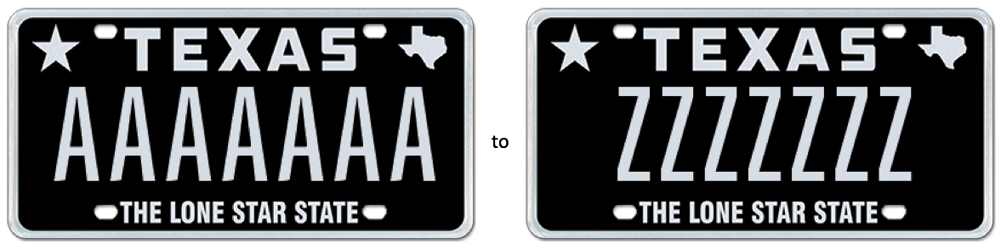

9 March, 2017 (Austin, TX) – The My Plates Alphabet Auction is underway offering 23 unique 7-letter sequential license plate messages from AAAAAAA to ZZZZZZZ. These truly one-of-a-kind 7-letter repeater messages are sure to get noticed on the streets of Texas and are available on over 30 different plate designs, from Classic Black, to Lone Star colors like Pink, Green and Purple or choose Texas-themed designs from Oil and Gas, Texas Tough or Dallas Cowboys, to name a few.

In Texas, the maximum letters or numbers that can appear on an official state plate is seven. My Plates is offering via this auction the most A’s, B’s & C’s all the way to Z’s you can fit on your official Texas license plate. This is the very first time these unique plate messages have ever been offered in Texas.

Unlike other everyday Texas license plate messages, plate messages sold at auction by My Plates are legally transferable. Meaning the plate owner has the right to sell the plate message to another person (with the same ongoing rights), or gift it to a family member or friend. Transferability also means these plates could make great investments.

All plate messages within this auction come with a 5-year term, and have an opening bid of only $500, with no reserve beyond that. If only the opening bid has been received when the auction closes, that will be the final and winning bid!

“From A’s, B’s & C’s all the way to X’s, Y’s and Z’s, the Alphabet Auction is a great way for Texans to have fun on their license plate” said Steve Farrar, President of My Plates.

The Alphabet auction is conducted online and will run through March 22nd, 2017. If you don’t live in Texas that’s okay, people from outside the state can purchase a Texas license plate for display on their wall, however, to display the auction plate on a vehicle, the vehicle needs to be registered by a Texas resident.
Winning a 7-letter sequential license plate message from My Plates is as simple as A, B, C. Interested persons can, A) visit www.myplates.com/auction to get more information and view the complete list of plates for sale, B) complete an easy registration and C) bid!

The current high bids are $3,6000.00 for lot #21 featuring the message XXXXXXX and $2,200 for the message ZZZZZZZ, lot #23.
____________________________________________________________

My Plates designs and markets new specialty license plates as a vendor for the Texas Department of Motor Vehicles. Texans have bought more than 300,000 My Plates since November 2009, putting more than $51M in the state general revenue fund. My Plates’ goal is to create a long-term, mutually beneficial relationship designed to maximize revenues for the state through the sale of My Plates specialty plates. www.myplates.com.

The Texas Department of Motor Vehicles (TxDMV) serves protects and advances the citizens and industries in the state with quality motor vehicle related services. For every $1 it spends, the TxDMV returns $11 to the state. The agency currently registers 24 million vehicles; issues more than 7 million vehicle titles; licenses more than 38,000 motor vehicle dealers and distributors; credentials nearly 60,000 motor carriers; issues more than 800,000 oversize/overweight permits; investigates more than 15,000 complaints against dealers and motor carriers; and awards grants to law enforcement agencies to reduce vehicle burglaries and thefts. Learn more at www.TxDMV.gov.
____________________________________________________________

For more information, contact Steve Farrar at (512) 633-7978 or steve@myplates.com

Hero Image link:
https://ce9a9387e1bc258c3cfa-af7906f4e771b24864bbfa3048e4a635.ssl.cf2.rackcdn.com/Screen%20Shot%202017-03-09%20at%2011.15.42%20AM.png

