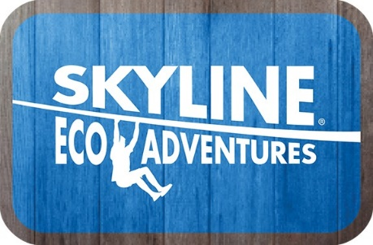

Media Contact:
Thomas Kratsch
Director Marketing
Skyline Eco-Adventures
808-878-8037
tkratsch@zipline.com
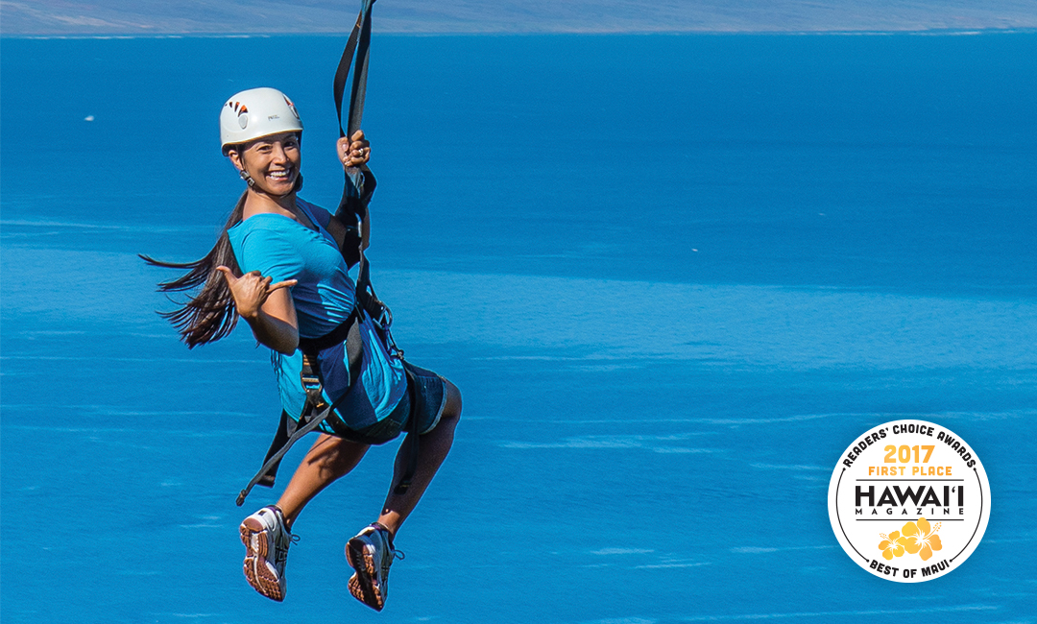

Skyline Eco-Adventures Receives Nine Best of the Best Awards from Hawaii Magazine’s 2017 Readers Choice Awards
MAUI, HAWAII (March 9th, 2017) – Skyline Eco-Adventures, Hawaii’s award-winning zipline company and operator of the first zipline course in the United States, has received Best of the Best Awards in nine categories for 2017 by HAWAI‘I Magazine’s fifth-annual Best of the Best Reader’s Choice Awards.

Featured in the March/April 2017 issue, Hawaii Magazine tallied thousands of reader’s votes in for Hawaii’s “Best of the Best” in hotels and resorts, places to eat and shop, activities, attractions, and more. Skyline Eco-Adventures was voted the #1 Zipline Company on Maui for the fifth year in a row and Skyline’s Akaka Falls, Big Island course was for voted the #1 Zipline tour in Hawaii for the 2nd year in a row. Skyline’s nine awards for 2017 included:

Skyline Eco-Adventures received three No. 1 rankings for 2017:
- Best Maui Zipline Company & Course – Skyline Ka’anapali & Haleakala
- Best Hawaii Island Zipline Company & Course – Skyline Akaka Falls
- Best Hawaii Island Extreme Tour – Skyline Akaka Falls

Skyline Eco-Adventures received three No. 2 rankings for 2017:
- Best Hawaii Island Land Activity/Adventure Tour Company – Skyline Akaka Falls
- Best Maui Extreme Tour – Skyline Ka’anapali & Haleakala
- Best Kauai Extreme Tour – Skyline Poipu, Kauai
Skyline Eco-Adventures received two No. 3 rankings for 2017:
- Best Kauai Zipline Company & Course – Skyline Poipu, Kauai
- Best Kauai Guided Tour Company – Skyline Poipu, Kauai
Skyline Eco-Adventures received one No. 5 ranking for 2017:
- Best Kauai Land Activity/Adventure Tour Company – Skyline Poipu, Kauai

Last summer and fall, the magazine polled thousands of its mainland U.S., Hawaii and international readers, asking them to share their selections. More than 100,000 picks were tallied and compiled into the magazine’s Readers’ Choice Awards lists, covering more than 98 categories – from best Hawaii hotels and resorts, beaches, indoor and outdoor activities, to scenic road trips, fashion designers, and coastlines. HAWAI‘I Magazine is published bi-monthly, reaching subscribers around the globe with stories that explore the best of Hawaii.

Skyline Eco-Adventures embraces a Do Good Have Fun culture and as a member of 1% For The Planet has given back more than $1 million to environmental and charitable causes since opening in 2002.

Skyline Eco-Adventures is a leading commercial zipline company that thrills more than 95,000 guests annually with “knock-your-socks-off” experiences. As the first commercial zipline operator in the United States, Skyline operates two Maui zipline tours at Ka‘anapali and Haleakala, in addition to the Akaka Falls Skyline Adventure on Hawaii Island, and the Poipu Skyline Adventure on Kauai. Call (888) TO-GO-ZIP or visit www.zipline.com.

###

