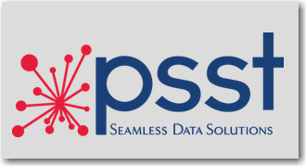

Fact Sheet

- Founded in 1992
- Corporate officers and executives
  - Larry Roach, CEO and President
  - Connie Younger-Roach, Executive Vice President
  - Carl L. Williams, Sr., Chief Operations Officer
  - Donna McDonald, Chief Financial Officer
  - Curt Broyles, Vice President, Product Innovation
- PSST offers data integration and compliance solution in the areas of Human Resources, Finance, Payroll and Benefits.
- PSST has provided Munis integration products and services for more than 27 years.
- More than 750 total clients throughout the United States:
  - More than 200 U.S. K12 districts use PSST products
  - 135 of Kentucky’s 173 school districts use PSST products
  - 27 industries represented among PSST’s clients, including K12, Retail, (Automotive, Dining), Local Government/Municipality, Healthcare, Construction, Transportation/Logistics, Manufacturing
- Developed ACA-Track™, a software solution for the Affordable Care Act employer compliance and reporting, in 2013
- Employees: 27; Office location: 303 Middletown Park, Suite B 40243; Phone: 502-244-9280

