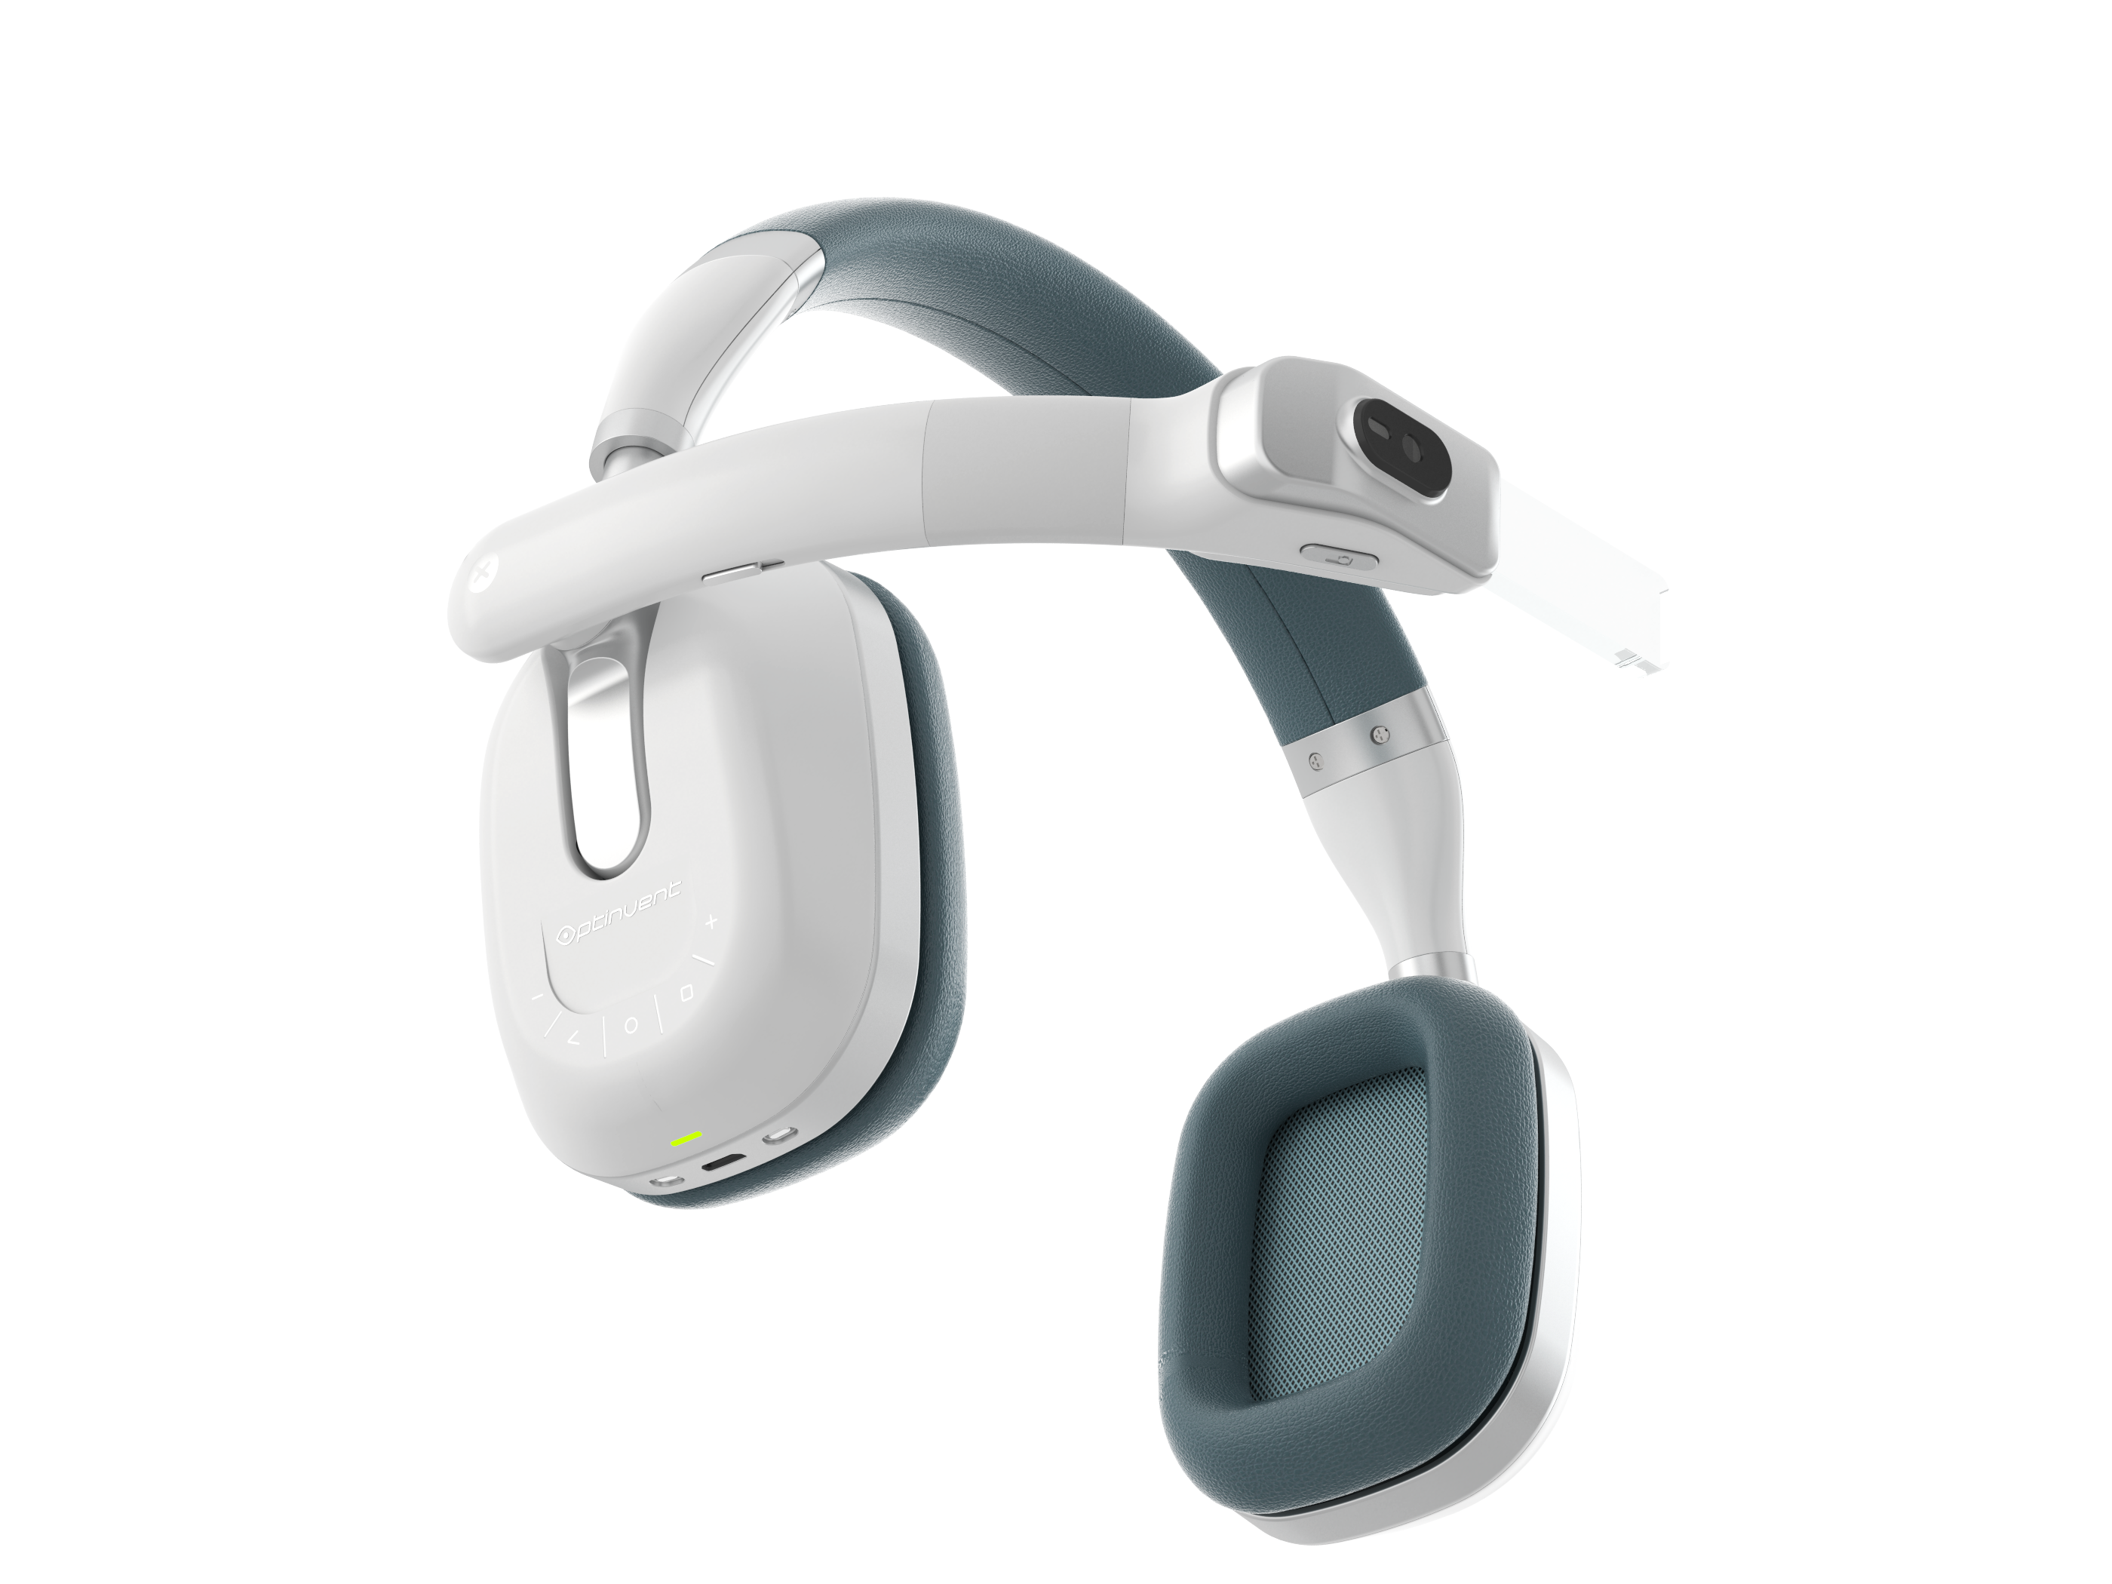



New Mobile Music Experience Introduced at SXSW

ORA-X : World’s 1st Augmented Reality Headphone


Austin, TX, March 13th 2017: Optinvent presents the ORA-X at the South By South West conference. ORA-X enables a new and awesome mobile music and entertainment experience. The ORA-X is the future of headphones and a new product category – AR Headphones – running Android – with high quality audio – and a retractable see-through display. Experience the ORA-X for yourself on Booth Number 1325 Hall 4 at the SXSW conference in Austin on the 13th and 15th .
Targeting music lovers on the go, the ORA-X is a brand new category, an Android powered smart AR headphone. The ORA-X is a stylish headphone with high quality audio sound, a standalone Android computer, as well as a disruptive see-through retinal projection technology.

The ORA-X enables a brand new mobile entertainment experience. Not only can you hear music, but you can ‘see music’. And that’s just the tip of the iceberg. As a standalone Android computer and a stylish pair of high-end headphones, the ORA-X will allow never before seen mobile entertainment applications such as watching music videos, mobile gaming, AR, and much more. It will take headphones to the next level!

See Video Here: https://youtu.be/E2ioouhqqTs


Imagine watching music videos and news clips on the go, playing casual games, recording and sharing video on social media, getting notifications, AR navigation, all while listening to your favorite songs. Traditional headphones can give you mobile audio but their functionality hasn’t evolved much beyond that for the past 30 years. The ORA-X takes this experience much further by adding vision and computing. This is a new and compelling user experience and this revolutionary device could mean the end of the “regular” headset. Why just hear when you can see?


Contact:
Kayvan Mirza
kayvan.mirza@optinvent.com
+33 683150213
+44 7452012703

