(IRVING, TEXAS. MARCH xx, 2017) – StoneGate Senior Living, a Lewisville, Texas-based transitional health care and senior living company announces 10 of its transitional care centers are recipients of Pinnacle Quality Insight’s 2017 Customer Experience AwardTM.
Community | Location | Best In Class Services | Years In Operation
 | Tulsa, Oklahoma | Cleanliness | 6
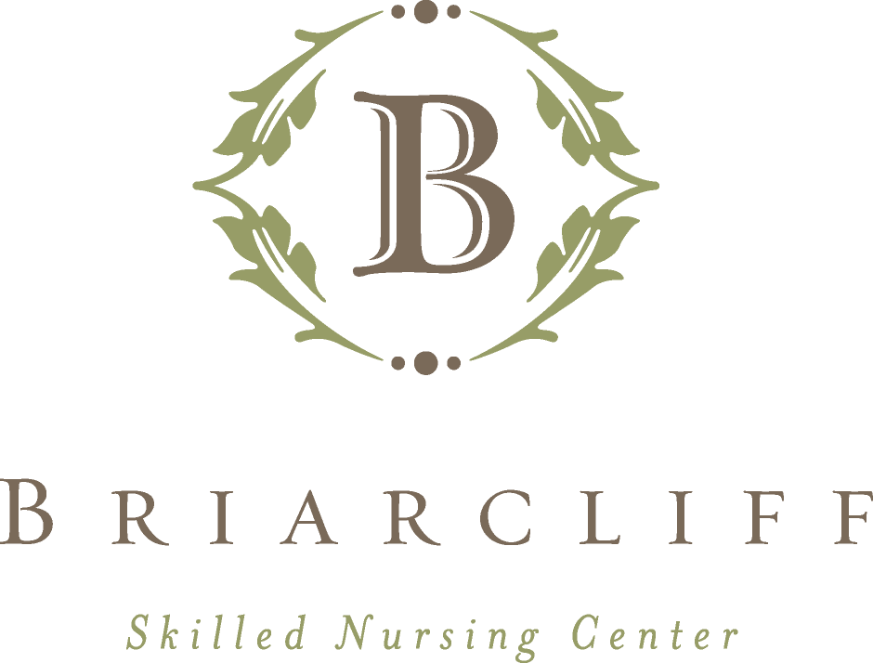 | Tyler, Texas | Activities, Dining Service | 14
Colonial Nursing  & Rehabilitation Center | Lindale, Texas | Professional Therapy Services | 2
 | Wylie, Texas | Admission Process, Dining Services | 7
 | Texarkana, Texas | Activities | 14
 | Dallas, Texas | Safety & Security | 6
 | Longview, Texas | Cleanliness, Professional Therapy Services | 3
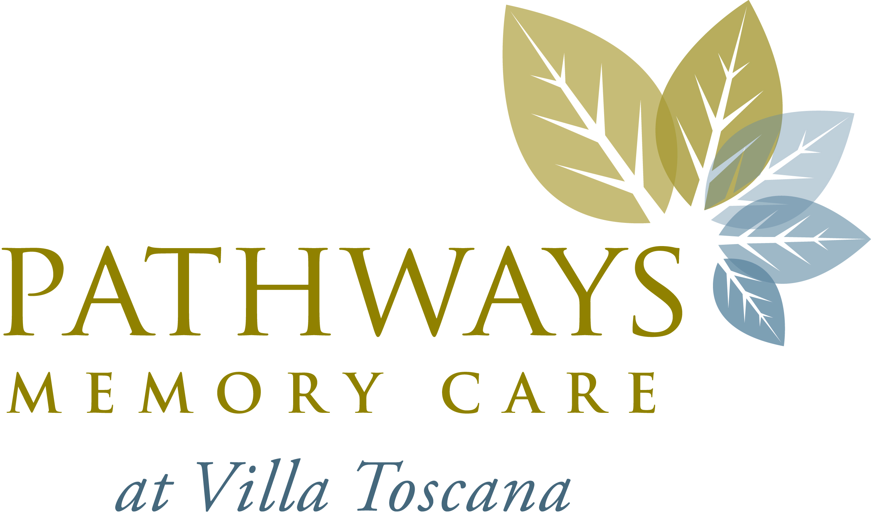 | Houston, Texas | Admissions Process, Safety & Security | 2
 | Sherman, Texas | Activities, Professional Therapy Services, Safety & Security | 11
 | Irving, Texas | Professional Therapy Services | 3

John Paul Taylor, COO of StoneGate Senior Living LLC, describes receiving the award(s) as an honor, stating, “We are proud that 10 StoneGate-managed transitional care centers received this important recognition from Pinnacle Quality Insight, and that the recognition is in multiple areas that are important to our objective of always delivering a positive patient experience. What this also tells us is that there are many areas where we can continue to improve and deliver an even better patient experience.”
Throughout its 16-year history of serving the community, StoneGate Senior Living placed a strong emphasis on ensuring the individual needs of every patient and resident are met. Over the course of 2016, a sampling of each of StoneGate’s customers and their families participated in monthly telephone interviews that include open-ended questions, as well as the opportunity to rate StoneGate in specific categories.
Pinnacle Quality Insight, a third-party survey company, is StoneGate’s patient satisfaction research provider. Utilizing a telephone survey throughout 2016, a sampling of StoneGate’s customers and their families provided feedback about patient satisfaction in 15 distinct areas. The information gives StoneGate the granular information to help it understand customer perceptions of quality of care, the overall customer experience and the likelihood of residents to recommend a community to others.
“I hope that our commitment to quality demonstrates that when something is not up to expectations, we will always work to make it right,” says Taylor.
By qualifying for the Pinnacle Customer Experience Award™, StoneGate Senior Living satisfied the demand of scoring in the top 15% of the nation across a 12-month average. Clients have the opportunity to achieve this Best in Class distinction on a monthly basis in many categories designed to accurately reflect each resident’s experience.
For more information or to Schedule and Interview with StoneGate Senior Living, please Contact:
Media Contact Media Contact
Tara Vreeland, PR Manager Anne Marie Petersen, PR Coordinator
(303) 929-8363 (760) 522-4400
tvreeland@promoteonpurpose.com ampetersen@promoteonpurpose.com

About Pinnacle Quality Insight
A customer satisfaction measurement firm with 20 years of experience in post-acute healthcare, Pinnacle conducts over 150,000 phone surveys each year and works with more than 2,300 care providers in all 50 US states, Canada and Puerto Rico.

About StoneGate Senior Living, LLC
StoneGate Senior Living, LLC provides support services to senior living and care properties that offer skilled health care, assisted living, memory support, and independent living locations in Colorado, Oklahoma, and Texas. Founded and led by a team of senior living industry veterans, StoneGate understands that careful attention to customer expectations is vital to the success of a senior living and care community. Learn more at www.StonegateSL.com.

###

