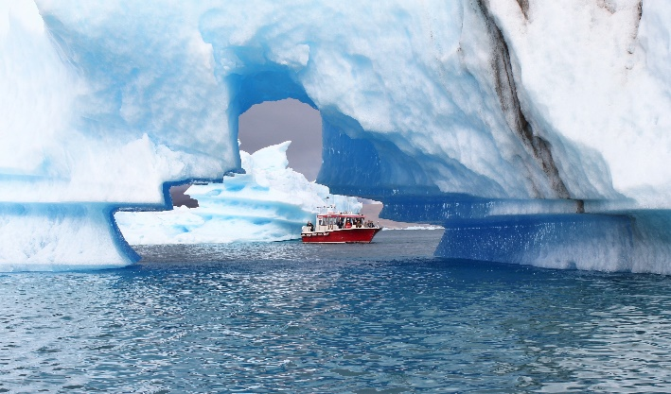

Press Release

Expedition Cruise to Iceland and Greenland
Iceland ProCruises

REYKJAVIK, Iceland— Offering discerning travelers unique experiences both on and off the ship, Iceland ProCruises announce two sailings which will visit the islands of Iceland and Greenland. On the voyage from Iceland to Greenland, discover the immense scenic and cultural variety of the world’s largest island. From the beautiful and fertile south with its fascinating Viking history and the modern capital of Nuuk in a traditional Inuit society to the town of Ilulissat with its floating icebergs and UNESCO World Heritage site, Ilulissat Ice Fjord. All these spectacles and more await your unforgettable journey aboard the Ocean Diamond.
Iceland and Natural Wonders of Greenland departs Reykjavik, Iceland July 27 and ends in Kangerlussuaq, Greenland August 7. Natural Wonders of Greenland and Iceland departs Kangerlussuaq, Greenland on September 2 and sails to Reykjavik, Iceland September 13. Spectacular scenery, activity-rich shore excursions and an enthusiastic expedition staff all make this trip memorable for everyone.
Thanks to two stabilizers that significantly reduce roll and an ice-strengthened hull (ice class 1D), the ship, OCEAN DIAMOND, is ideal for expeditions in the Arctic region. Due to the ship’s compact size, it can take passengers to places off the traditional cruise routes to experience all the highlights of both Iceland and Greenland.
With a maximum of 199 passengers, the OCEAN DIAMOND features a range of modern onboard amenities and is staffed with outstanding officers and crew, as well as bilingual expedition leaders and guides. The 107 cabins and suites, all of them elegantly designed, offer modern amenities and exterior views. The ship’s own Zodiacs are available for shore excursions. After a busy day of explorations, passengers can browse books or DVD’s in the well-stocked Polar Library or enjoy views of the spectacular Arctic scenery from the panorama salon.
###
About Iceland ProCruises
Iceland ProCruises is an Iceland based company and a part of the Iceland ProTravel family which is located in six countries and is a leading tour operator for incoming travelers to Iceland. Their office in Iceland includes: Iceland ProCruises, Iceland ProTravel--a local DMC, Iceland ProTravel Services and Iceland ProFishing. Owners Gudmundur Kjartansson, a native Icelander, and Anne-Cathrin Brocker from Luxembourg, have over twenty years of combined experience in Icelandic tourism and are owners of the whole Iceland ProTravel family.

Media Contact: Nancy Harrison
Adventure Media
nharrison@adventuremedianews.com
307.421.4473

