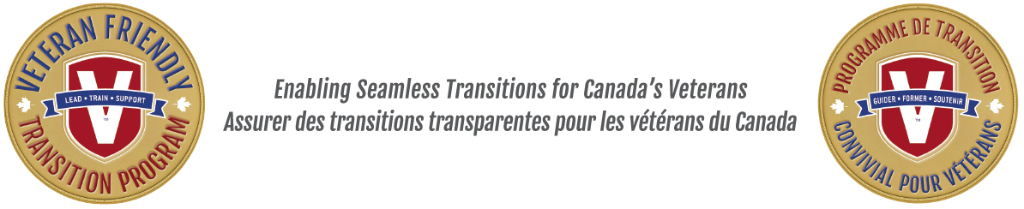
NEWS RELEASE
For immediate release

Veterans Emergency Transition Services Canada (VETS) & Veteran Friendly Transition Program (VFTP) Announces a National Partnership
March 29, 2017, Ottawa, Ontario – Today, the Veterans Emergency Transition Service Canada (VETS) and the Veteran Friendly Transition Program (VFTP) announced a national partnership. The partnership aims to support Veterans who might need personal support during their program of studies and their transition from service.
"VETS Canada is pleased to partner with VFTP and Willis College where it will provide emergency support to Veterans at Willis College. Transition is difficult for our Veterans and we are proud to do whatever we can to help our Veterans as they transition from service, said Jim Lowther, Founder of VETS Canada”.
Every year, the Canadian Armed Forces releases about 5000 men and women from service. Although a number choose retirement, many more want to transition to a civilian career, putting their skills and talents to work in a different way. That transition, however, is not always easy for Canada's Veterans as they face varying social, academic, and financial challenges in finding employment and establishing a new career.
"Leaving the military and the men and women that you serve with can be very overwhelming at times," explained Master Corporal (ret'd) Michael McBride, who was released after 13 years with the military and three tours in Afghanistan. "There are so many complicated things that you have to learn to do as you go through the stages of transition, when all you really want is to provide for your family. Having an organization like VETS Canada ready to support Veterans in a time of need during their academic studies will go far to assist our Veterans to have a more seamless transition."
The new VFTP combines career counselling, personal and professional support, and transition training, all under one roof, simplifying the transition process for Veteran students. Willis College, Canada's oldest college, is the first college who will receive the support from VETS Canada.
"Willis College is pleased to be the first postsecondary institution in Canada to work with VETS Canada," stated Rima Aristocrat, VFTP Founder and President & CEO of Willis College Canada. "Willis College has a long and proud tradition of supporting Canada's Veterans and is pleased that VETS Canada will help to support our Veterans during their studies.”
Many industry leaders are supporters of the initiative, as they already know the benefit of hiring Veterans who have trained for a new career.
The program was announced on Parliament Hill on 23 March, 2017 and registrations will begin in late April. Veterans released from the regular or reserve Canadian Armed Forces, Royal Canadian Mounted Police, and Provincial Police Forces are eligible to apply and register.
About Veteran Friendly Transition Program
The Veteran Friendly Transition Program (VFTP) is a transition program for Veterans that provides a flexible and supportive Veteran-friendly career and learning environment that will help enable Veterans to find gainful and meaningful employment following their service to Canada. Developed by and for Veterans, the program includes three components: a career and employment support program; a personal support program; and a training support program. The VFTP helps to ensure that Veterans have the skills and abilities to effectively transition from military to civilian life. More information is available on the new website: www.vftp.ca
SOURCE Willis College
About VETS Canada
VETS Canada has aided over 1,400 veterans in-crisis, at risk of homelessness, or living homeless since 2010. As the Veterans Affairs Canada service provider in the field of veteran homelessness and in-crisis outreach, VETS Canada’s volunteers provide aid and comfort to veterans in need, including endeavors such as moving veterans from the streets or shelters into affordable housing, securing food support and needed health care, navigating community services and resources, and helping facilitate re-entrance info the work force. Learn more at www.vetscanada.org
-30-
For more information or to schedule interviews:
Dan Planetta
E: dan.planetta@williscollege.com
P: 613-233-1128

