**Prüfen**

## World's First USB Cable with - Auto-Off Timer - mAh Meter Auto-Stop against - Temperature Overheating - USB Adaptor Overload - Abnormal High Current

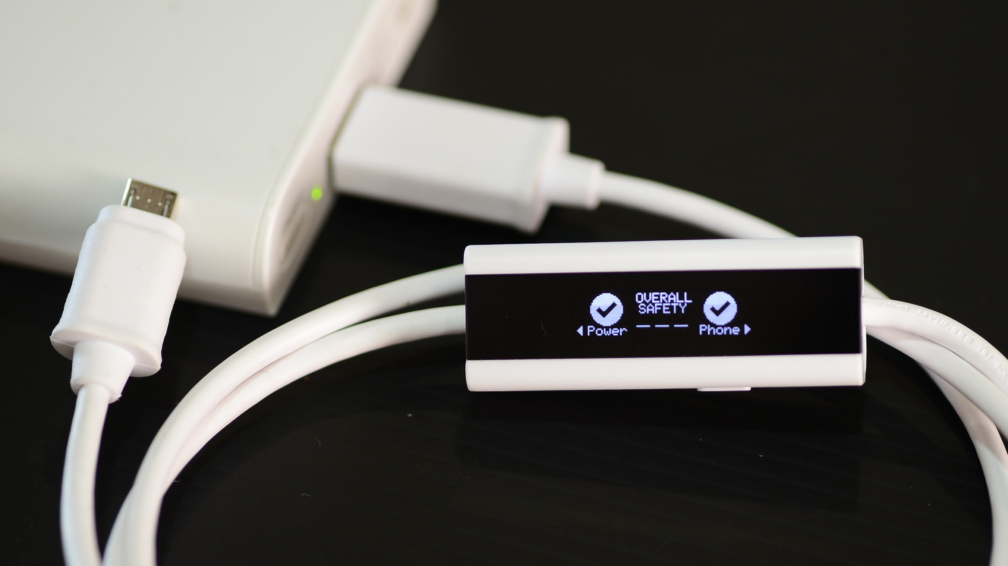

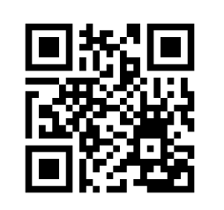

YouTube Video: <https://youtu.be/A5Y4bYdY1ns>

**Prüfen**

**Temperature Overheating Check**

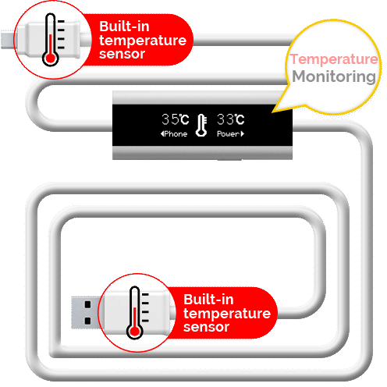

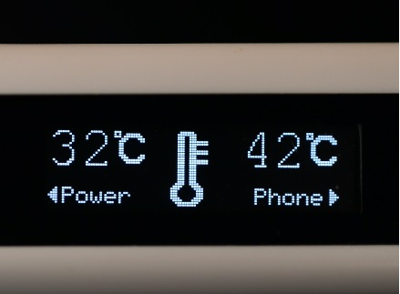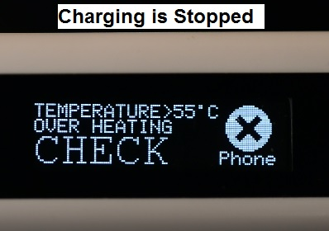

**Phone and USB Adaptor Overheating?**

Prufen Smart USB Cable has temperature sensor built into the USB connectors at each end of the cable. If any dangerous temperature is detected, the microprocessor in the Prüfen Smart Cable will automatically stop the charging process. A temperature error message is then displayed.

Charging is aborted when Temperature is greater than 55ºC when charging power is less than or equal to 7.5W (eg 5v 1.5A).

Charging is aborted when Temperature is greater than 65ºC when charging power is more than 7.5W eg FAST charge (9V 1.67A) and Apple® Ipad® (5V 2.1A).

**Prüfen**

**USB Power Overload Check**

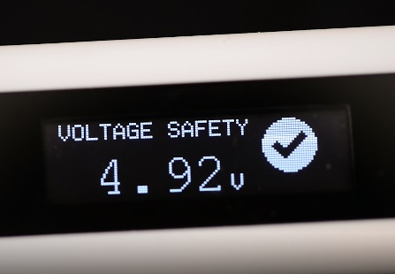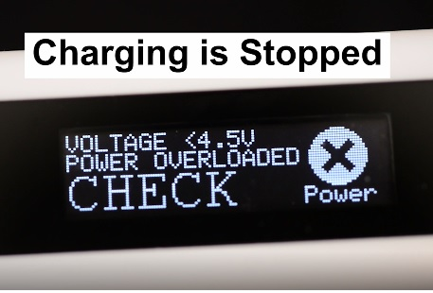

**Power Adaptor dangerously overloaded?**

The microprocessor in the Prüfen Smart Cable continuously performs safety check on the voltage of USB Power supply to check for power overloaded. When the USB Power supply is overloaded, the microprocessor in the Prüfen Smart Cable will automatically stop charging and display voltage error message.

Charging is aborted when Charging Voltage is less than 4.5V

**Prüfen**

**Abnormal Current Check**

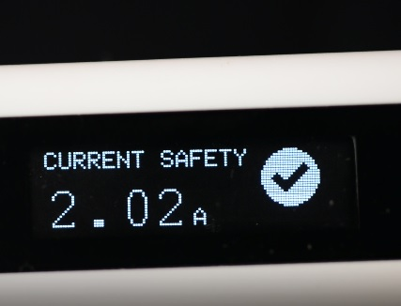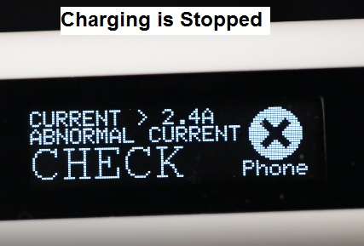

**Abnormally High Current during Charging?**

Prüfen Smart Cable continuously performs check on the current flowing through the cable. If a high current of greater than 2.4A is detected, Prüfen's microprocessor will automatically aborts charging and display current error message.

#### 

**Prüfen**

**Charge Energy Meter**

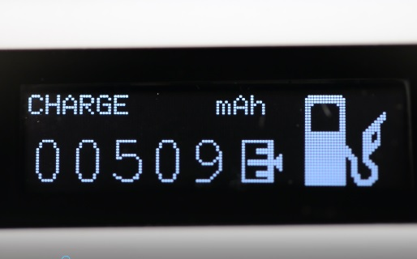

**10,000mAh Power Bank really 10,000mAh?**

Power Banks are popular and are supplied by many manufacturers. Now you can check if your 10,000mAh power bank is really 10,000mAh.

**Time to change the battery in my Phone?**

Poor-quality manufacturing or prolonged use can reduce battery's capacity to store energy. Charge the depleted battery with Prüfen and see if the actual mAh charged is within 80% of battery’s specification.

**Prüfen**

**Best in Class Cable**

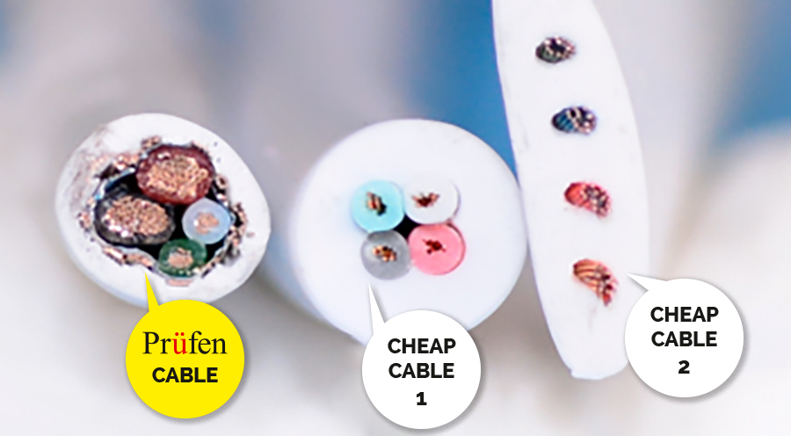

Prüfen uses thick gauge wires which improves charging and data transfer speed. Cheap cables are largely plastic and very little wire.

Prüfen's copper wires are tin-plated to prevent corrosion and thus improve reliability. There are also shielding wires added to the cable to prevent Electro-Magnetic Intererence (EMI).

**Connector Compatibility (Apple® & USB-C)**

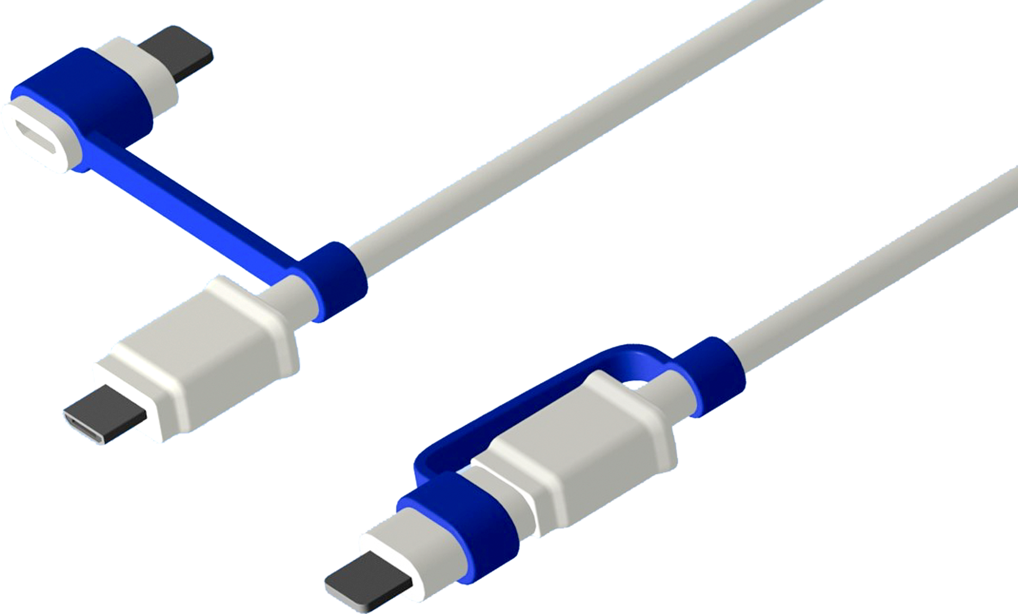

Prüfen is made for use with Apple and USB-C micro-USB adaptors. These adaptors include any authorized Apple® Lightning® Adaptors and USC-C. Please note that adaptor is an optional item.

Prüfen maintains a micro USB connector so that Apple® users may also charge their power banks.

Apple® & Lightning® are trademarks of Apple Inc.

**Prüfen**

**Patents Pending**



Prüfen Smart USB Cable is a result of many years of research resulting in many proprietary designs and innovative features.

Patents pending 14/892,966 104136824 050401

**Prüfen**

Prufen Pte. Ltd.

Prufen Pte. Ltd. is a company incorporated in Singapore.

For more information, please contact:

Mr Goh Sian-Ee

18 Boon Lay Way, #07-110, Tradehub 21, Singapore 609966

Managing Director

mobile: (+65)-9639-2258

Video: <https://youtu.be/A5Y4bYdY1ns>



Email: [sales@prufen.com](mailto:sales@prufen.com)

Website: prufen.com

Date: 2nd April 2017