FOR IMMEDIATE RELEASE

LaundryCares Foundation Hosting Free Laundry Day in Irvington, New Jersey
  - New Jersey community welcome to enjoy complimentary laundry - along with food, literacy resources and fun - at Dirty Laundry Express laundromat in Irvington, NJ on April 13, 2017
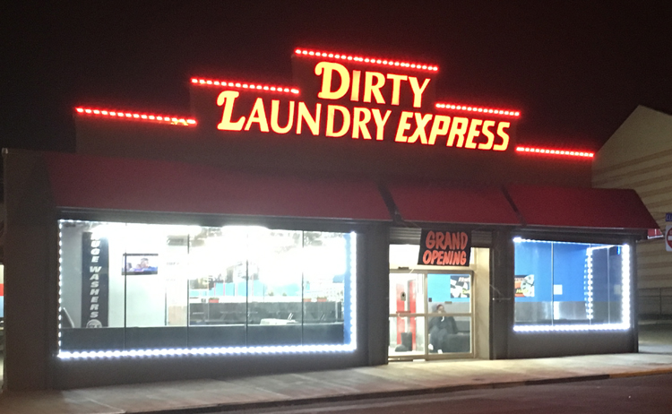
Picture: Dirty Laundry Express
Oakbrook Terrace, IL April 4, 2017 – On April 13, 2017 the Coin Laundry Association’s LaundryCares Foundation will host a Free Laundry Day in Irvington, NJ from 11AM until 4PM ET. The event will take place at Dirty Laundry Express – a newly opened self-service laundry serving New Jersey’s greater Irvington and Newark areas. The store – located at 931 Clinton Ave. in Irvington – features more than 80 washers and 94 dryers. LaundryCares invites all to join in for a family-friendly and fun afternoon of free laundry. Volunteers and donations are needed and welcome. More information about this event including forms for volunteering and donating can be found by visiting http://bit.ly/2nYXL3j.
This free laundry event will include free food, family activities and prizes. The LaundryCares Foundation is thrilled to add the upcoming free laundry day to the list of hundreds of successful outreach attempts accomplished over the last five years, said LaundryCares Chairperson Jeff Gardner.
“A single laundromat can make such a difference wherever it is, which is why we’re very excited for both Dirty Laundry Express and the Irvington community,” Gardner explained. “We’re confident that the footprint this laundromat will make in the area can greatly improve the daily lives of thousands of individuals.”
LaundryCares’ overall mission is to expand literacy and give back to communities that support self-service laundries. Members of LaundryCares are eager to give back to the communities that support their businesses. The Foundation was created by the Coin Laundry Association and has a longstanding history of supporting the self-service laundry industry. Members of LaundryCares Foundation are always eager to give back to the individuals who support their businesses.
Anyone interested in giving back to their community is asked to consider participating in the form of a tax-deductible, charitable donation to LaundryCares. For information on how to donate, please visit www.laundrycares.org.
###

